Press release
Autumn 2017

GRAFF’s Luxurious Designs for the Bath chosen for Mediterranean Resort
SADE Faucet Collection furnishes the bathrooms of Monte Carlo’s Villas du Sporting
Architecturally impressive and technologically advanced, GRAFF's library of faucets and fixtures are used to elevate hotels, villas, and resorts across the globe. These luxurious abodes serve as elegant platforms for sophisticated collections, including Les Villas du Sporting Monte-Carlo Bay Hotel & Resort, which has furnished its bathroom suites with the SADE Collection.
Immersed in the idyllic setting of Cote d'Azur, the chic residence, surrounded by waterfalls and exotic gardens, plays to the sleek aesthetic of the collection.
Furniture and accessories of the resort are contracted by the most exclusive brands in contemporary design. From Starck's complements and the limited-edition chairs by Poltrona Frau to the modern SADE faucet collection by GRAFF, each piece elegantly furnishes the room's spaces, providing guests with maximum comfort.
Designed internally by GRAFF’s G+Design Studio, the SADE collection provides an eye-catching element built with durability in mind. The minimal design is its strength, as evidenced by the curved and extremely flat mouth made distinct with its brilliance. SADE’s design is further enhanced by the harmonious arch that forms the faucet body, providing a modern interpretation of old-world fountains with the elegant, natural gush of water it delivers.
The Villas du Sporting Monte-Carlo Bay Hotel & Resort enjoys a full seafront experience with 334 rooms and 22 luxurious suites. The interiors were meticulously designed by the Belgian studio Atelier d'Art Urbain and Monegasque architect, Louis Rué, who selected the SADE Collection. The exclusive complex provides high-design throughout, with guests having access to an in-house casino, spa, heliport, private moor, nightclub, and award-winning restaurants.
Editor’s note: The SADE collection is produced in emptied brass, with a very low nickel and lead content and developed in compliance with the drinking water regulations, as established by the company policy, fully meeting the most restrictive criteria required for the protection of health and the environment.

SOME OF THE IMAGES AVAILABLE FOR THE PRESS

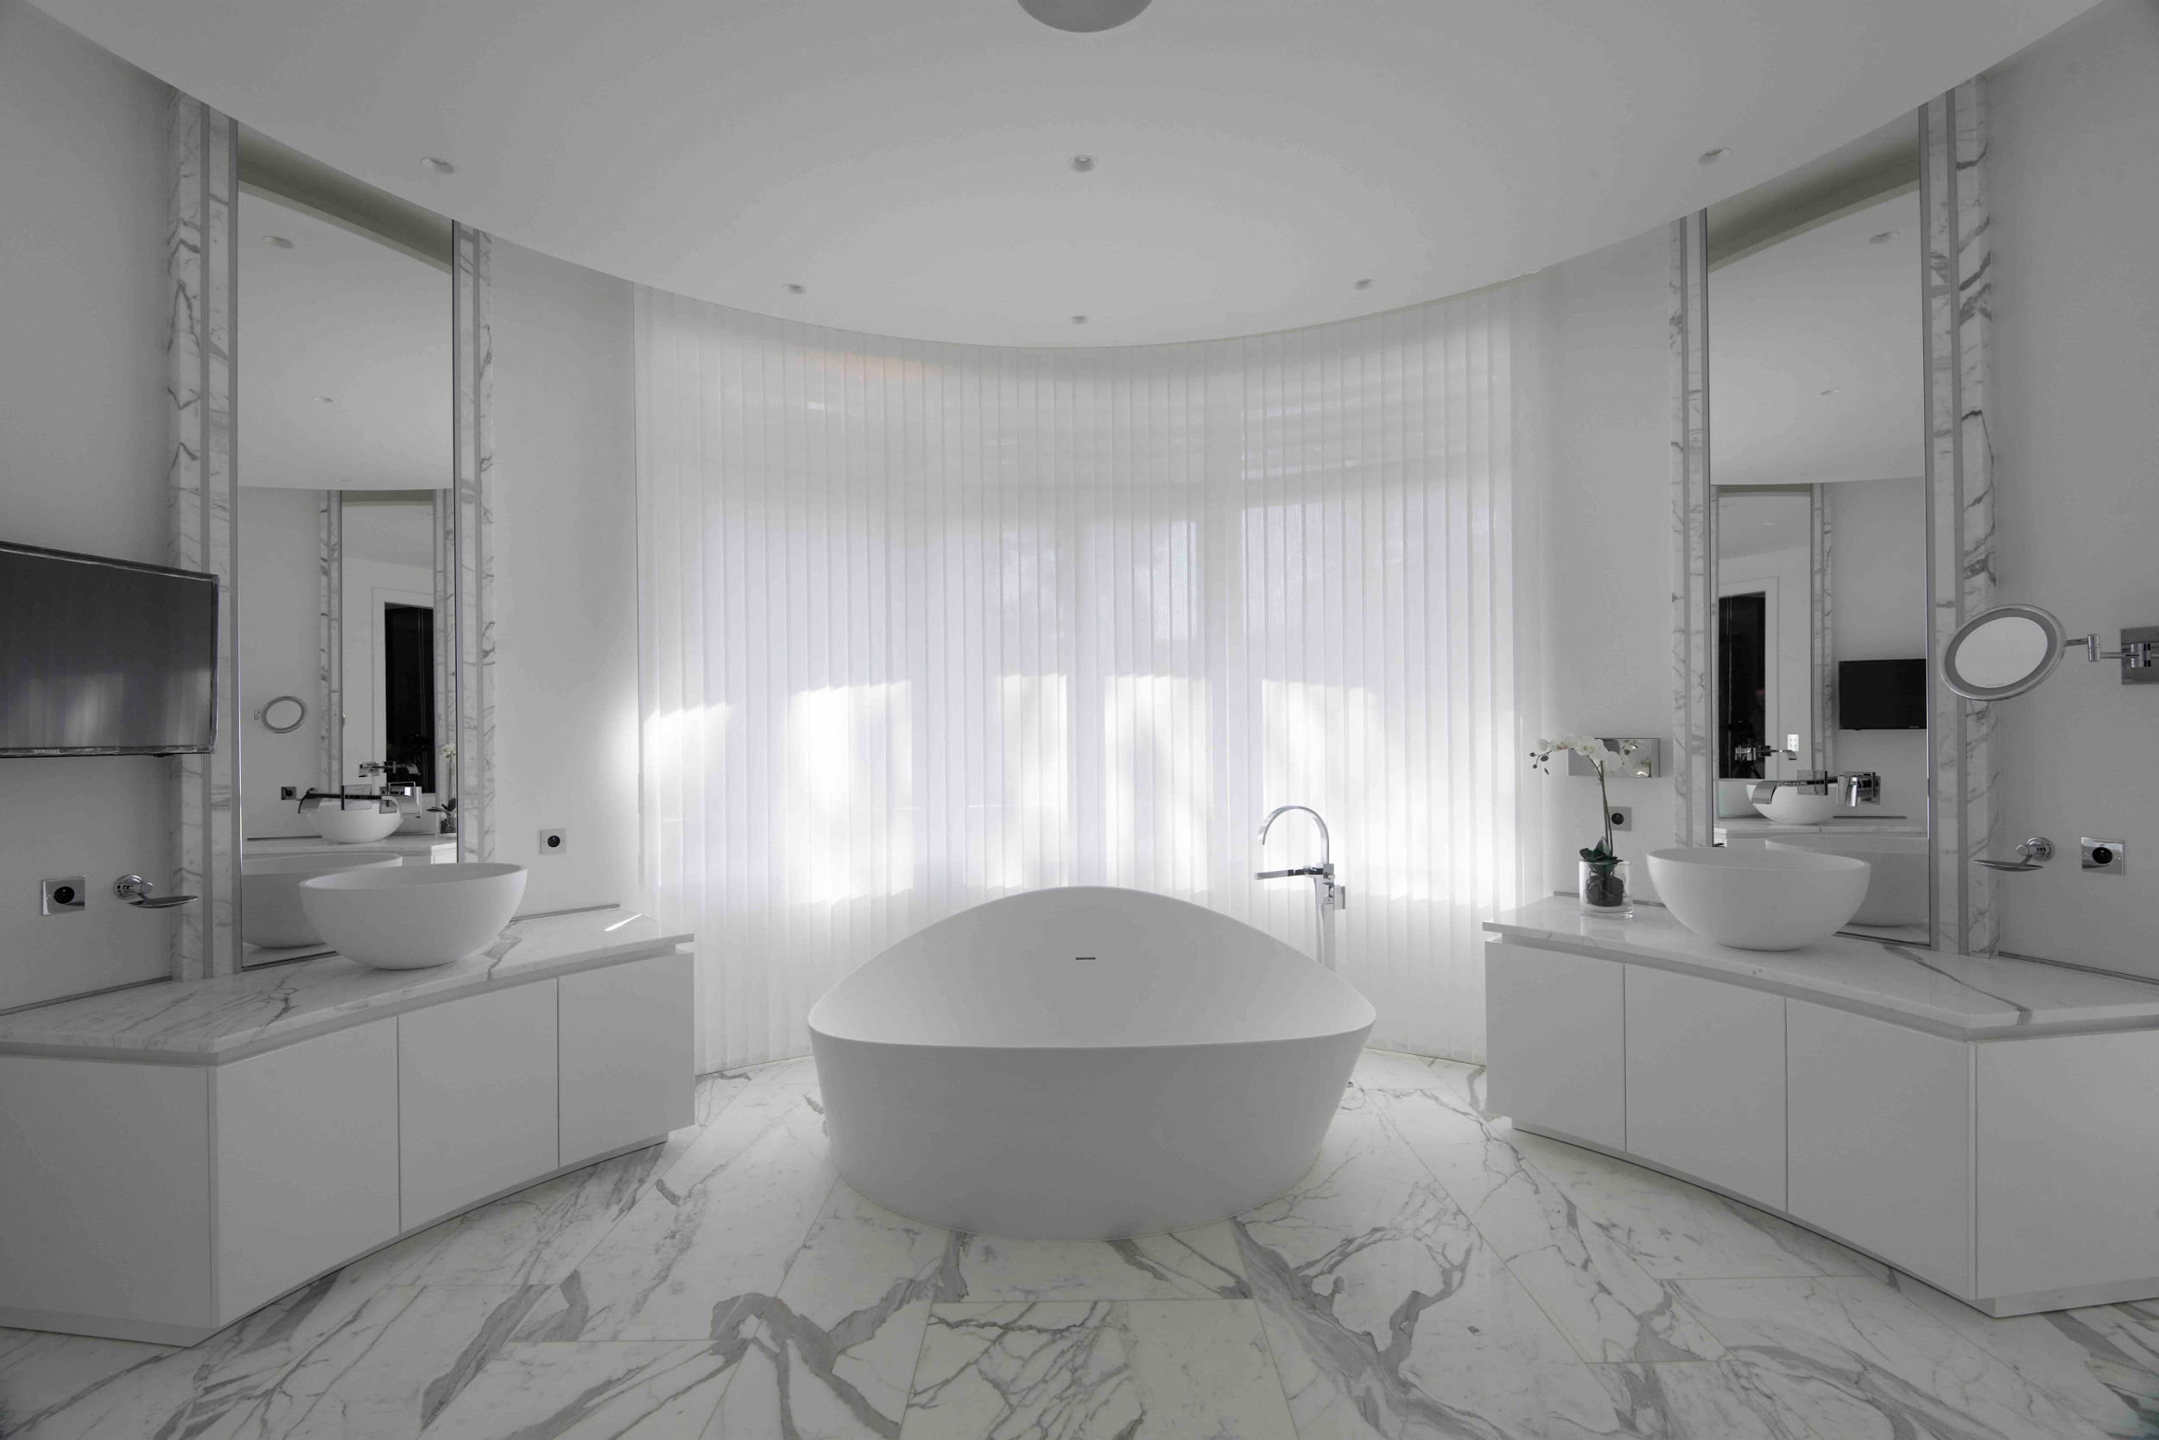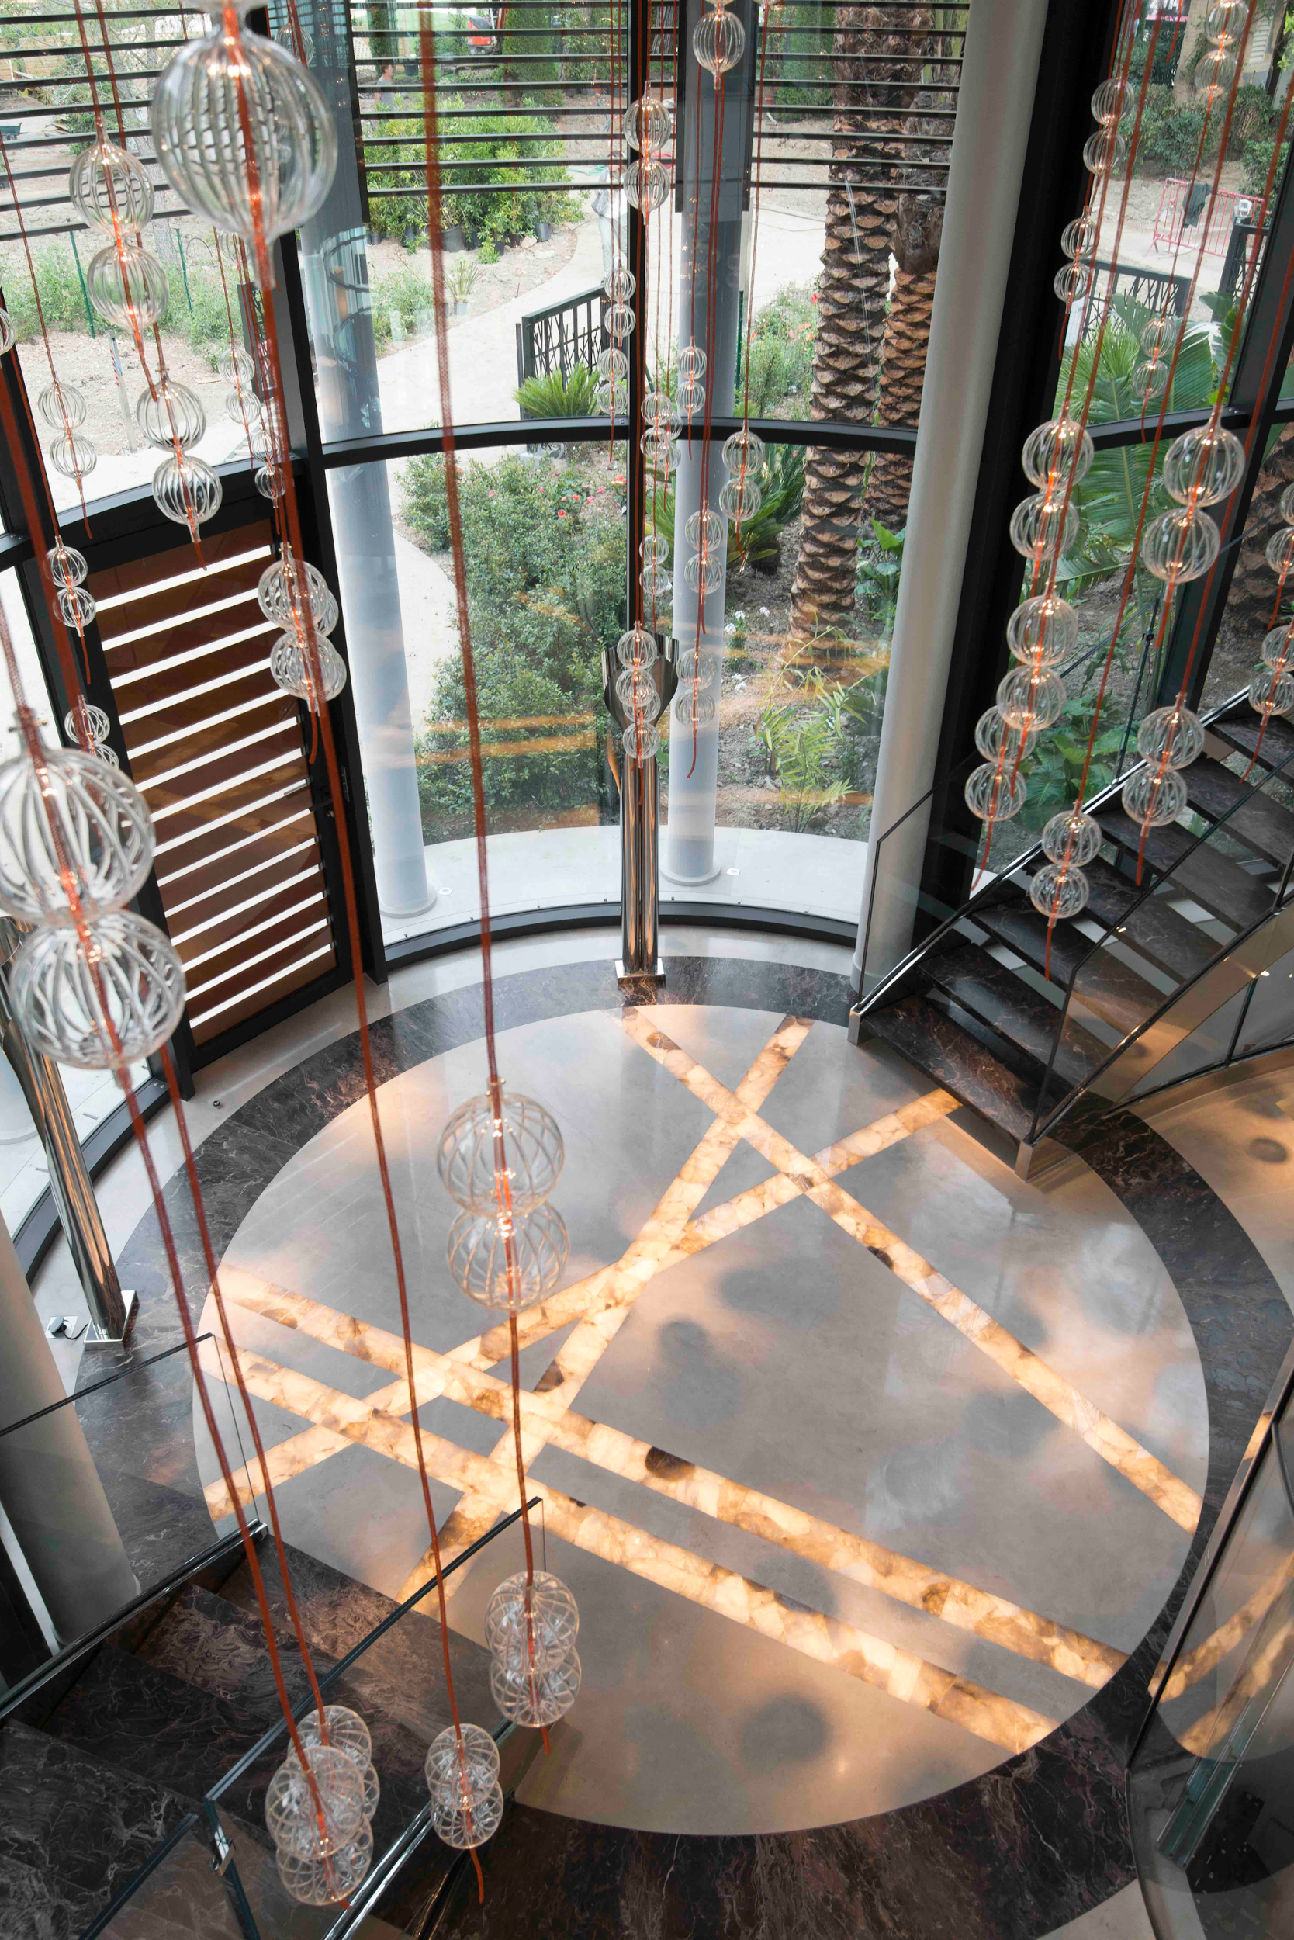

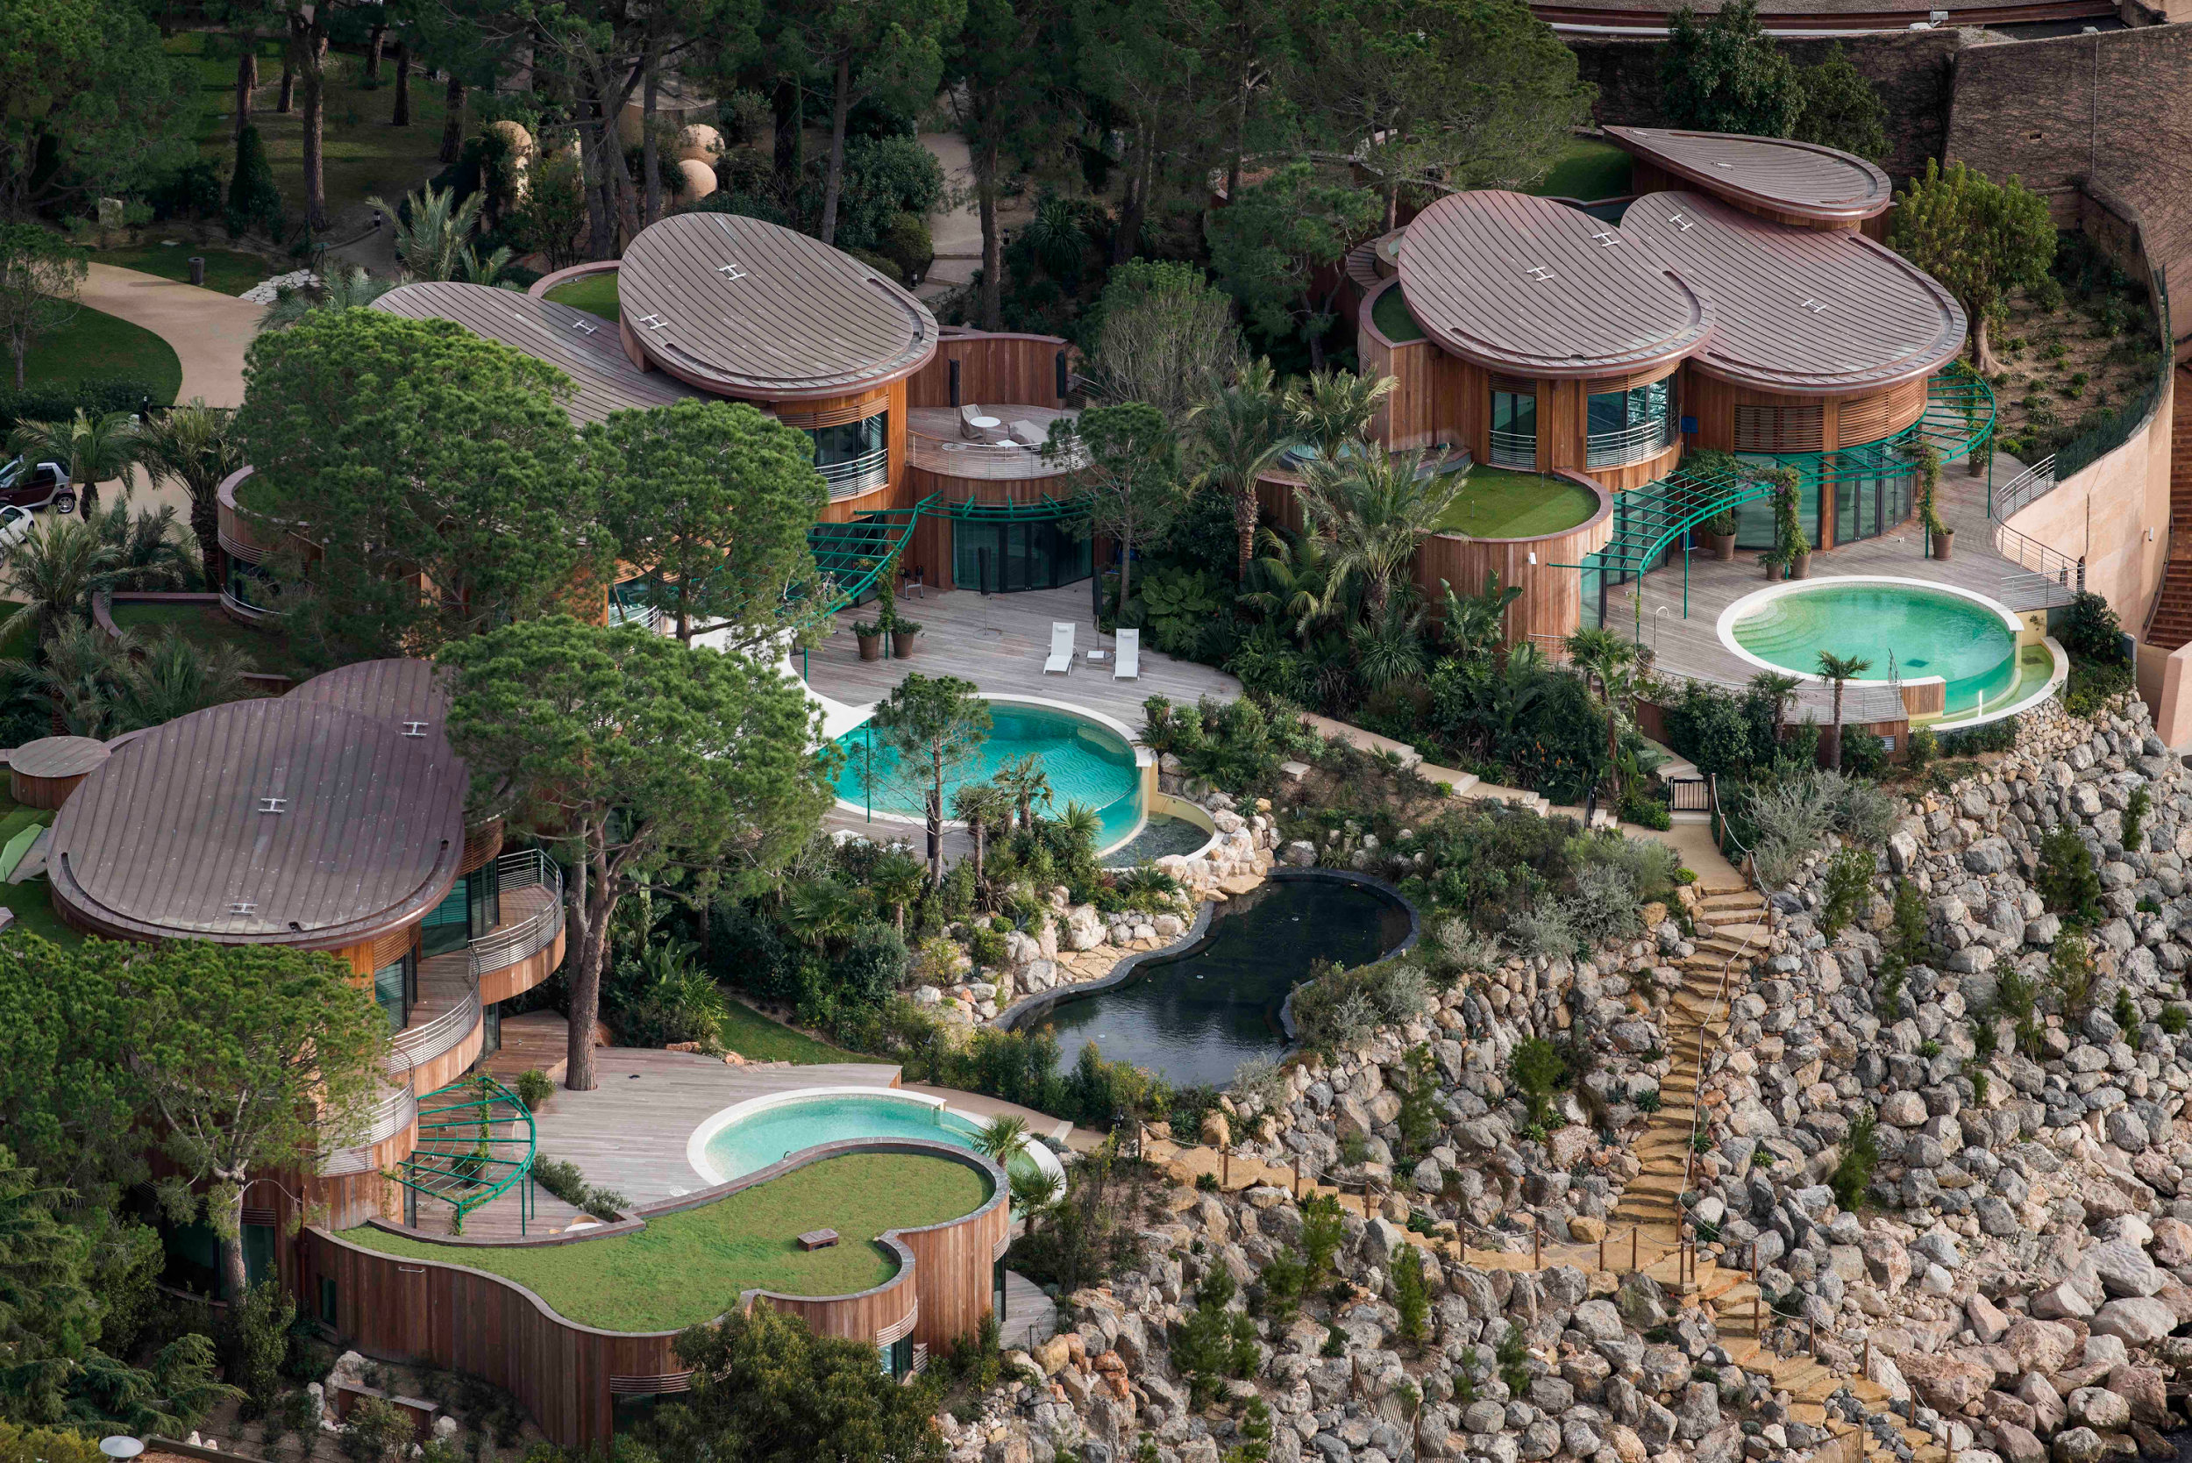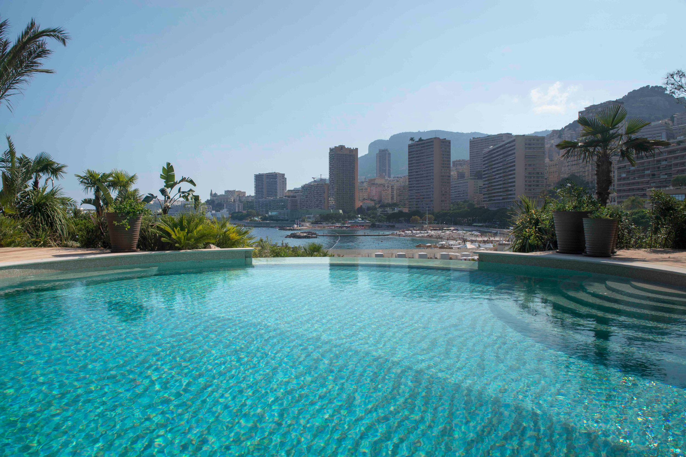

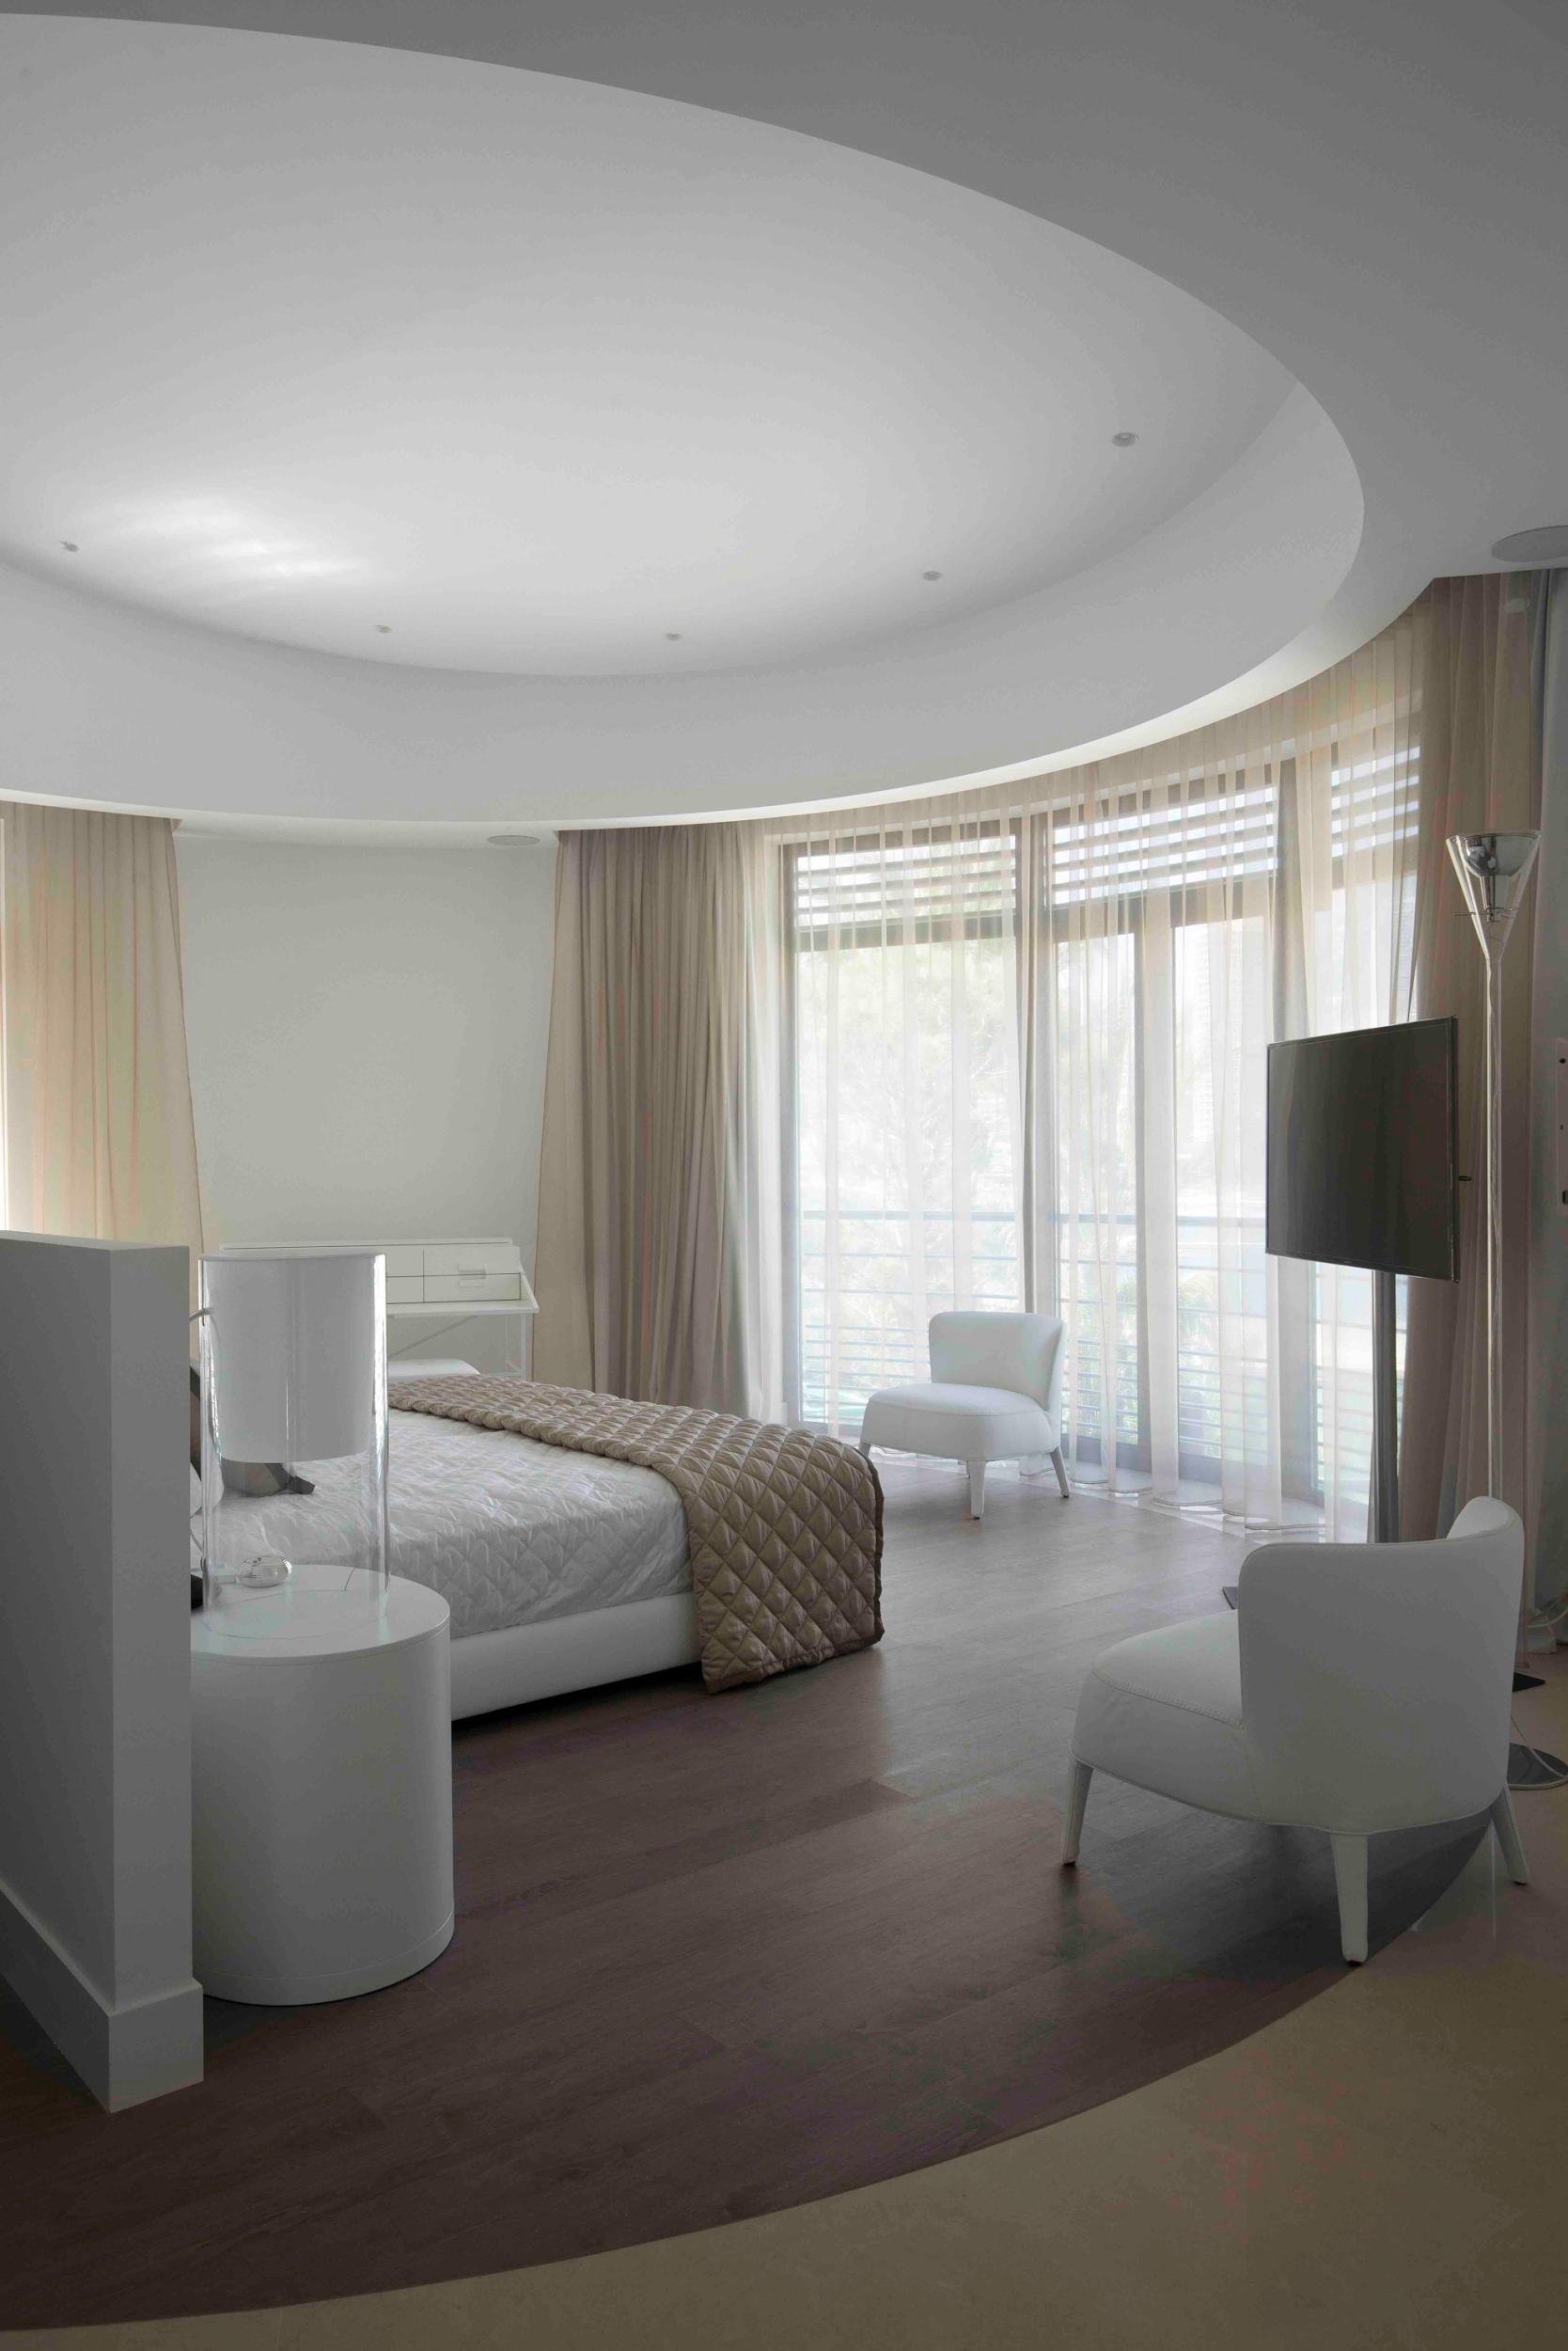

GRAFF EUROPE
Via Aretina 159, 50136 Florence - ITALY
Tel: +39 055 9332115,
fax: +39 055 9332116
email: info@graff-mixers.com
www.graff-faucets.com

For information and high resolution
images
Press release:
tac comunic@zione milano|genova
tel +39 02 48517618 | 0185 351616
press@taconline.it | www.taconline.it

