GRAFF’s M.E. Faucet Collection
Adds Luxury to Renovated London Residence
Trend-forward Architectural Black
selected to update and enhance residence bath’s

Nestled in Finsbury Park, North of London, the Wittering House project by GPAD, has been completed with the addition of luxurious GRAFF faucets. Installed throughout the transformed property’s bathrooms, the manufacturer of contemporary precision-engineered kitchen and bath products’ striking M.E. Collection provides a touch of glamour with the enchanting Architectural Black finish.
Melding with the modern and simple design of the once-abandoned garage, the M.E. Collection’s fine lines enhanced the space’s overall aesthetic that garnered a prestigious ‘New Homes Award’ by the Evening Standard.

The sleek faucet was also selected for its materiality with included brass elements featuring extremely low nickel and lead content, complying with the most restrictive drinking water regulations and the criteria required for the protection of health and the environment. Additionally, the faucet’s special powder coating, which came to manufacturer over 40 years ago, offers a particular durability and protection rarely found elsewhere.
Powder coated products are more environmentally friendly and more durable if compared to those in other finishes since they resist humidity, chemicals and ultraviolet light. The powder-coating treatment reduces the risk of scratches, chipping, abrasions, corrosion and other wear problems.

WITTERING HOUSE, GRAFF’s M.E. collection in the ARCHITECTURAL BLACK powder coating finish

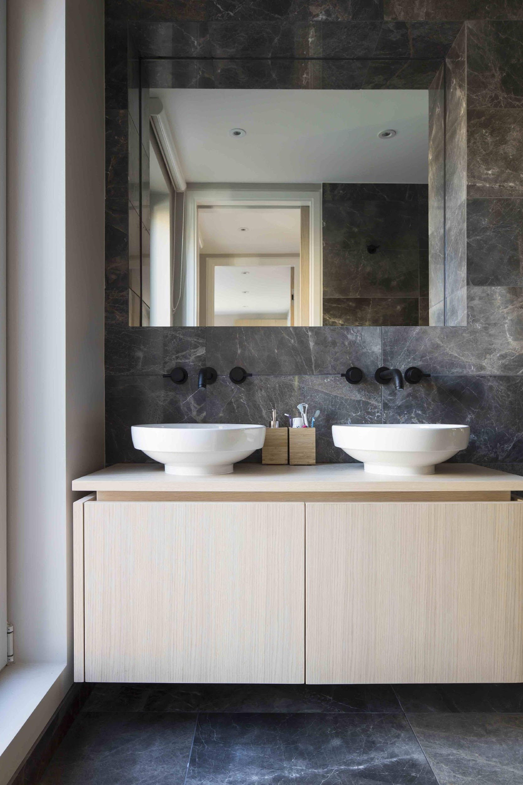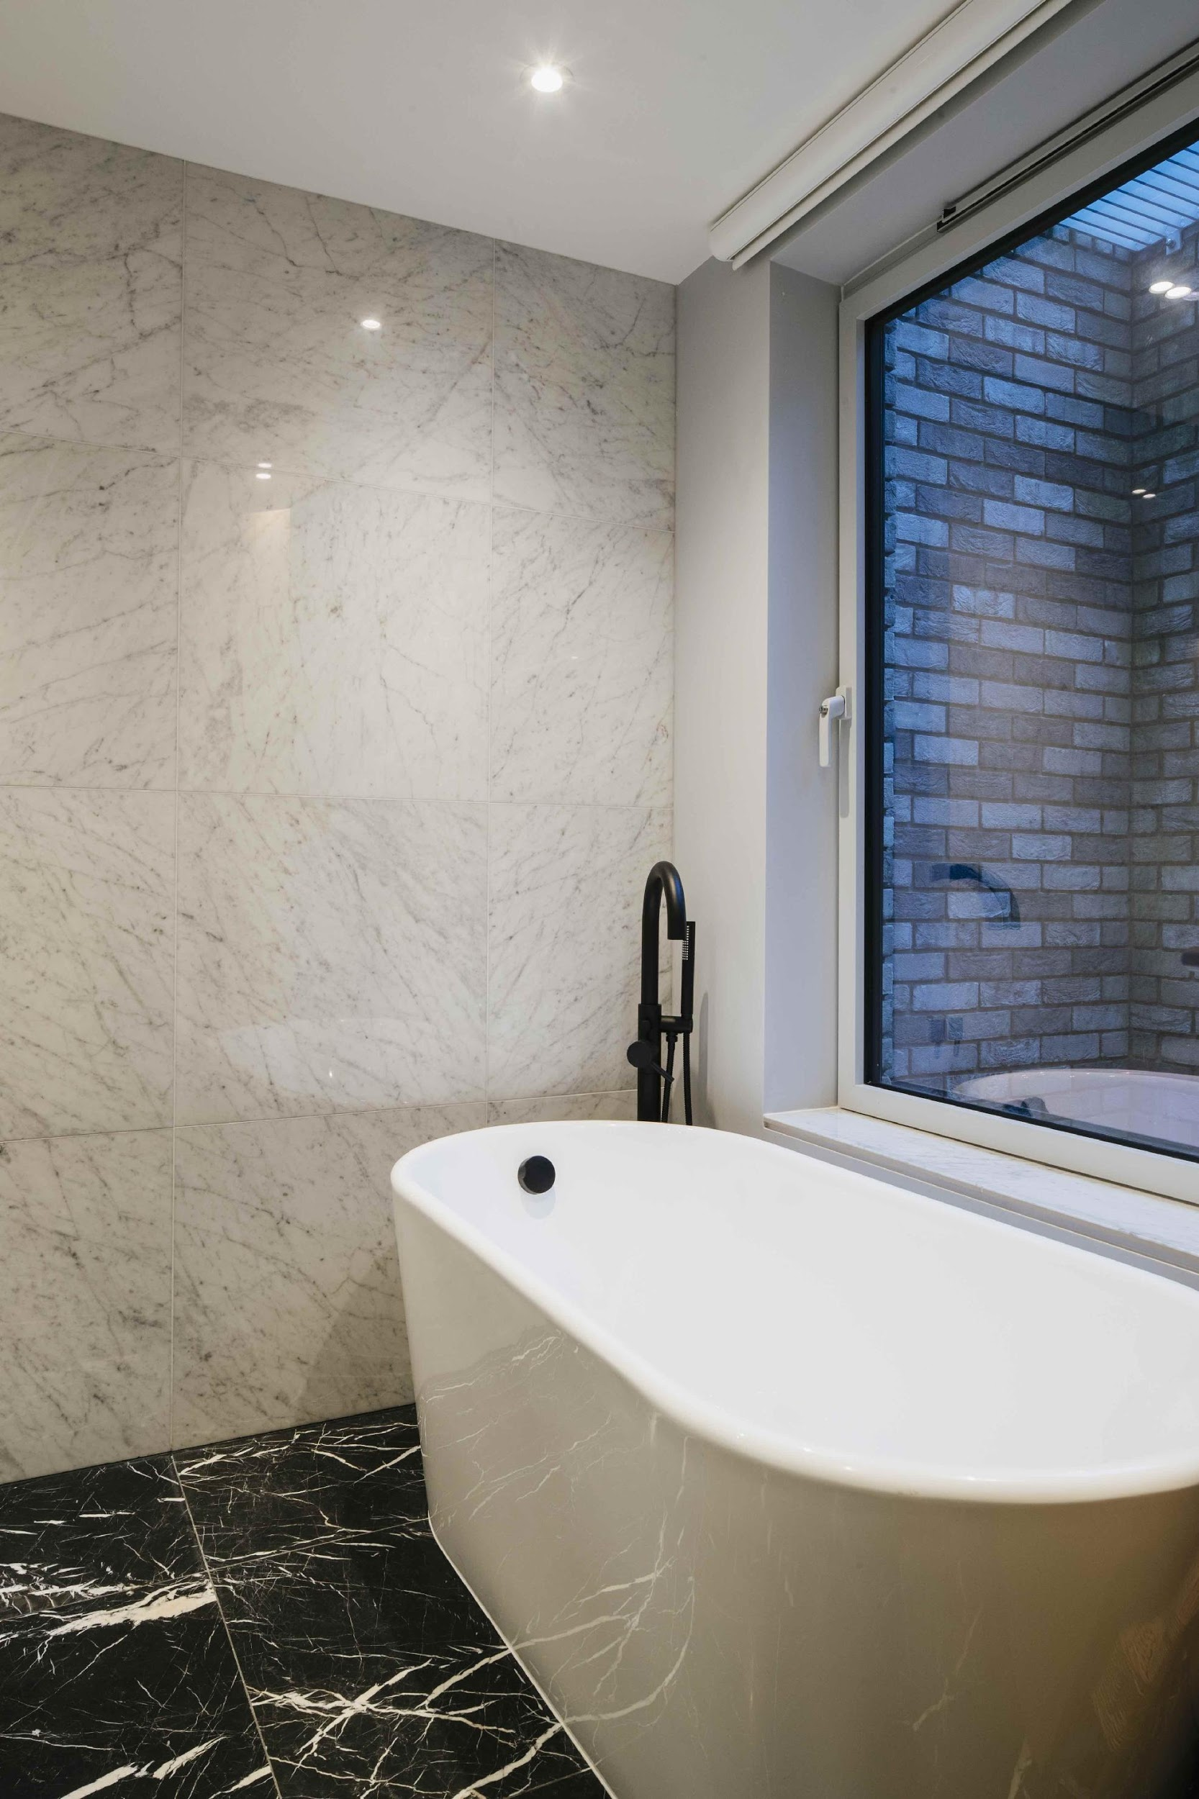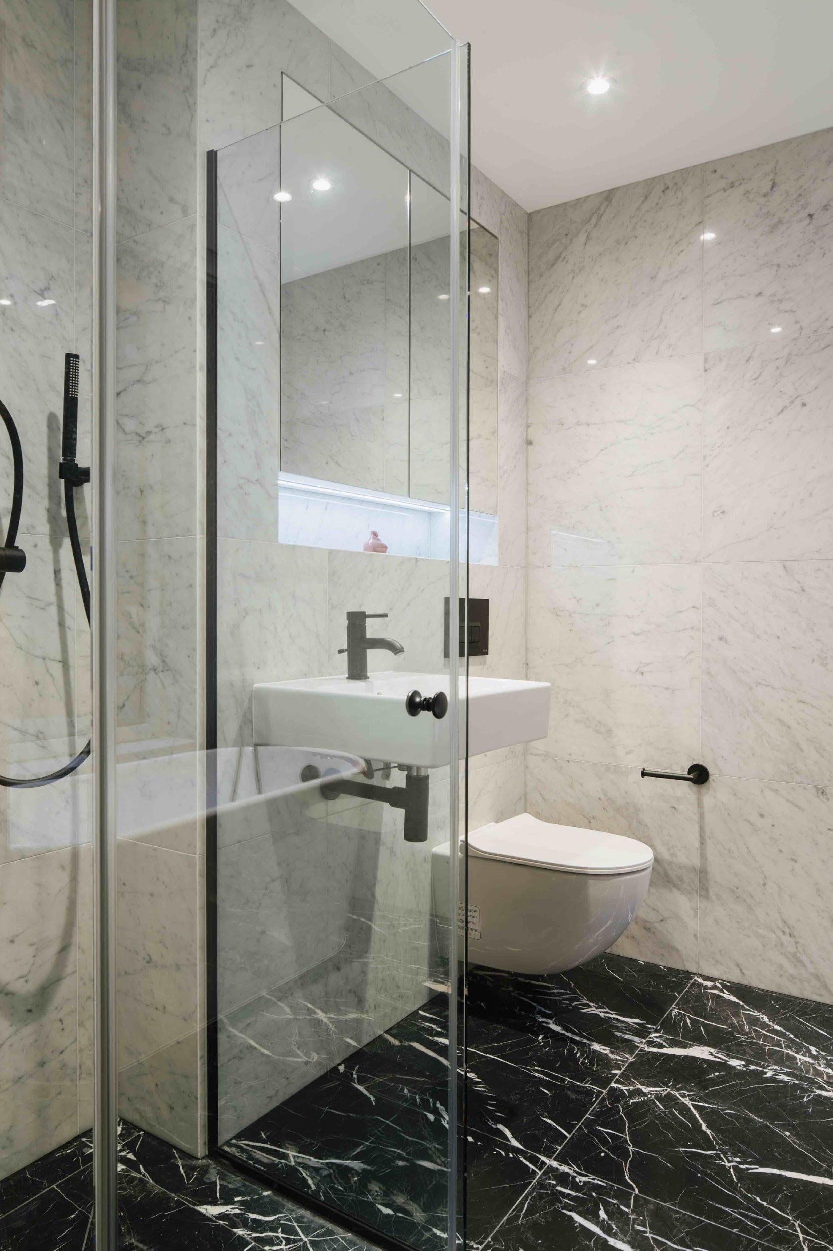
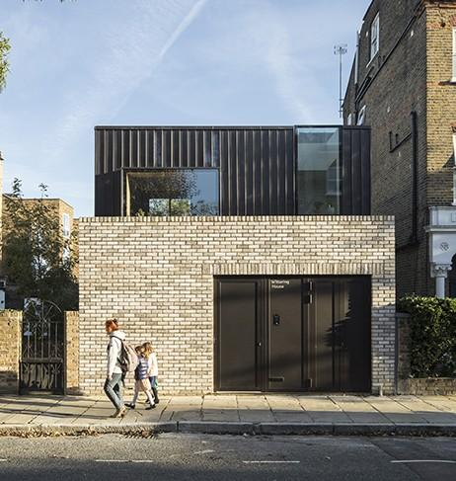
For further information and high resolution images
Press Office:
tac comunic@zione milano|genova
tel +39 02 48517618 | 0185 351616
press@taconline.it | www.taconline.it
GRAFF EUROPE
Via Aretina 159, 50136 Florence - ITALY
Tel: +39 055 9332115,
fax: +39 055 9332116
email: info@graff-designs.com
www.graff-designs.com

More GRAFF’s collection in the ARCHITECTURAL BLACK powder coating finish

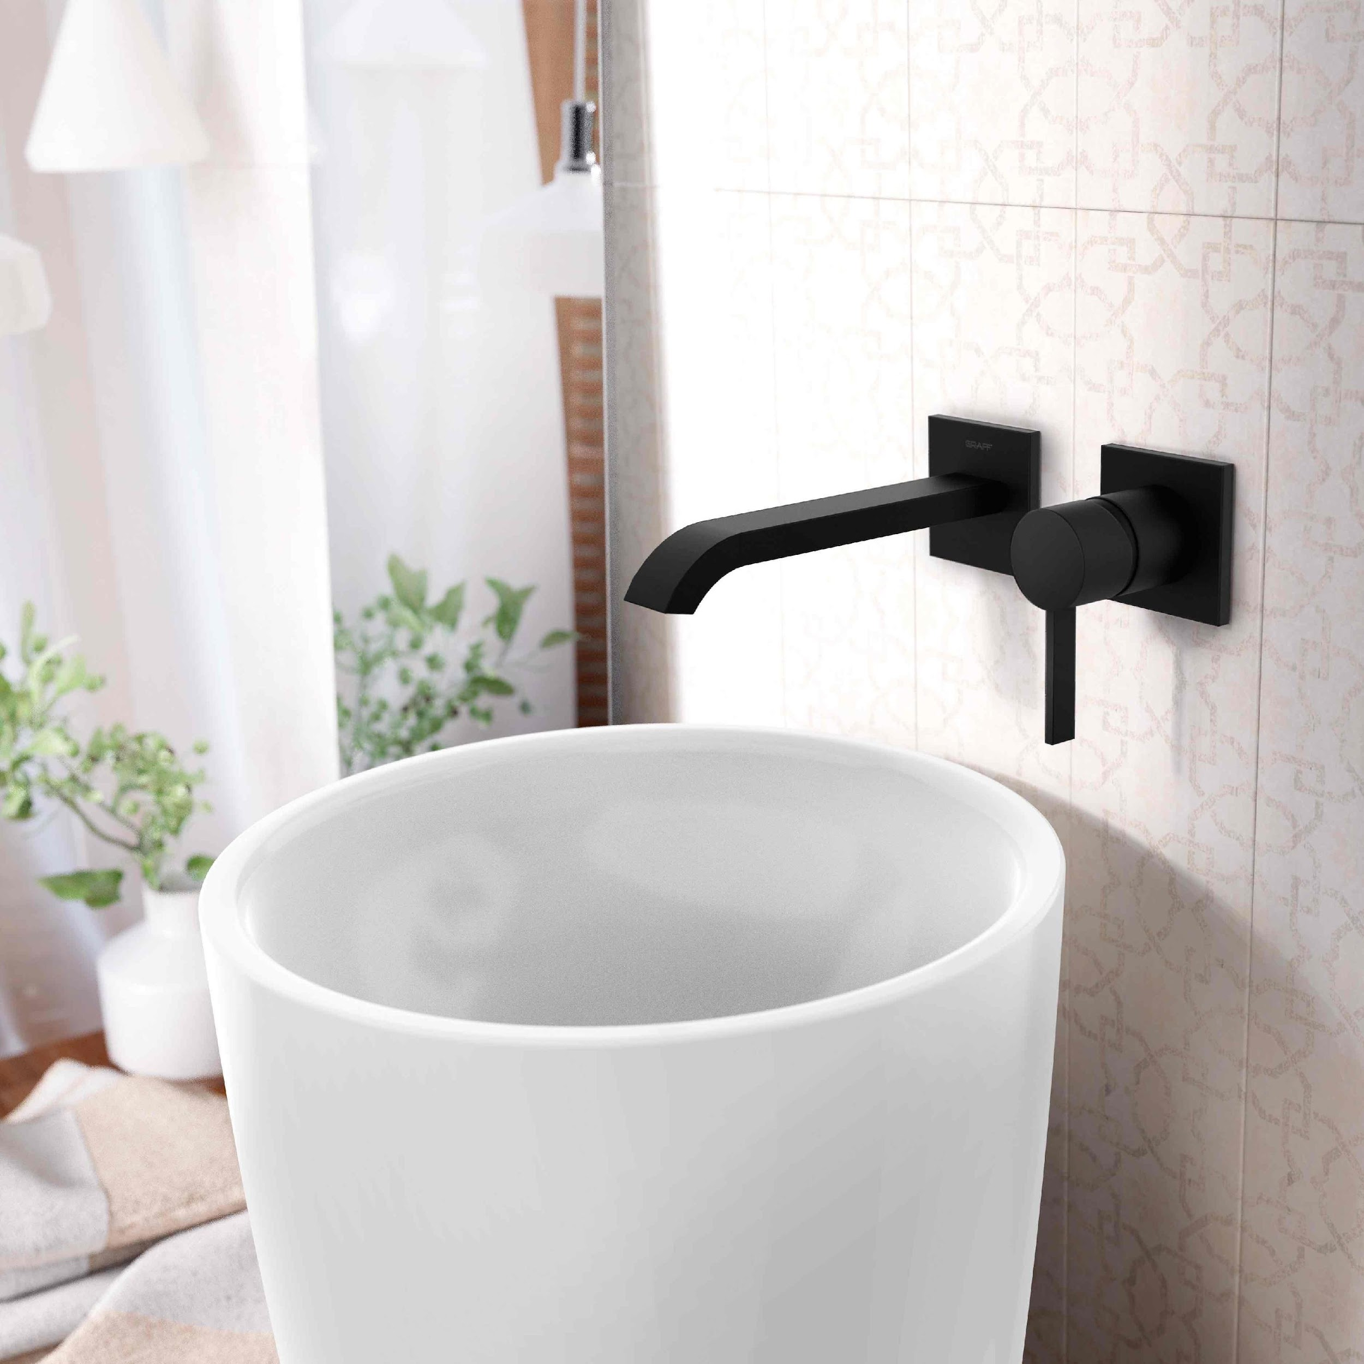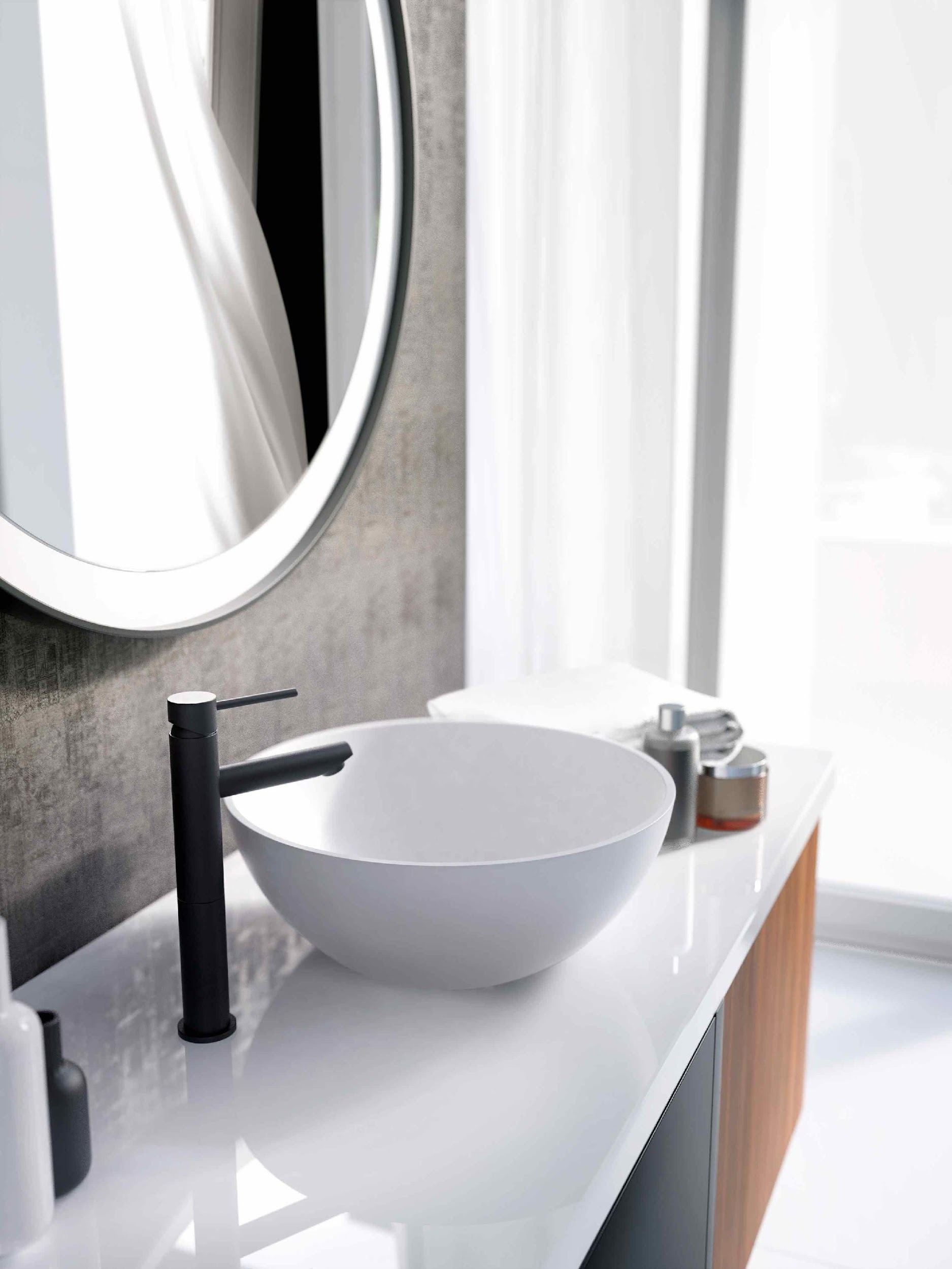

QUBIC by GRAFF M.E. by GRAFF AMETIS by GRAFF

