PRESS KIT 2018

CAMDEN, the GRAFF collection of faucets and accessories under the name of ENGLISH tradition

When creativity is synonymous of elegance, we enter the design dimension of CAMDEN, a line of faucets and accessories created to furnish the bathroom in a sophisticated way, with a modern and refined taste that recalls the atmospheres of the past.

Designed by GRAFF’s G+ Design Studio, the collection’s style is transitional and highly unique, allowing it to fit into both traditional and contemporary settings. Blending Victorian and Edwardian aesthetic sensibilities with modern principles and technologies, each fixture exhibits a luxurious artistic quality.

A strong hallmark of the CAMDEN collection is the british style silhouette: the harmonious form of the faucet body recalls the imperious shapes of chess figures. The object is not made from a forged brass bar, but rather a solid brass block, internally emptied. With this, the spout of the faucet is more full-bodied and gives the whole element a unique importance and proportion.

The CAMDEN handle is available in two variants: the classic "cross" or "lever", both functional and practical in everyday use.

Produced in brass with a very low nickel and lead content, guaranteeing a long service life - GRAFF’s guarantee is for five years - the collection is engineered in compliance with drinking water regulations and therefore according to the most restrictive criteria required for the protection of health and the environment.

In designing this collection, an emphasize was placed on the shower area. A combination of the signature cross and lever handles may be used with the wall-mounted shower plates.

All thermostatic units are compatible with the M-Series, the new modular GRAFF concealed system that combines diverters and cut-off valves, to meet all application needs.

When using a diverter, it is possible to choose one output at time, while with the cut-off valves, it is always possible to operate an output simultaneously and independently from those controlled by diverters or other cut-off valves (i.e.: the bathtub shower head or spout can be operated at the same time as with the side showers or the hand shower).

The installation can be carried out with great flexibility and is therefore customizable. The components stack on top of each other, almost like Lego bricks, creating a monobloc that always sets the handles at the same distance and allows an endless series of combinations. The M-Series is a tailor-made system that makes it possible to arrange the shower commands as preferred, both vertically and horizontally.

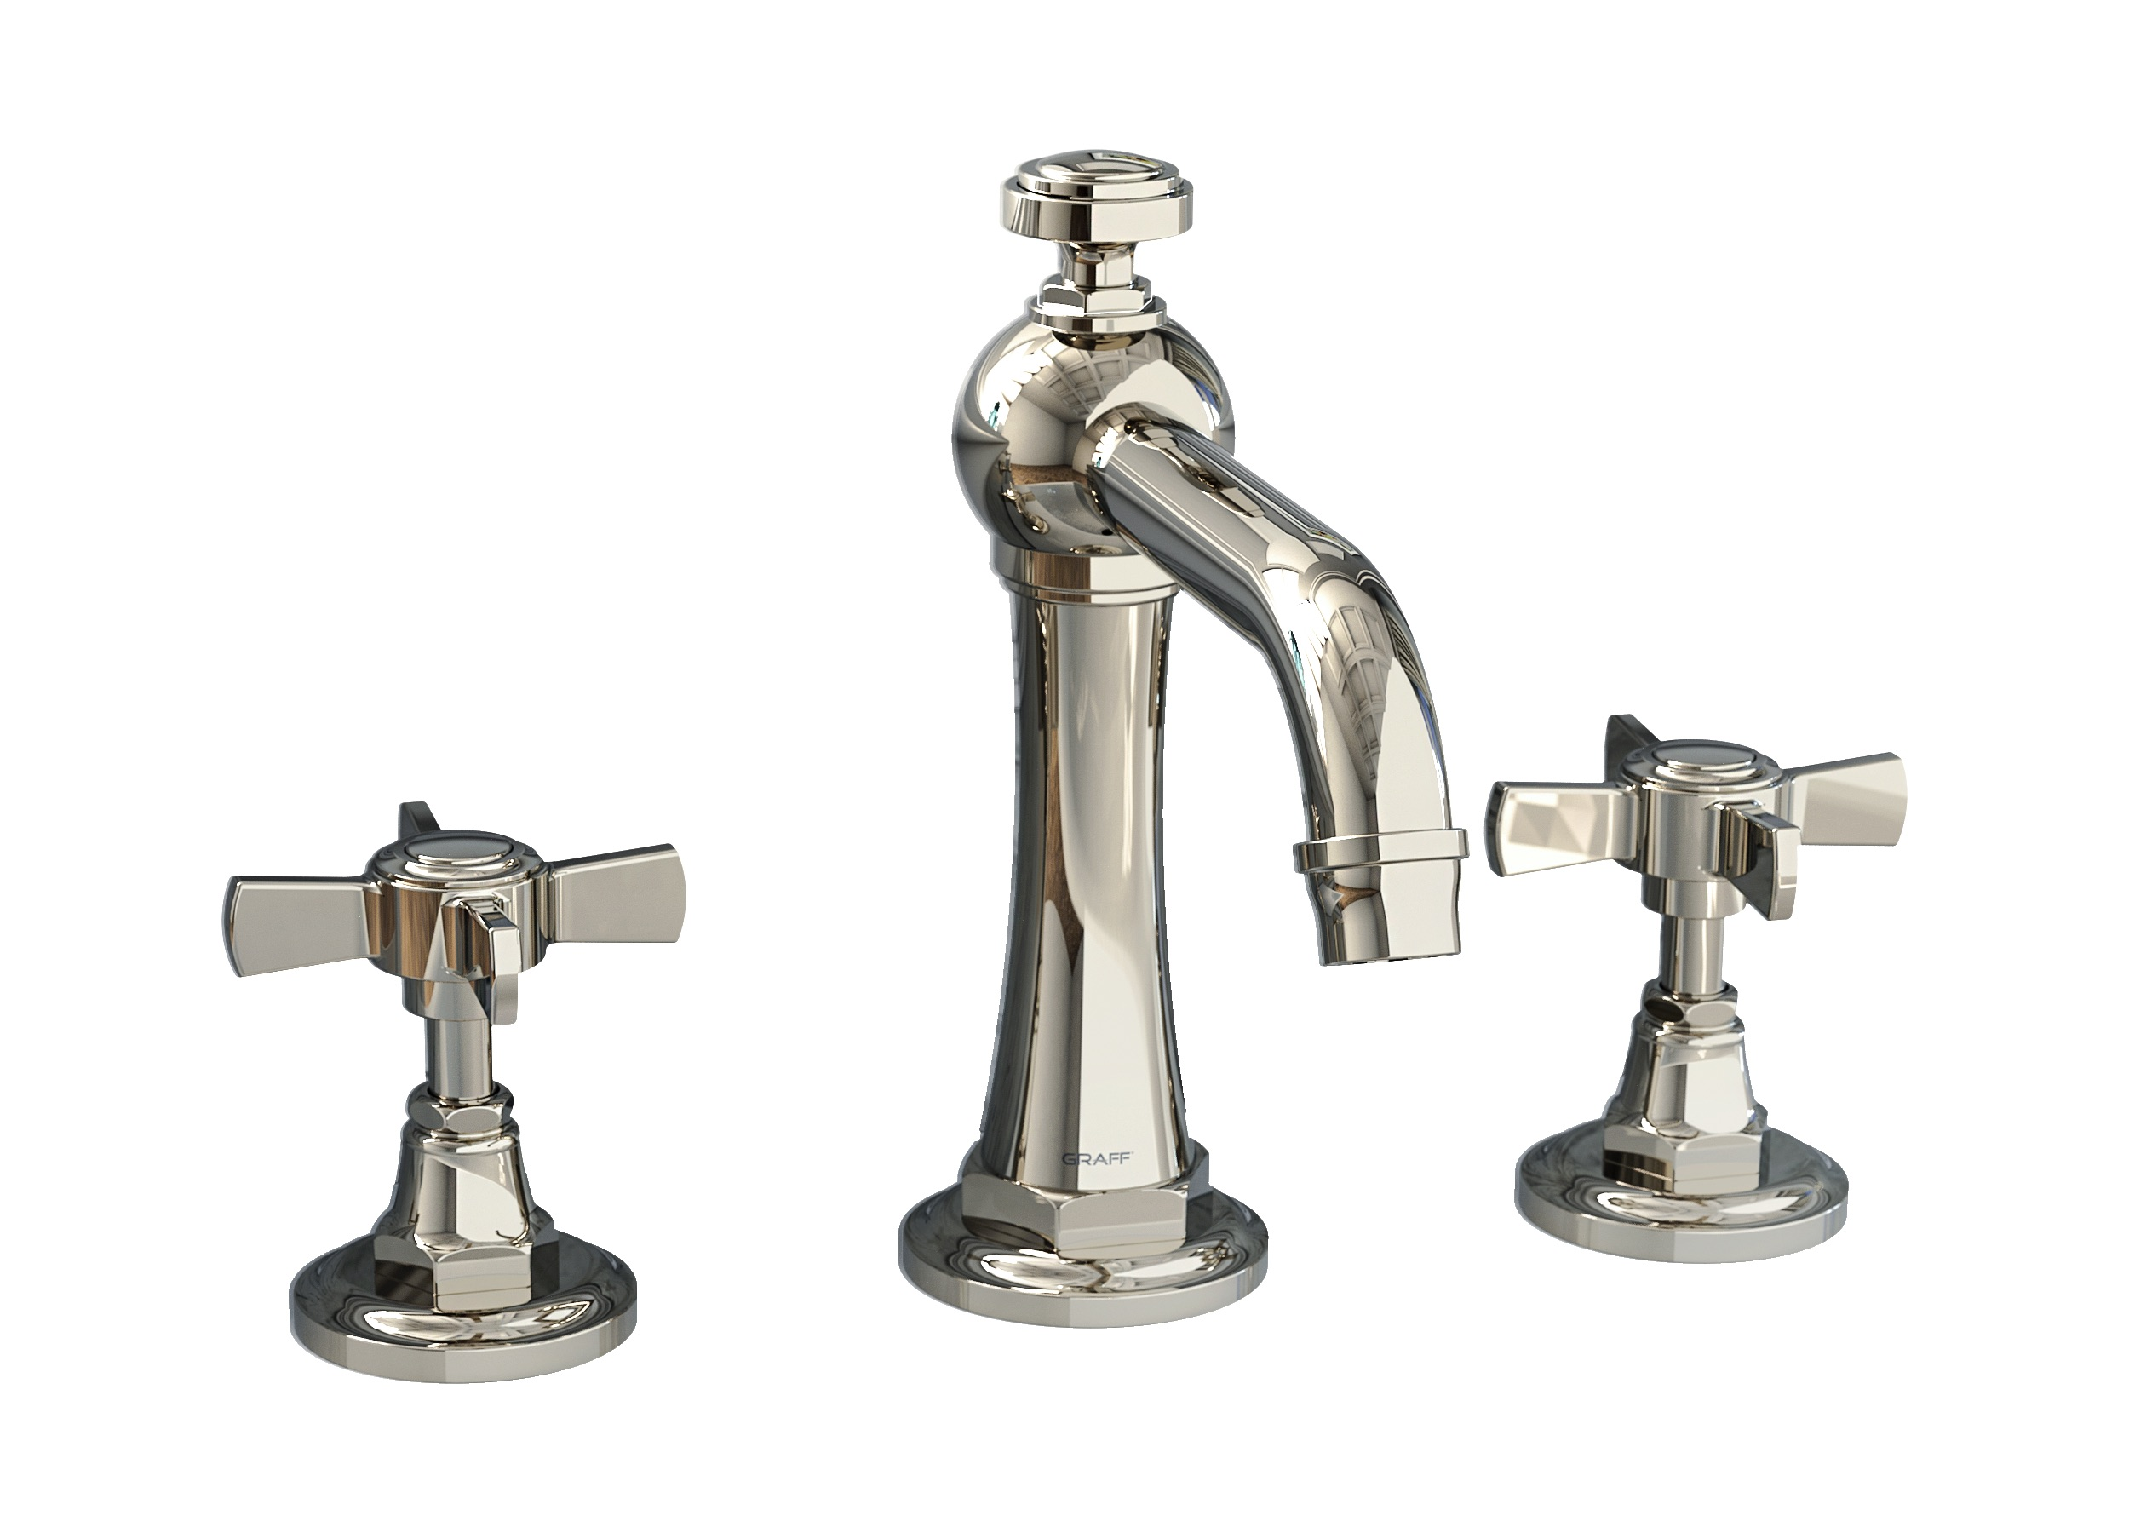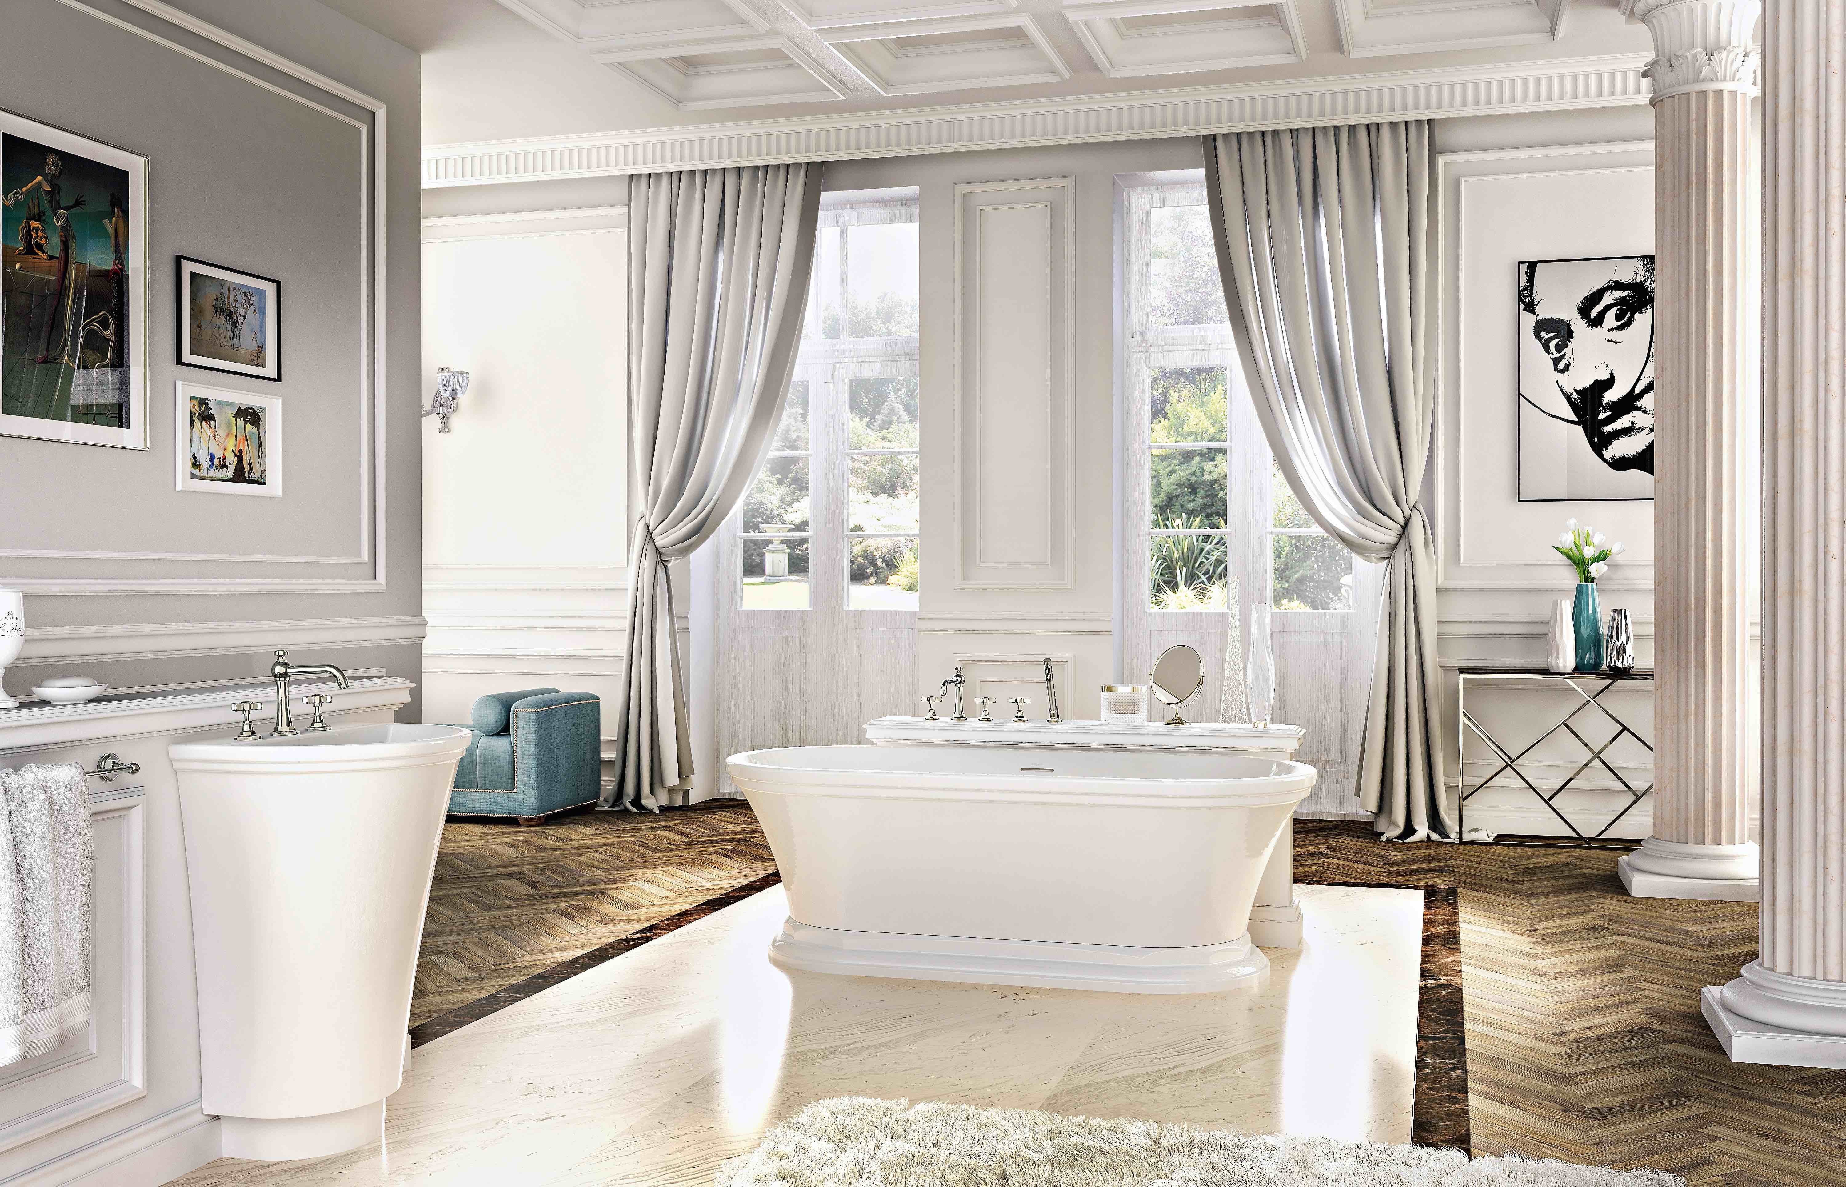

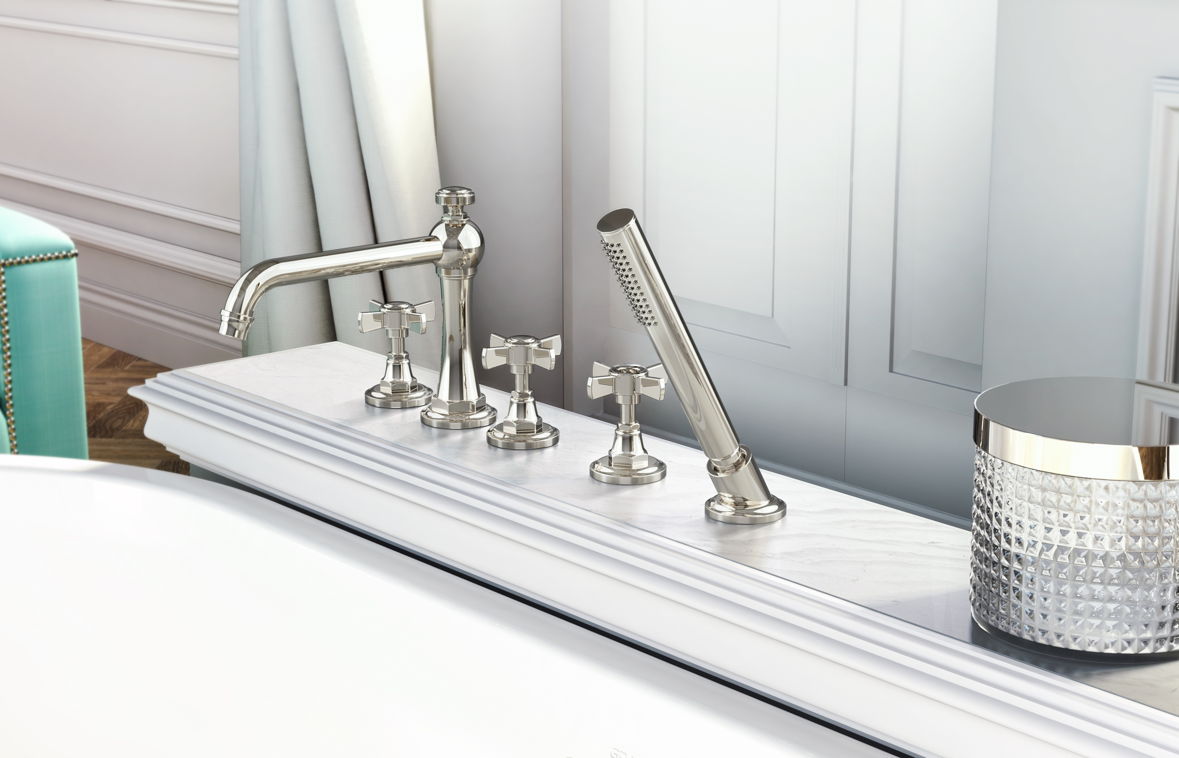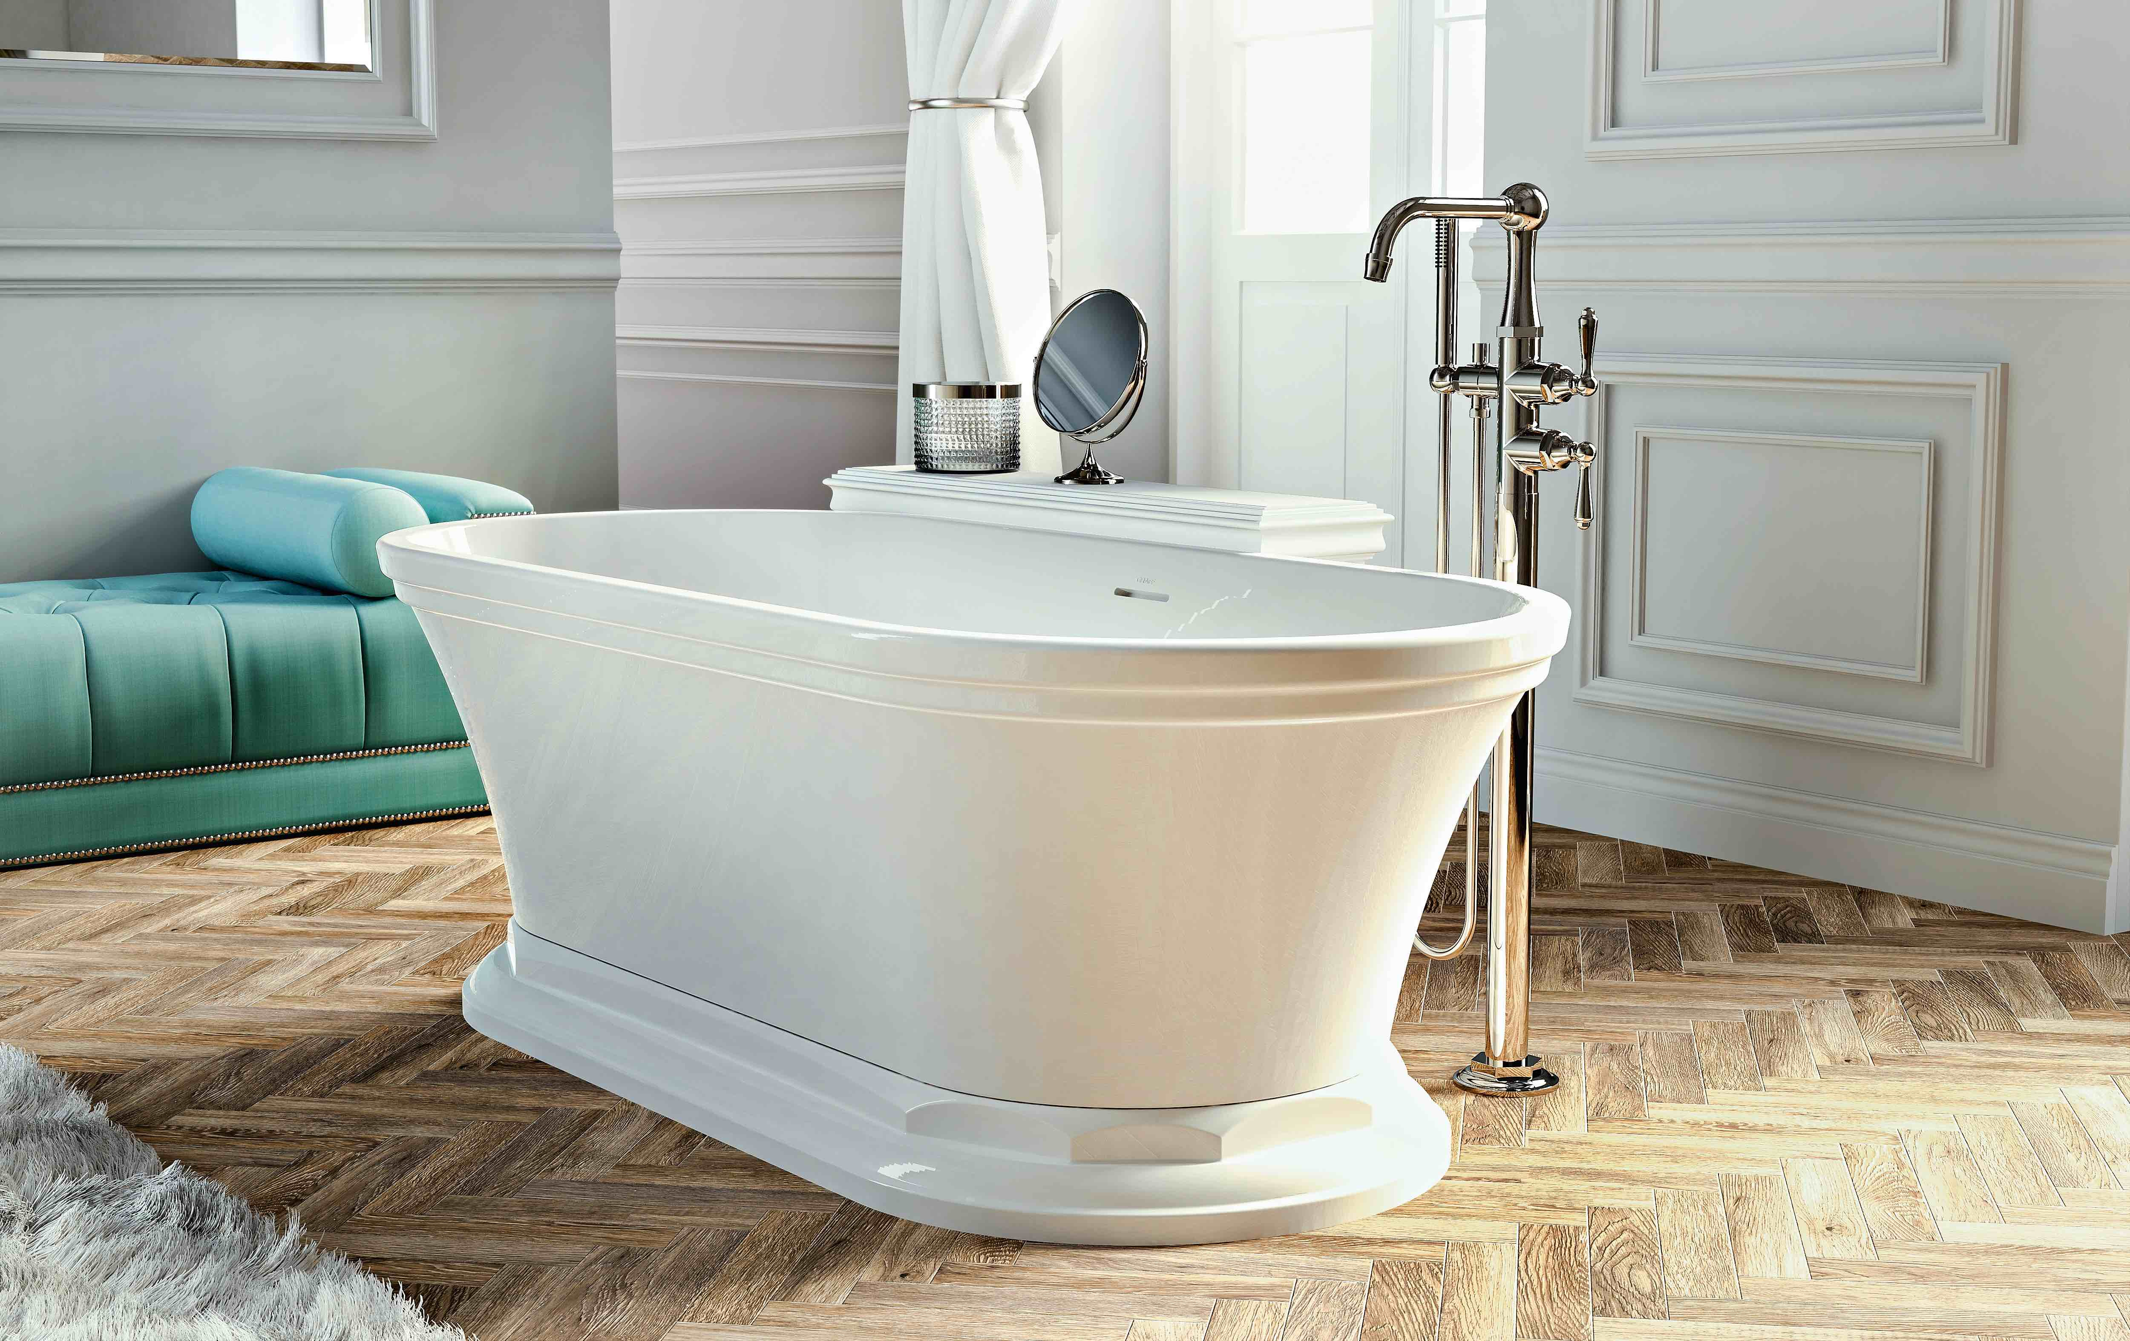
Press Office
Ufficio Stampa:
tac comunic@zione milano|genova
tel +39 02 48517618 | 0185 351616
press@taconline.it | www.taconline.it

Polished Nickel is obtained through a galvanic process and features a very pleasant texture to the touch. It’s a contemporary finish with an edwardian, refined look.
GRAFF EUROPE
Via Aretina 159, 50136 Florence - ITALY
Tel: +39 055 9332115,
fax: +39 055 9332116
email: info@graff-designs.com
www.graff-designs.com

