FOR IMMEDIATE RELEASE

GRAFF® COMPLETES PENTHOUSE BATHROOM SUITE ON LONDON’S FAMED THAMES RIVER BANK
The Sento Faucet Collection acts as the suite’s design focal point

2018 -- A former beer brewery in the London neighbourhood of Southwark, located on the Thames riverbanks, has been transformed into a luxurious apartment complex, Towerbridge. Designed by local firm Alex Gardner from Interior Designed, the building’s penthouse bathroom features GRAFF’s® stunning Sento collection.
The Sento collection is characterized by clean, essential lines that result in a strong visual impact. Sento focuses on the pure form, enhanced by the almost maniacal research of perfect proportions, in an impeccable union between sensuality and rigor. Materials, details, workmanship and heritage are all expressed by the high quality of this faucet.
In this iteration, the Sento collection has found itself as part of the refurbishment of the historic Anchor Brewhouse building, which was previously a small brewery purchased in 1787 by the Scottish master brewer, John Courage.
The architectural design of the faucet was a natural fit for this project. Interior designer, Alex Gardner comments, "When I received the briefing to develop the interior design project, the furniture had many white elements and several metal railings. My idea was to emphasize the environments, especially in the living area, in the kitchen and in the bathrooms, by playing with tones, colours and luminous elements like GRAFF’s faucets.”
The Sento faucet’s body features an important diameter that allows it to cover the basin hole avoiding the unaesthetic base plate. The sinuous cuts allow the internal cartridge to perform all the necessary movements even without the classic lever cap. The spout is developed in a slim silhouette, giving the faucet as admirable lightness.
The finishes and materials used for the London apartment are polished chrome, copper and gold. In this context, the Sento collection, in 24K polished gold, stands out inside the penthouse luxury settings.

For further information
www.graff-designs.com
https://www.interiordesigned.co.uk/towerbridge
*** Produced in emptied brass with a very low nickel and lead content, to guarantee a long life - GRAFF warranty is five years - the Sento faucet is made in compliance with the regulations for drinking water and therefore according to the most restrictive requirements for the protection of health and the environment. GRAFF production system is based on an innovative concept of Lean Manufacturing Management. By eliminating excess consumption of time, energy and materials, each process achieves remarkable standards of efficiency. Even in the processes of casting, finishing and galvanizing, GRAFF uses a zero-discharge system that recycles 100% of brass and paper. In line with the strong commitment in the field of environmental sustainability, Sento products are some of the most sustainable by the American company, one of the first companies in the world to have publicly expressed their willingness to truly contribute to eliminating their impact on environment in the near future.

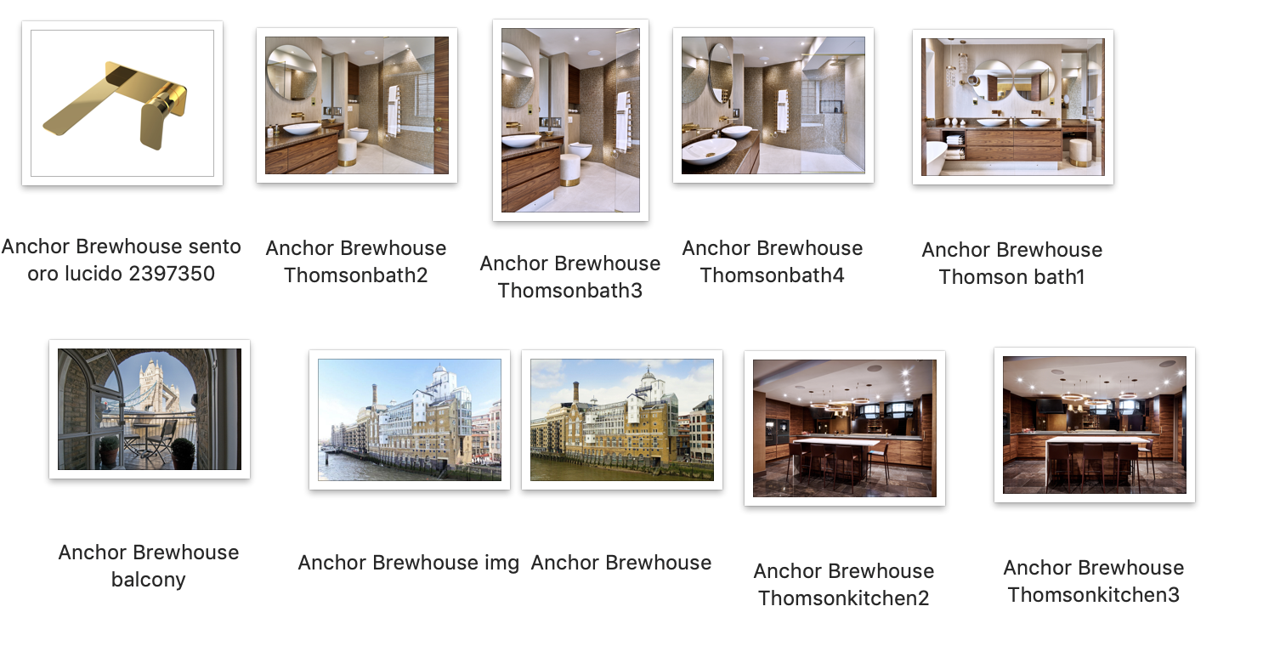

GRAFF EUROPE
Via Aretina 159, 50136 Florence - ITALY
Tel: +39 055 9332115,
fax: +39 055 9332116
email: info@graff-designs.com
www.graff-designs.com

Press Office & PR
tac comunic@zione milano|genova
tel +39 02 48517618 | 0185 351616
press@taconline.it | www.taconline.it

