PRODUCTS THAT ADAPT TO ANY SPACE AND MAKE THEM EVEN MORE BEAUTIFUL. THIS IS PLANIT.

It is no secret that details make the difference. This is true of every field. In fashion, for example, the right accessory can bring an outfit to life, or ruin it.
PLANIT makes the difference in the bathroom. The company’s made-to-measure products in warm and soft to the touch Corian resolve any situation and bring new light into this room.

This private home, designed by the architect Michele Roccabruna of Trento, is just one example. PLANIT provided the perfect trait d’union between warm and rustic elm wood floors and bright and lively blue walls.
With a made-to-measure Linea shower tray in Dupont Corian and a Free bathtub in Cristalplant – two solid surface acrylic materials – PLANIT helped create a harmonious and well-designed space.
The bathroom occupies a large space in this home. In fact, it is divided into two zones: the first with the shower and tub, dedicated to relaxation and bodily care. A concrete designer lamp hangs gently above the tub, the ideal space for moments of comfort with a glass of a wine and good book, in total privacy. The second and more functional space contains the rest of the sanitary fittings.

LINEA was selected and installed flush with the floor to create a truly unique experience of pleasure for the senses. Thanks to its discrete and elegant appearance, LINEA, finished in Corian® Glacier White is an ideal companion for everyday activities in any bathroom. Velvety to the touch and with an essential design and a geometric profile this wash basin is as much about aesthetics as technology. The thermoformed and non-slip basin features a removable matching drain cover for proper cleaning and drainage.

Thanks to its abundant space and soft lines inspired by the human body, the FREE bathtub perfectly and naturally welcomes anyone. The elegant and sinuous curves of this model ensure comfortable positions either when sitting or lying back.
The possibility to add a matching backrest that allows for three different angles brings an added touch of relaxation that completes the tub and ensures that moment is perfect.

There are no limits on design. This is the mantra that drives PLANIT to keep pushing the boundaries offering constantly new solutions. The company can count on twenty years of experience in working with Corian® and the technique of thermoforming.
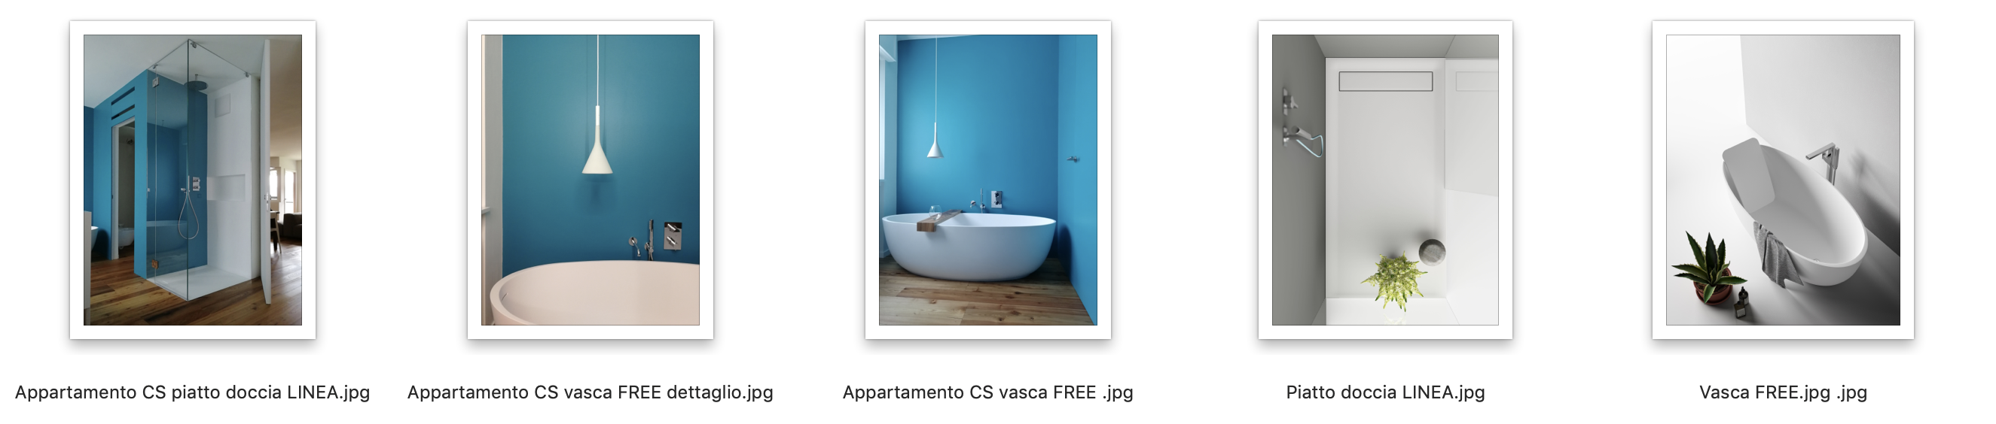
PLANIT boasts numerous collaborations with prestigious international designers and the furniture industry. The company’s objective is to unite the skills of craftsmen with the highest levels of technology and innovation. In addition to finished products, PLANIT also offers pre- and post-sale consultancy to assist with the selection of the materials and technologies required to complete even the most ambitious project. Flexible manufacturing processes and state-of-the-art facilities allow PLANIT to create unique made-to-measure pieces and small series. PLANIT is now a leader in the sector of bathroom furnishings, with its own collection of high end wash basins, shower trays and bathtubs. The Contract sector is also one of the company’s principal divisions. Products for public spaces include furnishings for hotels, bars and commercial activities, for public buildings and products for the hospital construction sector. This range is completed by work surfaces for kitchens by carpenters and furniture retailers.

