with PLANIT design REACHES THE PERFECT conditions
FOR A natural AND necessary evolution
AT THE Milan FURNITURE FAIR

PLANIT, a regular guest at the Milan Furniture Fair, the international showcase of the most innovative trends in home furnishings and design, returns for the 2018 edition.

This dynamic company from Alto Adige, offering a prefect balance between cutting edge technologies and attention to design, creates true emotional experiences thanks to its mastery in working Corian®: a material in continuous evolution that PLANIT has been skilfully transforming for over 20 years.

In a completely revamped stand, devised by Imago Design, PLANIT will present its latest metallic and gold finishes, elegant and smart geometric engravings, its new SYMPHONY washbasin collection and a truly innovative bathtub/washbowl/vanity composition.

FREESTANDING AND COUNTERTOP SYMPHONY WASHBASINS

Made from Dupont™ Corian®, PLANIT’s all new SYMPHONY collection, designed by Marco Devigili, is offered in a range of versions: freestanding washbasins, countertop washbowls or fully integrated vanity washbasins.

Thanks to its slender and tapered form and availability in infinite combinations, SYMPHONY by PLANIT is perfectly at home in small or large spaces in combination with top mounted, wall mounted or floor mounted taps & mixers.
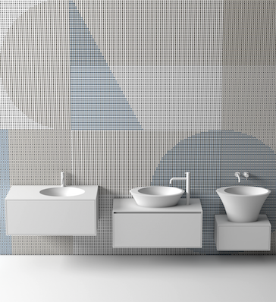
The delicate and soft lines and curved washbasins and bowls – accentuated by the beauty of this attractive and velvety material – are at their best in the Total White version.

One hundred percent produced in PLANIT’s facilities, this product is the result of a three-dimensional thermoforming process: the material is heated, bent, glued and honed before being lacquered in a range of colours. This is where PLANIT demonstrates is technical skills: modelling and moulding an almost infinite number of forms.

FREESTANDING bathtub/wasHBOWL/vanity composition

The desire for a more comfortable, protected and uncontaminated space that offers moments of total relaxation produced a system that unites the FREE bathtub with the SYMPHONY washbowl in a unique module connected by a specially designed console.

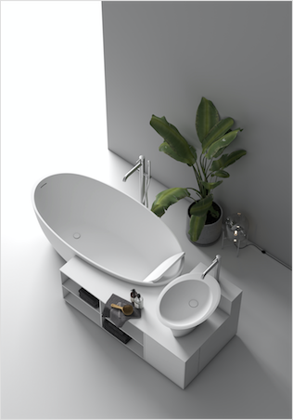
The particular characteristic of this composition is that each element appears to be a continuation of the other, despite the use of three different materials: DuPont™ Corian® for the washbasin, Cristalplant® for the bathtub and Silestone® for the console. Despite the differences between Corian®, the other types of Solid Surface, natural stones, wood, microcement – and so on – with this combination PLANIT manages to exalt the unique characteristics of every element. The composition clearly demonstrates how the combination of three “different” elements can inspire designers to work with PLANIT and bring constant innovations to the world of design.

Perfectly at home at the centre of a room, the console creates a compact composition whose smooth and velvety finish and clean lines are equally attractive when placed near a wall.
The generous spaces and soft lines of the FREE bathtub – in this composition – recall those of a sinuous body that naturally welcomes the widest range of users. The elegant curves of this model make for perfectly comfortable seated or reclining positions.
The possibility to insert a coordinated back support with grooves allowing for three different positions offers an additional level of relaxation and makes this collection truly perfect.

INFINITY VANITY: INFINITE DIMENSIONS, COLOURS AND NOW ALSO TEXTURES

INFINITY, a vanity with an integrated washbasin realised in DuPont™ Corian®, was studied to respond to any idea, particular need, space to be occupied or desire to be fulfilled; with no standard modules, the dimensions of the bases and fronts can be fully customised.

PLANIT believes there are no limits on the design of a home, based on the conviction that, in order to be truly special and welcoming, it should represent the maximum expression of our soul. This is why INFINITY can now be personalised with cool and exhilarating engravings, including custom patterns.

Handcrafted INFINITY vanities are made from an antibacterial – and very hygienic –material with an elevated resistance to humidity and scratches. What is more, their solid surfaces are pleasingly warm to the touch.
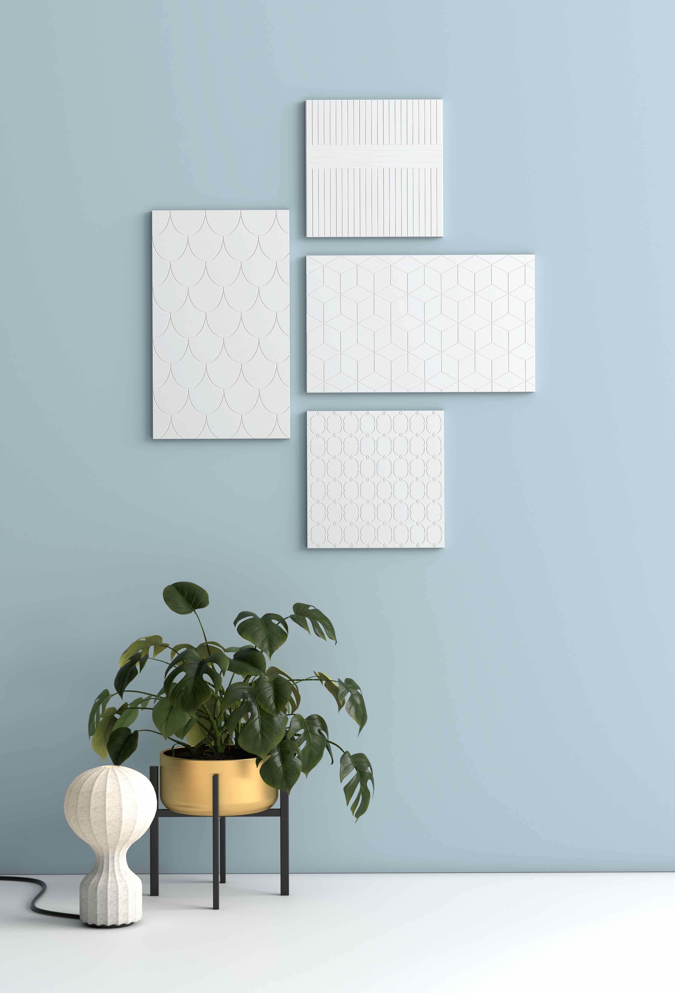
A 12 mm thick edge, flush front panels and the possibility to choose a handle-free version fitted with a TIP-ON opening system make the INFINITY vanity an extremely clean product like few others.
PLANIT is an Italian company with over twenty years of specialisation in Solid Surface materials – primarily DuPontTM Corian®. The company collaborates with prestigious international designers and a range of companies in the furniture industry. Our objective is to unite the skills of craftsmen with an elevated level of technical and technological efficiency and innovation. In addition to finished products, PLANIT also provides pre and post sale services, including assistance during the selection of the materials and technologies required to complete even the most ambitious project. Flexible manufacturing processes and state-of-the-art facilities allow us to create unique and one-off pieces as well as products in limited series. PLANIT has become an industry leader in bathroom furniture with its own collections of high-end washbasins, shower trays and bathtubs. Our Contract division represents one of the company’s principal sectors. PLANIT provides furnishings for hotels, bars and stores, for public buildings and hospitals. We also realise kitchen countertops for carpenters and furniture manufacturers.

For more information please contact
tac comunic@zione Milan|Genoa
tel +39 02 48517618 | 0185 351616 press@taconline.it | www.taconline.it
Silvia Gabalin c/o PLANIT srl
Via Nazionale 61 – 39040 Ora (BZ) Italy
Tel. +39 0471 811490 - Fax +39 0471 811494 - gabalin@planit.it - www.planit.it

