GRAFF to Present Stunning Work at Salone del Mobile 2018
Inspired by the Photographs of Viennese Artist Inge Prader, Display to Celebrate Geometry in Design

2018 - Presenting new collections in tandem with artful displays, GRAFF, the American-based manufacturer of luxurious bath fittings, will treat Salone del Mobile visitors to an immersive world of art and abstract photography as part of their 2018 International Bathroom Exhibition. Titled Art of Bath, GRAFF’s display is defined by feminine seduction, beauty and elegance, which is underscored by the brand’s product portfolio.
From April 17th - 22nd, GRAFF plans to unveil an eye-catching booth display, inspired by the work of Inge Prader. The Viennese photographer is well known for her charming interpretations of painter Gustav Klimt’s masterpieces, including Beethoven’s Frieze (1902), Danae (1907), and Life and Death (1908).

The "living" representation of Klimt's works is a continuous unfolding of scenes from reality to decorative abstraction: dreamy and delicate figures that intertwine in soft hugs and kisses, creating geometric forms and sinuous compositions.
The concept interpreted by GRAFF at Salone will showcase similar scenography blending the brand’s acclaimed faucet and accessory collections together, aiming for a new, modern and enveloping idea of furniture.
The space at the fair, designed by Dcube.swiss (Geneva), welcomes a series of projects that are unique in fashion. GRAFF’s luxurious shower systems, faucets, bathtubs, washbasins and accessories on display interact with Inge Prader's works to create a splendid combination of iconic textures and colors.

Each piece, in its own way, is the protagonist of the precious mise en scène, corresponding to a precise aesthetic philosophy: the search for timeless beauty. Klimt's Era of Gold is the source of inspiration for GRAFF's new scenographic design at Salone del Mobile. A perfect context to present the company's innovations and the new on trend finishes - gold, rose gold, bronze with a waxed or textured effect - that refer to precious and refined colors and shades.
GRAFF’s latest product releases will be included at The International Bathroom Exhibition, which capture today’s popular industrial aesthetic. Amongst the collections on display are the following:

- New finishes: products will be showcased in new finish offerings including Gunmetal, Distressed Gunmetal, Unfinished Brass, Unfinished Brushed Brass, Rose Gold PVD, and Onyx.
- Incanto Faucet: The faucet collection on display is defined by a symmetrical square shape.
- Desideri: The new collection, which includes an assortment of bathtubs and washbasins in Sleek-Stone®, is a versatile patented material that offers the same appeal of natural stone with all the advantages of a completely new and technologically advanced material.

ENCLOSED PREVIEW IMAGES (DESIDERI):

- Arnina Washbasin: The Arnina basin is made of Sleek-Stone®, a composite stone material that combines the dolomitic marble with a unique resin, creating a solid compound with a finished surface. Its anti-stain and UV-resistant properties make the surfaces easy to clean, with minimal maintenance. Sleek-Stone® is available in glossy or matt white finish.
- Luna Faucet: The Luna faucet is a brass element, chrome plated with a mirror finish, that floats, gently reflecting on the wall. The curved spout is an extremely elegant object that seems to generate a flow of ethereal water inside the bathroom.

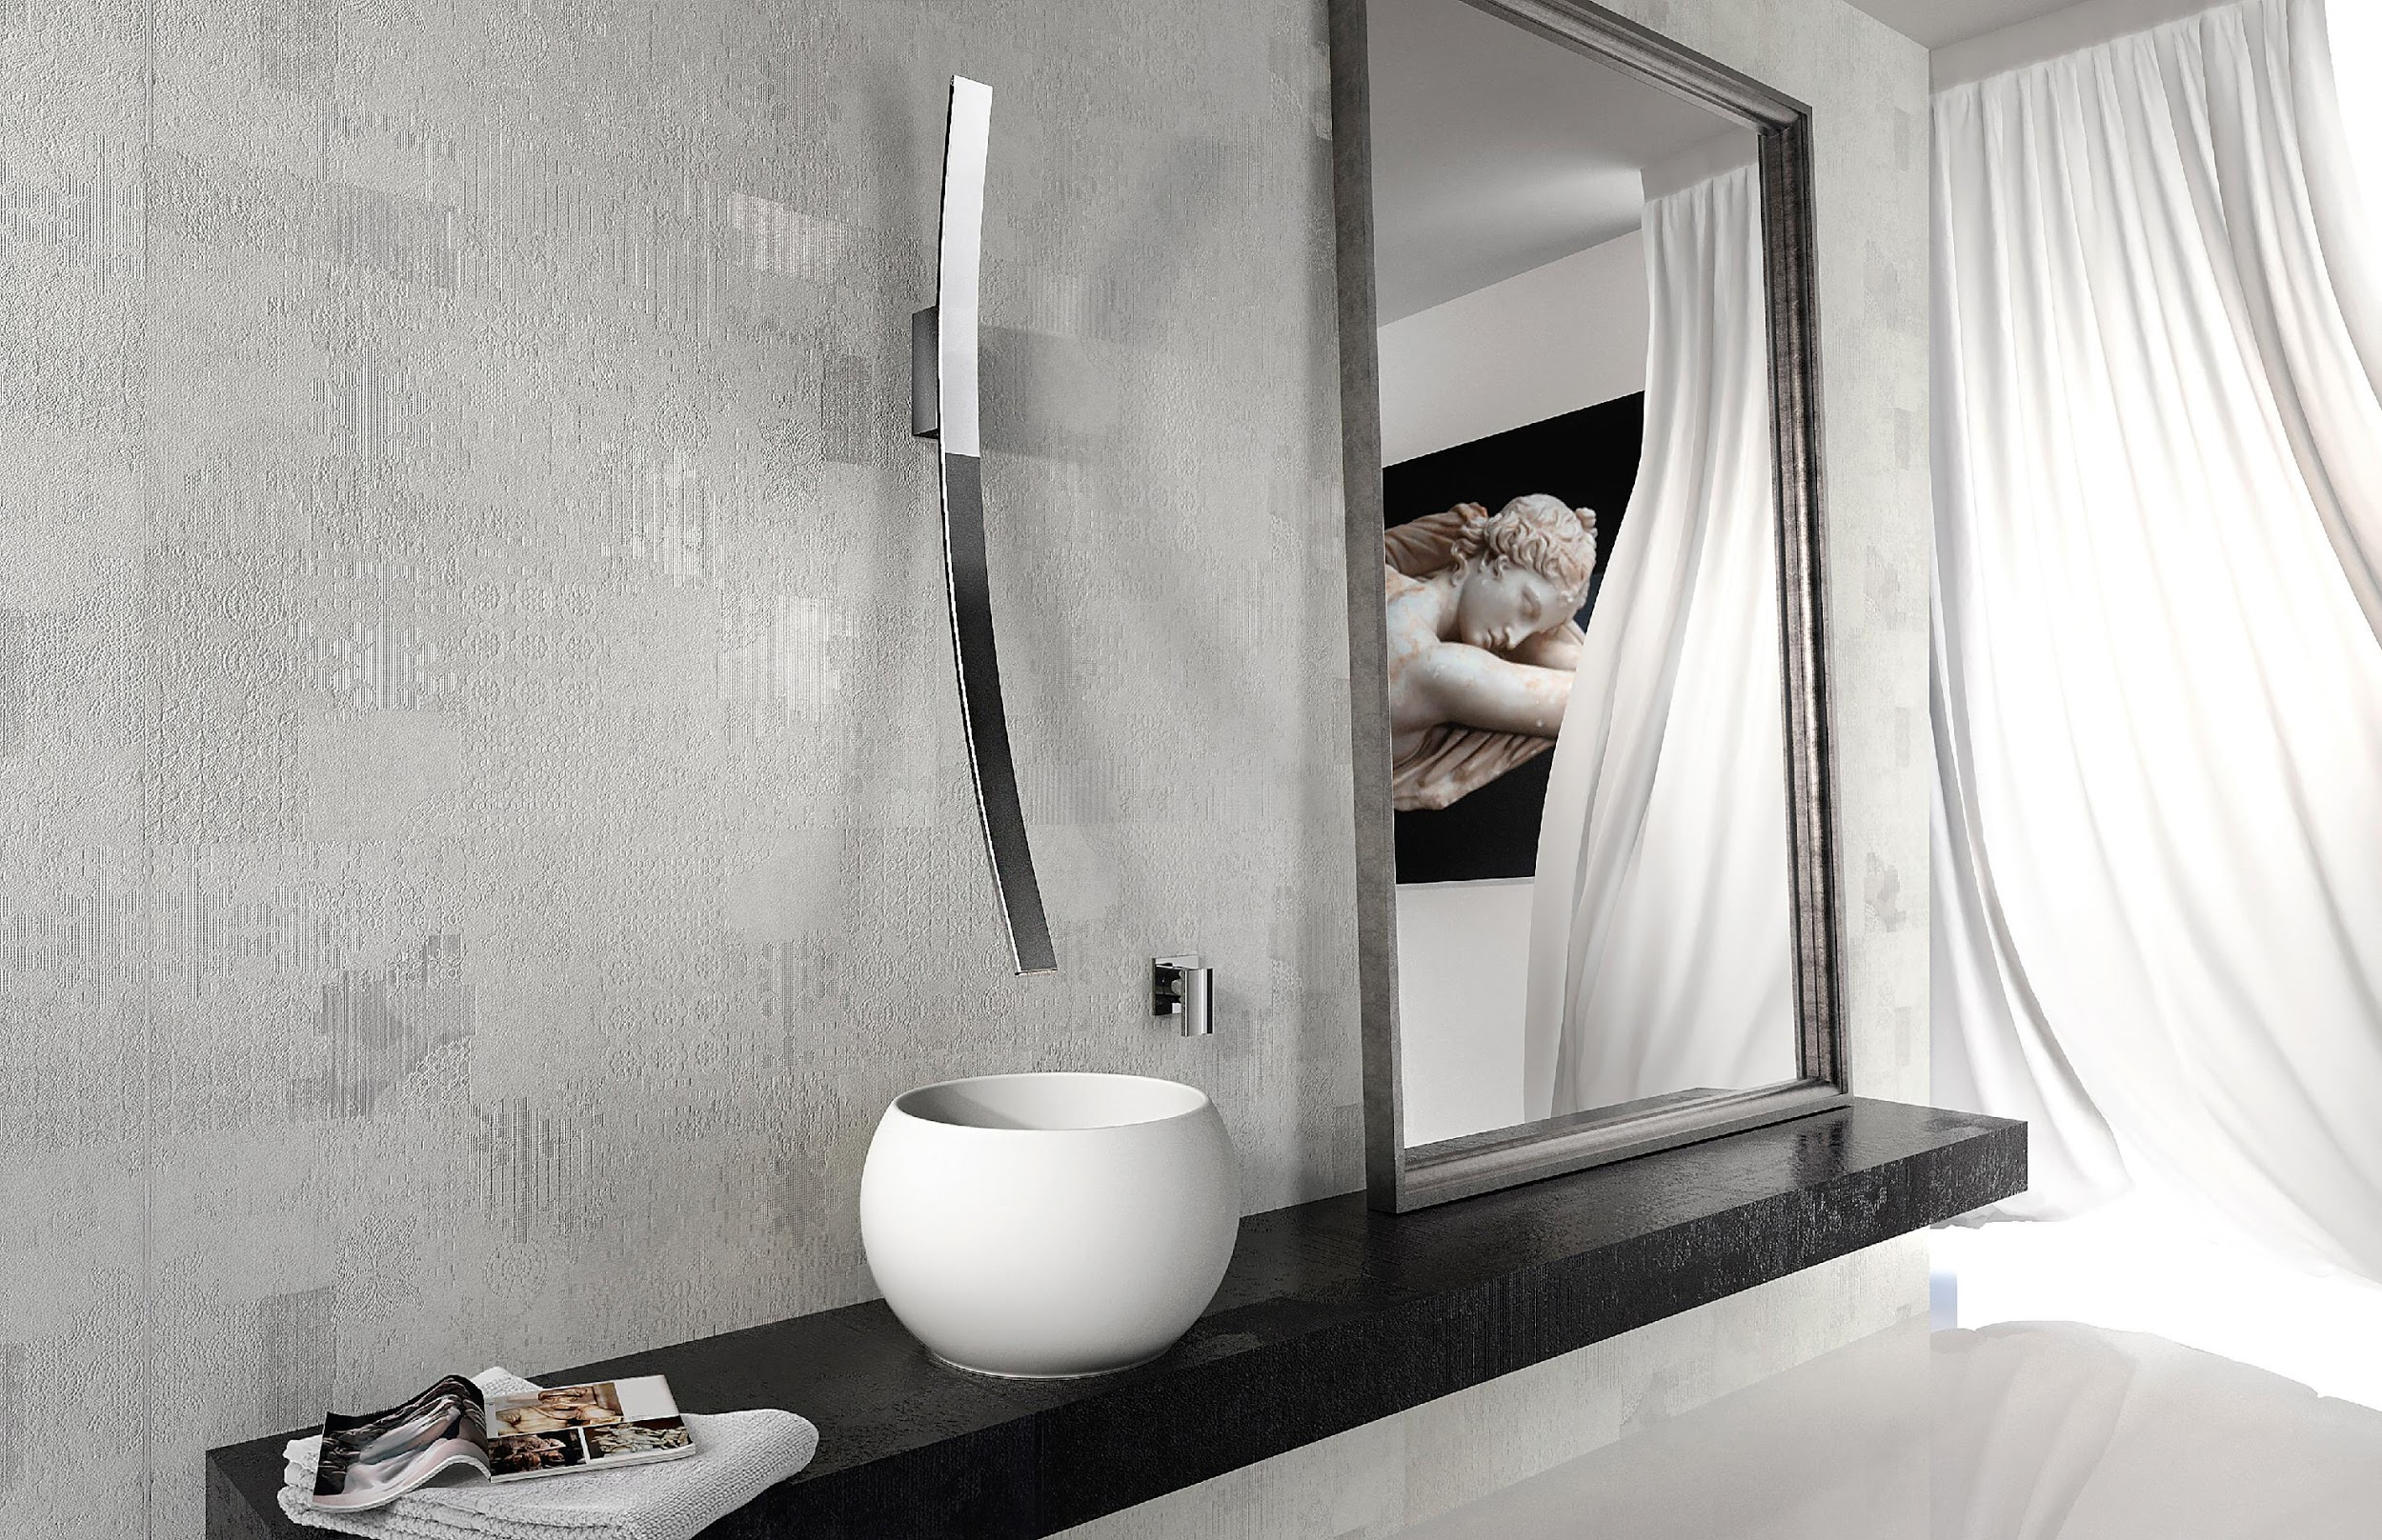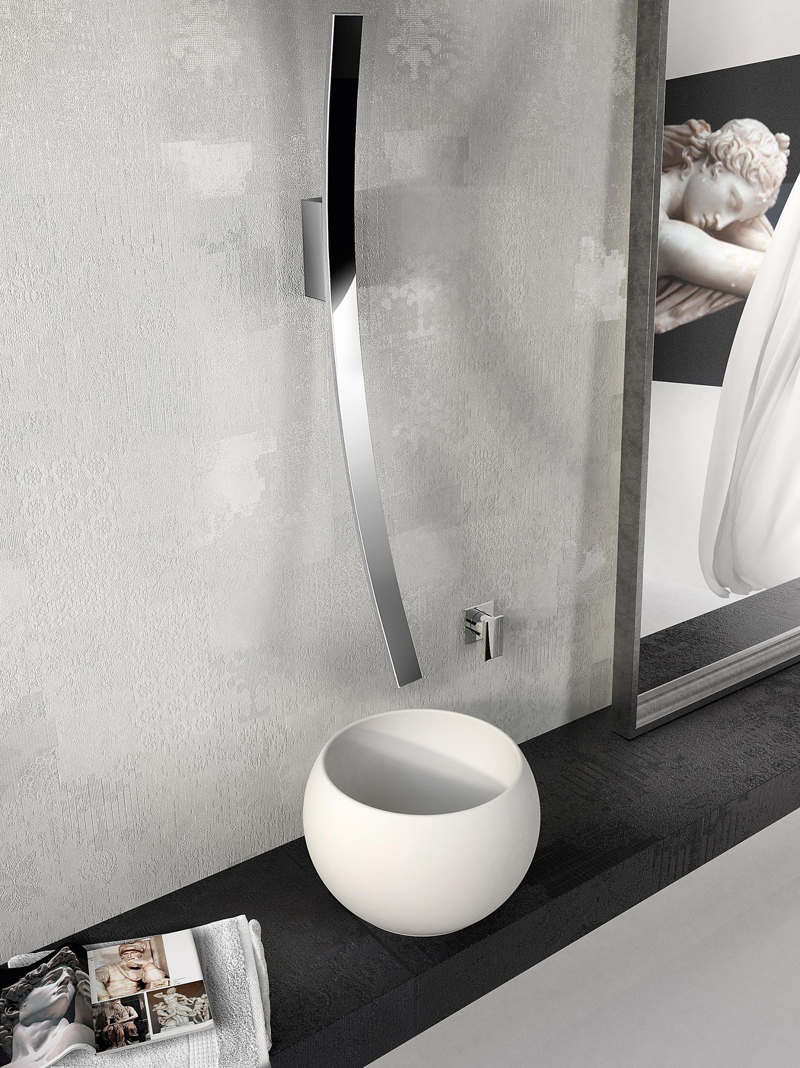

ENCLOSED PREVIEW IMAGES (Salone del Mobile 2018 Concept)
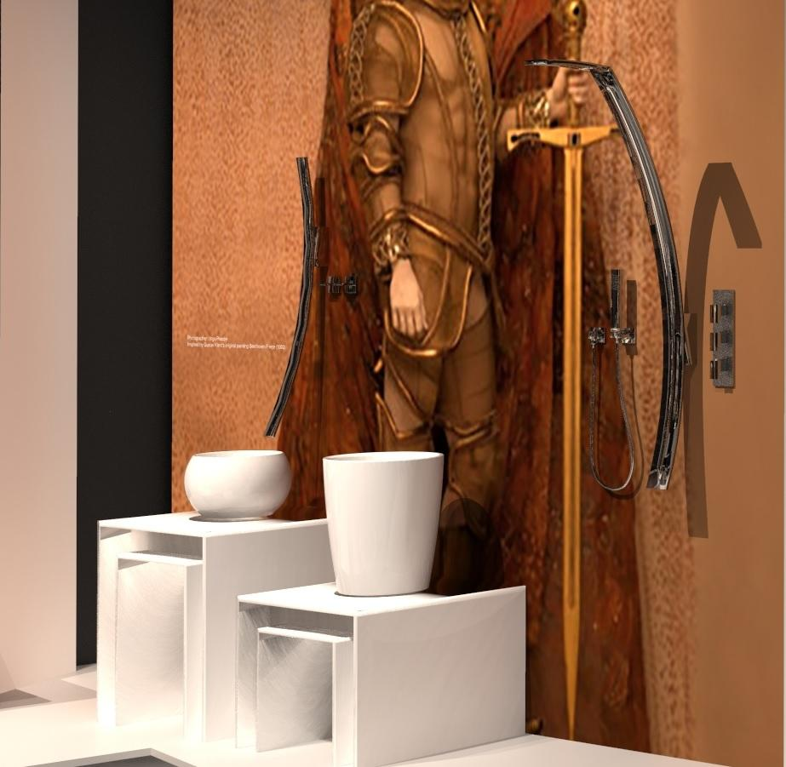

For further information and high resolution images
Press office:
tac comunic@zione milano|genova
tel +39 02 48517618 | 0185 351616
press@taconline.it | www.taconline.it
GRAFF EUROPE
Via Aretina 159, 50136 Florence - ITALY
Tel: +39 055 9332115,
fax: +39 055 9332116
email: info@graff-designs.com
www.graff-designs.com

