Press release 2016

New GRAFF Aqua Sense,
artistic icons at the International Bathroom Exhibition

Unique vision, international design, precise materials, manufacturing tradition.
These are some of the secrets of the new GRAFF SHOWER offerings, a project that includes a complete collection for the shower area, an eclectic and versatile wellness program with solutions for every need and original answers for those who seek aesthetics, functionality, technology, eco-sustainability and performance.

The GRAFF SHOWER program is the result of a modern and innovative approach to the industry. It includes several modular thermostatic elements for simultaneous control of separate jets, and a new range of showerheads with innovative functions.

From watching videos and listening to music to enjoying color therapy, the Aqua-Sense shower system provides a multimedia experience through the use of a technological touchpad.

As part of the project "Art of the Bath Gallery", which had its highest expression at Salone del Mobile in Milan, GRAFF collections are decontextualized in a setting which is almost metaphysical, abstract and characterized by strong ties with art. Showers faucets, showerheads, and accessories connect, weaving interesting, colorful and iconic threads.
Enclosed images:

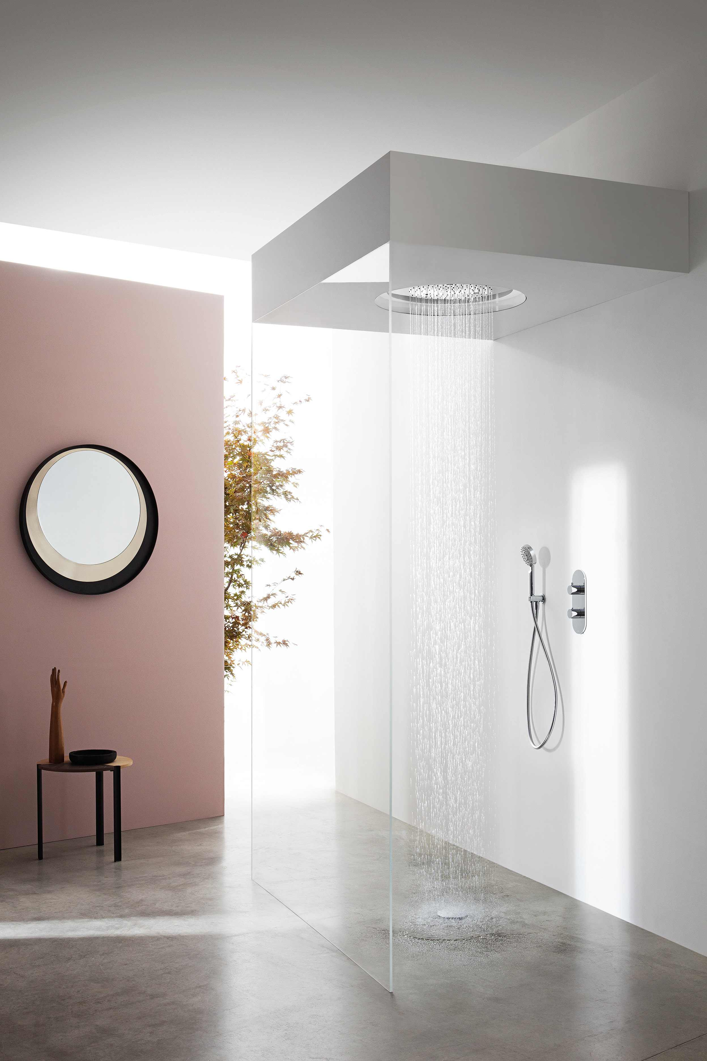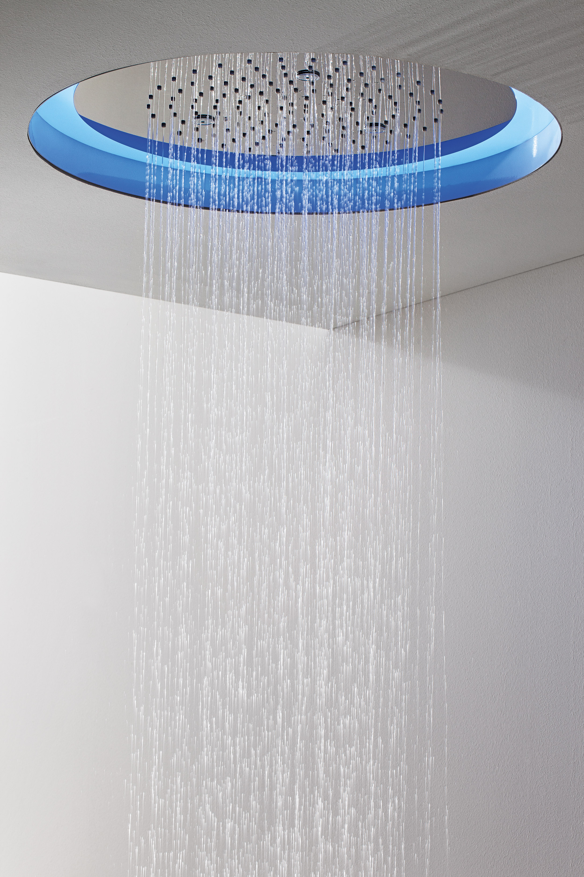
AQUA-SENSE
Ceiling mounted showerhead with rain and chromotherapy functions. Supplied with remote control. Dimensions: 500 cm diameter. Material: Stainless steel

PRESS OFFICE
Ufficio Stampa:
tac comunic@zione milano|genova
tel +39 02 48517618 | 0185 351616
press@taconline.it | www.taconline.it
GRAFF EUROPE
Via Aretina 159, 50136 Florence - ITALY
Tel: +39 055 9332115,
fax: +39 055 9332116
email: info@graff-mixers.com
www.graff-faucets.com

