Press release

GRAFF FURNISHES THE BATHROOMS OF THE COEUR DE MEGÈVE
BOUTIQUE HOTEL & SPA

THE DRESSAGE VANITY (DESIGN NESPOLI E NOVARA) IS THE PROTAGONIST
OF THE FASCINATING LODGE HOTEL ON THE FRENCH ALPS

Megève, an internationally renowned ski resort set in an artistic and creative mountain location, retains all the charm of an authentic village in the French Alps.
Here we find an intimate and welcoming lodge hotel, with a design style inspired by the surrounding environment: warm materials, patina wood, and bright, full colors all reminiscent of nature.

Coeur de Megève is a structure cleverly designed by the refined French interior designer Sybille de Margerie, who has been able to create a welcoming atmosphere, combining tradition and modernity.

“My philosophy is to reveal the unique soul of a place through its design. The interiors of the Coeur de Megève perfectly reflect my style through the use of tonic, pure and vibrant colors, inspired by nature and the fresh colors of a sunrise on the slopes,” says Sybille de Margerie.

To masterfully furnish the bathrooms of the hotel rooms, Sybille expressly requested to use the iconic Dressage furniture collection created by GRAFF and designed by Nespoli e Novara. With a clear artisan inspiration, the easel cabinet has the modern and poetic charm transmitted by wood when meeting the functionality of an innovative material such as Corian®. The strong hand-made component represents one of the distinctive elements of a collection designed for the bathroom but inspired by the world of interior design.

Coeur de Megève offers 39 soundproofed rooms and suites in a “reinterpreted” chalet spirit featuring a contemporary style, enhanced by bright and warm colors.

News 4 post: #Graff, #dressage #design #funzionalità
More info
www.graff-designs.com
https://www.coeurdemegeve.com/en

Available images

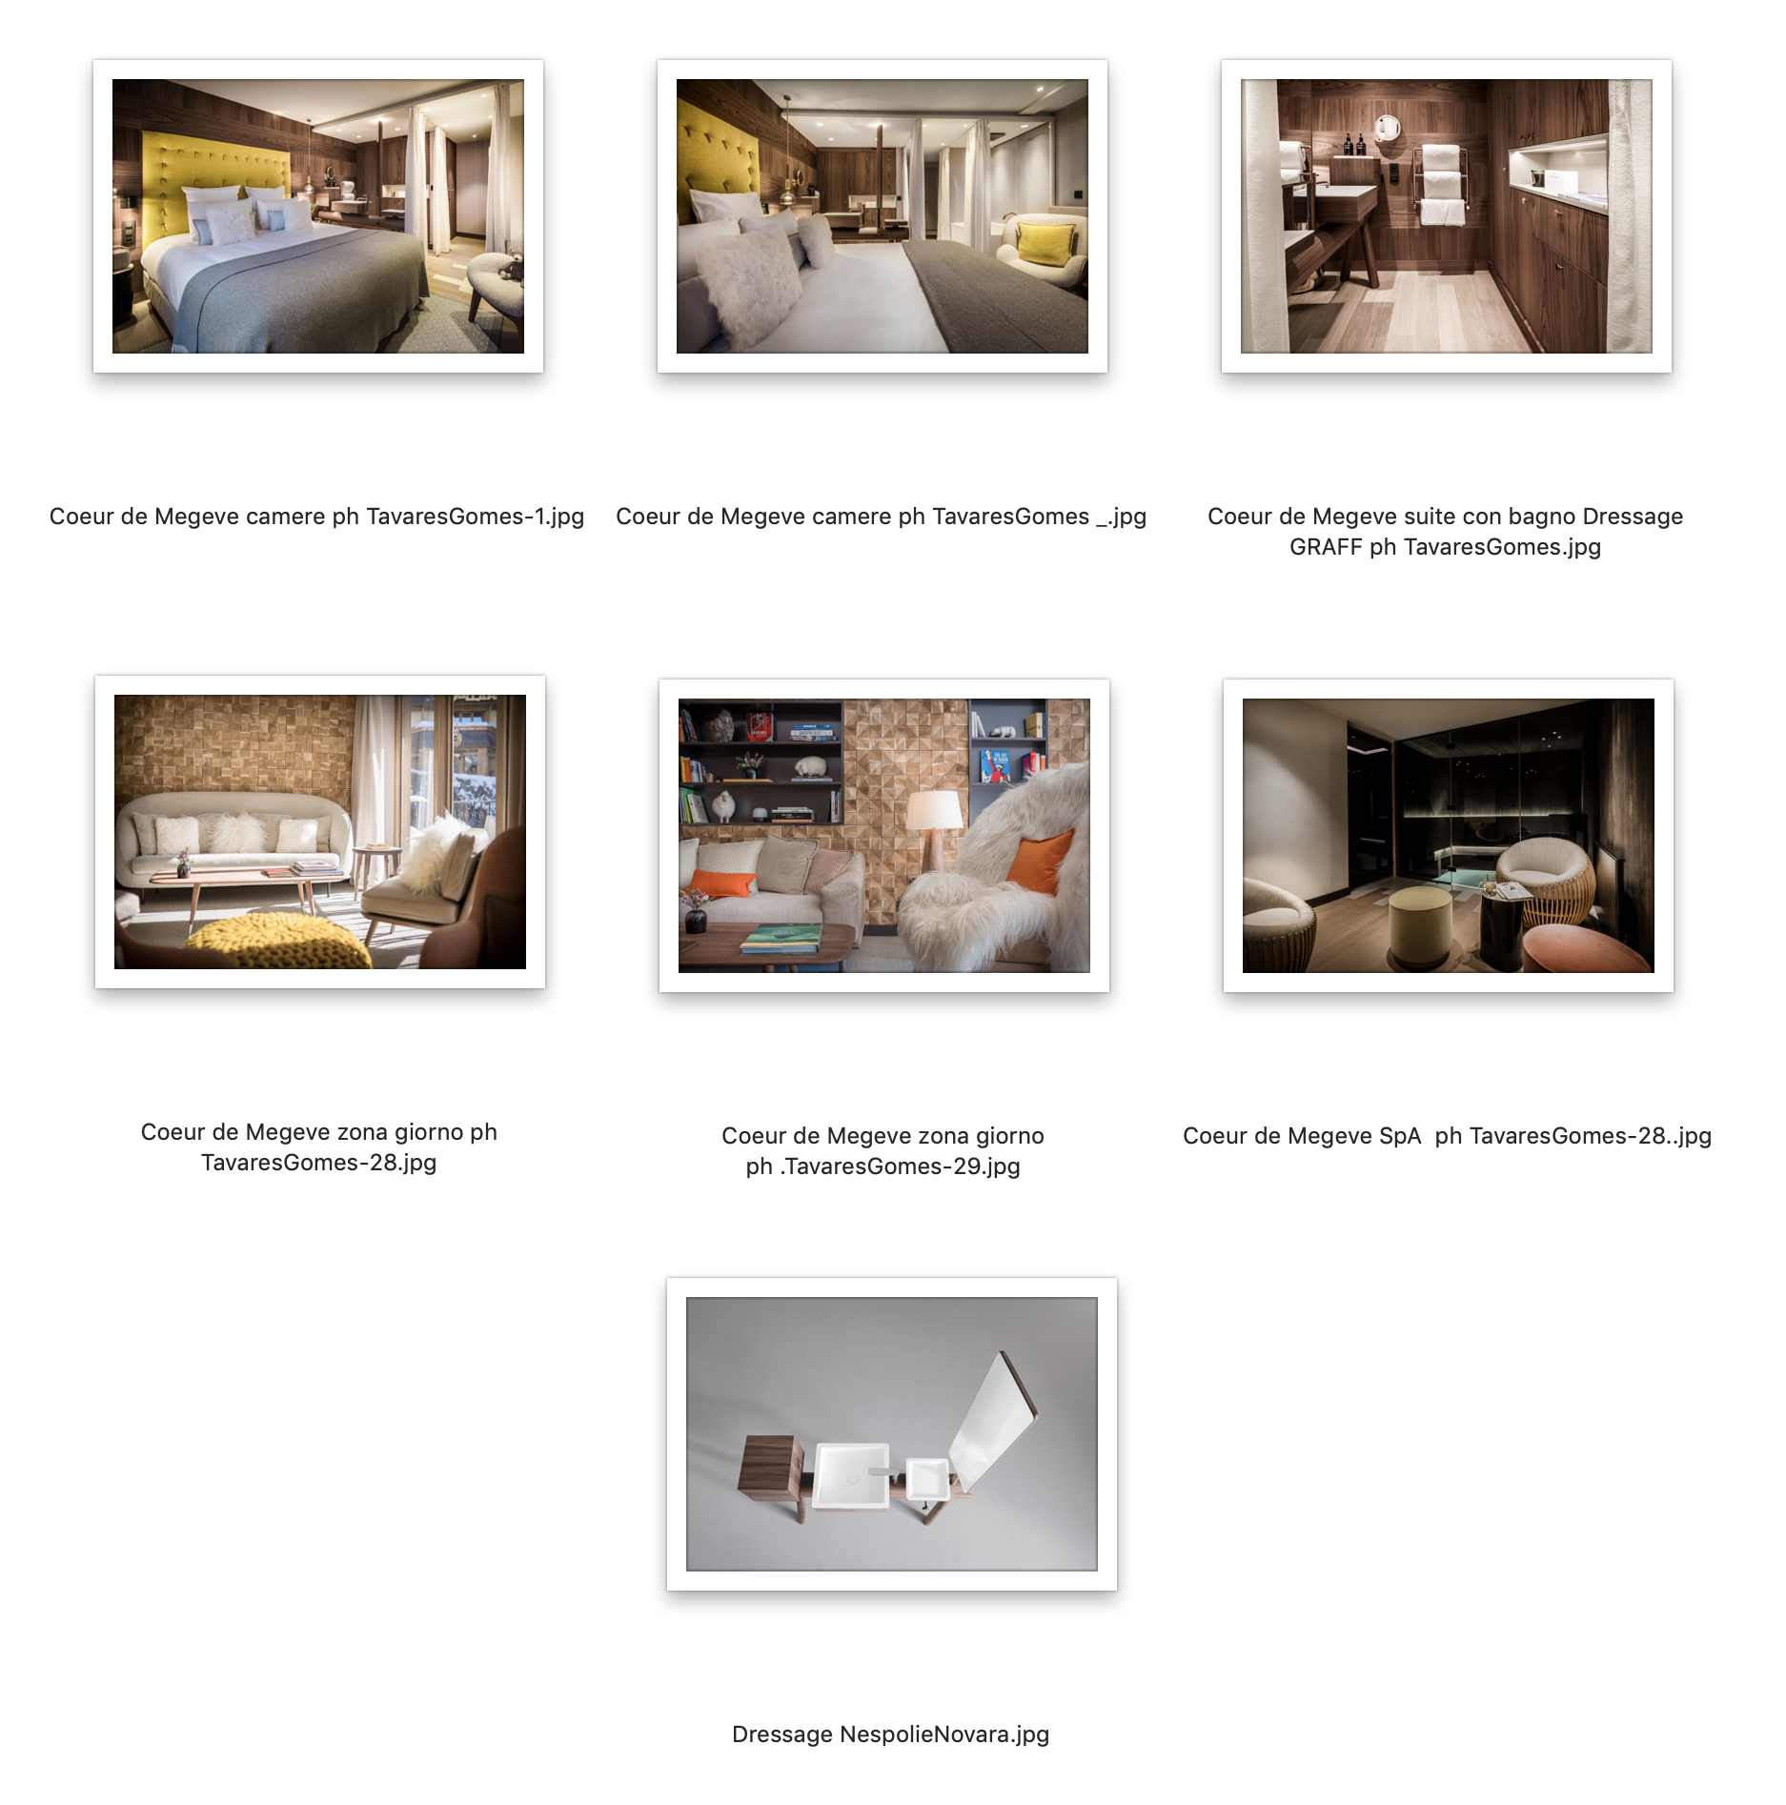

GRAFF EUROPE
Via Aretina 159, 50136 Florence - ITALY
Tel: +39 055 9332115,
fax: +39 055 9332116
info@graff-designs.com
www.graff-designs.com

For info and high-res images
Press office
tac comunic@zione milano | genova
tel +39 02 48517618 | 0185 351616
press@taconline.it | www.taconline.it

