RAK CERAMICS’ INNOVATION AT EXPO 2020 WITH THE ITALIAN PAVILION

IN ITS ROLE AS SUPPORTER SPONSOR, THE COMPANY WILL BE PARTICIPATING WITH ITS OWN LIFESTYLE SOLUTIONS FOR BATHROOM FURNISHINGS in the ambit OF THE PROJECT SIGNED BY Studio Ratti, Rota, Gatto AND F&M INGEGNERIA OF TURIN for THE FIRST UNIVERSAL EXPO TAKING PLACE IN THE ME.NA.SA REGION.

Rome | Fiorano Modenese, 23 September 2020

RAK Ceramics will be taking part in Expo 2020 of Dubai as a «Supporter sponsor» of the Italian pavilion. In fact, the partnership agreement has been signed between the Company and the Commissioner General’s Office for Italy, with the intent to strengthen the innovation and sustainability project promoted by our country with its participation in the Universal Expo scheduled to run from 1st October 2021 until 31 March 2022.

The partnership is perfectly aligned with the industrial strategy pursued by RAK Ceramics, which combines business with a keen attention to environmental issues within the framework of a development programme already in full swing, following its implementation several years ago, and centred on products and processes that are both innovative and sustainable. As a Supporter Sponsor, RAK Ceramics will be present at the Expo with its own lifestyle solutions for bathroom furnishings inside the Italian Pavilion, at the very heart of the first Expo organized in an Arab country of the ME.NA.SA. (Middle East, North Africa and South Asia) region.

The theme chosen for the Italian Pavilion at Expo 2020 Dubai, “Beauty connects people” has sparked the idea to link up the various industries in an interdisciplinary approach. Signed by Studio Ratti, Rota, Gatto and F&M Ingegneria of Turin, the project consists in an exposition area representing the best of Italian creativity which sets out to offer visitors a memorable experience, by providing an international showcase of our country’s expertise, talent and eclectic flair, with a high potential to attract new training, professional and business opportunities.
RAK Ceramics has been selected as a supplier of top-notch components for constructions, systems, technology and design, thanks to the company’s strong on-going commitment to sustainability in the circular economy and digital architecture.
The participation of RAK Ceramics is perfectly attuned to the values associated with good taste, lifestyle, sustainability and innovation, those same values forming the nucleus of the Italian project for the next edition of Universal Expo.

PRESS IMAGES

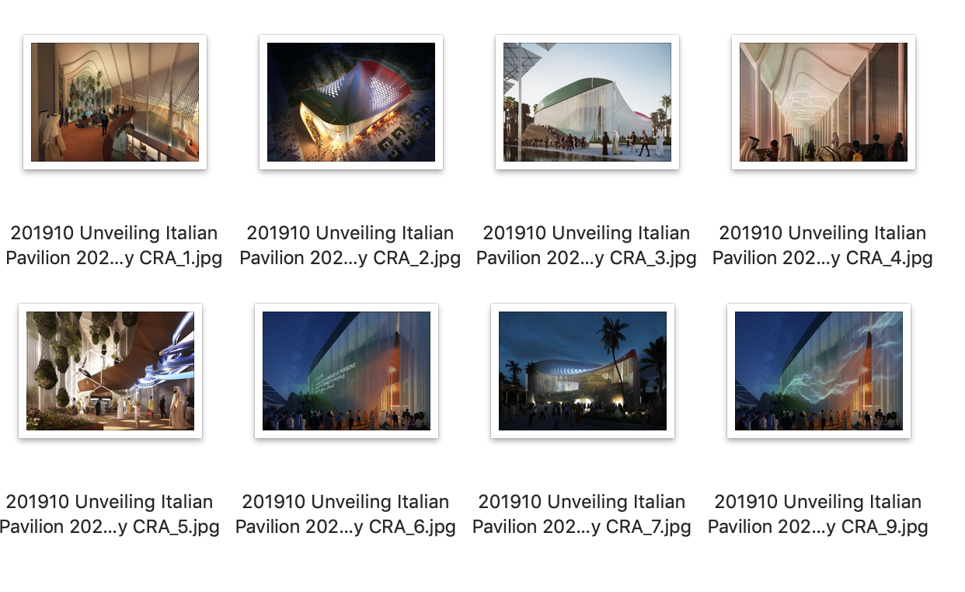
RAK Ceramics Distribution Europe
Fiorano Modenese (MO)
www.rakceramics.com

Marco Borghi
Deputy General Manager - Marketing & Communications
marco.borghi@rakceramics.com
Dir. +971 7 246 7423
Mob. +971 52 721 8935

Press Office RAK Ceramics:
tac comunic@zione
press@taconline.it
www.taconline.it
Paola Staiano
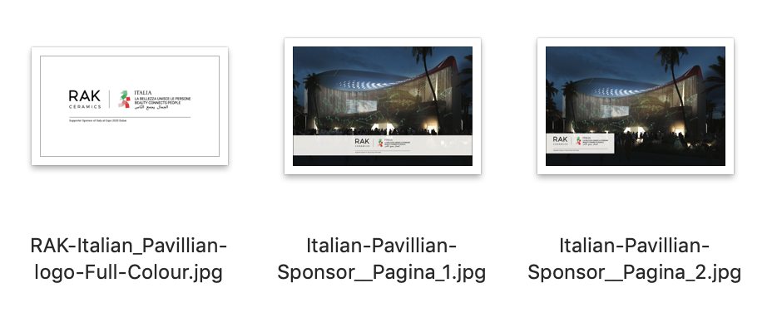

EXPO 2020
The Italy Pavilion for Expo 2020 Dubai will use architecture for a creative and innovative presentation of “beauty that connects people”.
The project sees the involvement of Carlo Ratti, Italo Rota, Matteo Gatto and F&M Ingegneria.
For six months, Dubai will become the world showcase in which the participating countries will present to the world their best ideas, projects, and example and innovative models in the field of tangible and intangible infrastructures focusing on the themes of the Universal Exhibition.
200 participating Countries. Expo 2020 Dubai will be the first Universal Exhibition to be held in the ME.NA.SA (Middle East, North Africa, South Asia) region.
The themes of Expo Dubai will include OPPORTUNITY – freeing the potential of individuals and communities to create a better future, MOBILITY – innovative logistics, transport and communication systems for people, goods and ideas, SUSTAINABILITY – accessibility and resilience of environmental, energy and water resources.
The Italy Pavilion will be located between the “Opportunity” and “Sustainability” thematic areas within the Expo 2020 Dubai site.
According to the project estimates, over 28 thousand people should visit the Italy Pavilion daily and more than 5 million over the six-month period of the event. The fact that the pavilion will be close to the park will greatly enhance its attractiveness but also guarantee an excellent view of the pavilion itself, as there will be no structures hindering its front and side views. Moreover, the Italy Pavilion will be situated near the pavilions of India, Germany, Saudi Arabia, Japan and the United States.
https://italyexpo2020.it/

RAK CERAMICS
RAK Ceramics Distribution Europe headquartered in Fiorano Modenese (MO), is part of RAK Ceramics, one of the largest ceramics’ brands in the world.
Specialising in ceramic and gres porcelain wall and floor tiles and sanitaryware we produce 123 million square metres of tiles and 5 million pieces of sanitaryware per year at our 22 state-of-the-art plants across the United Arab Emirates, India and Bangladesh.
Headquartered in the United Arab Emirates, we serve clients in more than 150 countries through our network of operational hubs in Europe, Middle East and North Africa, Asia, North and South America and Australia. Across our global operations we employ approximately 12,000 staff from more than 40 nationalities.
We are a publically listed company on the Abu Dhabi Securities Exchange in the United Arab Emirates and on the Dhaka Stock Exchange in Bangladesh and as a group have an annual turnover of approximately US$1 billion.

