PRESS RELEASE

HARLEY & BOLLERO:
GRAFF KITCHEN FAUCETS offering beauty and versatility

GRAFF’s design theme, the Art of Bath, is a concept that permeates not only their bathroom collections but kitchen faucets as well. An American company with a European heart, GRAFF offers various product lines featuring traditional, transitional, contemporary, and industrial styles. GRAFF’s wide range of products in different styles and finishes satisfies all furnishing needs and tastes.

Harley and Bollero are two among 13 presigious GRAFF kitchen collections. These are offered in different types of finishes – organic, galvanic, powder coating, 24K gold, and Physical Vapor Deposition (PVD). GRAFF’s PVD finishes are made with an innovative coating process that guarantees a very high level of surface hardness and unparalleled resistance to atmospheric agents and cleaning detergents.

Produced in brass with a very low nickel and lead content, GRAFF’s faucets are developed in compliance with drinking water regulations and in accordance with the most restrictive criteria required. GRAFF adheres to the most stringent international standards and is proud to be one of the pioneers in eliminating any minimum lead residue from the water supplied through its faucets.

HARLEY
GRAFF’s Harley kitchen collection perfectly combines classic elements and contemporary details.
An elegant reinterpretation of the industrial and mechanical shape of a luxurious car steering wheel and a motorcycle accelerator, the Harley handle gives the product its uniqueness, making it eclectic and adaptable to contemporary design. The Harley kitchen mixer merges form with function with its pull-out spray head with dual spray and jet function.
It is available in 17 different finishes, with a retail price starting from 713 euro+VAT.

Attached images: Brushed Nickel
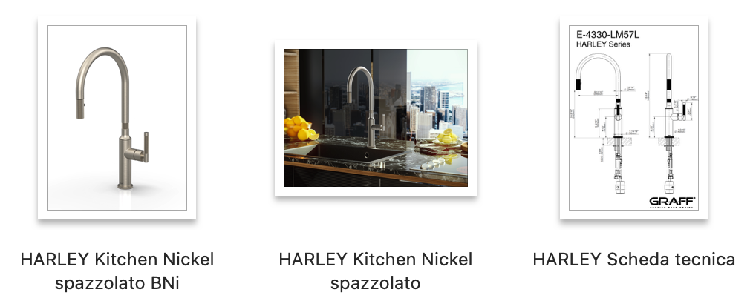

BOLLERO
Designed for beautiful and sophisticated kitchens, Bollero is also for those who require extreme functionality: the mixer is equipped with a pull-out spray head, double function (normal and spray), and a revolving spout which is one of the most sought-after features. The Bollero faucet boasts a transitional design with a balanced blend of classic details and modern aesthetic.

Retail price starts from 587 euro in Polished Chrome.The collection is also available in 16 other finishes.

Attached image: Polished Chrome finish (galvanic finish)

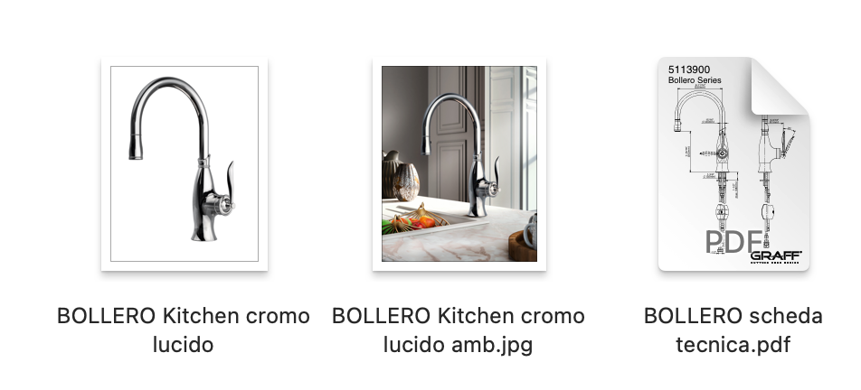

About GRAFF®
An internationally recognized company in the luxury bathroom and kitchen products sector, GRAFF® is part of the Meridian International Group based in Milwaukee, Wisconsin and employs over 1000 dedicated professionals. GRAFF® also has locations throughout Europe, and continues to grow and develop cutting-edge, luxury bath and kitchen collections for the global market.

Thanks to the collaboration with a renowned American motorcycle manufacturer, the Meridian group has raised the quality standards of production and finishes, following the very restrictive automotive regulations and bringing the quality of bathroom furnishings to a whole new level.
What makes the whole GRAFF® offering extremely valuable is the synergy between distinctive world-class designs and the highest level of industrial production. GRAFF® products are made with raw materials of excellent quality and with the most advanced technologies available on the market. With a vertically integrated production, GRAFF® has full control over all production processes, including the final finishing phase, to constantly supply exceptional products. GRAFF® owns the ISO 14001 certification, testifying its commitment to being an ethical and sustainable company with a responsible attitude towards the territory, people, and the environment.

GRAFF® stands out in the global luxury bath and kitchen market for their exceptional quality, vertically integrated production, unique and luxurious style, creative innovation process, and sustainable practices.

Press Office
tac comunic@zione milano | genova
press@taconline.it | www.taconline.it

GRAFF EUROPE
info@graff-designs.com
www.graff-designs.com

