PRESS RELEASE
Autumn 2021

ametis collection NOW in 24k gold

GRAFF’s Ametis collection draws inspiration from water, one of earth’s most precious resources. Now available in 24K Gold, Ametis offers a whole new way of experiencing water, transforming mundanities of everyday life into something extraordinary.

Designed by the Italian-Swiss designer Davide Oppizzi, this futuristic collection is inspired by the density and colours of water, the movement of waves and the refined Japanese ideograms, produced with a single brush stroke. As a whole, the Ametis collection represents the fusion between the universe and the oceans.

GRAFF’s Ametis boasts sophisticated features both in design and functionality, making it a unique addition to a luxurious home. Select items in the collection are designed with a high-tech LED lighting system that offer the benefits of chromotherapy.

Produced in hollowed brass and guaranteed to stand the test of time, the Ametis faucet is equipped with a coloured ring that changes from red to blue and vice-versa, as the temperature changes. The system is activated by a dynamo inside the tap and therefore does not require the connection to the electrical system or any additional use of energy.

The Ametis in 24K Brushed Gold (BAU) highlights the delicate design of the collection. In addition, the brushed finish creates a more contemporary and luxurious appeal. Ametis is now also available in 24K Gold (AU), a stunning mirror-like polished finish.

GRAFF President and CEO, Ziggy Kulig, commented, "Currently, styles that evoke warmth and opulence, with gold at the forefront, are making a significant comeback. The addition of 24K Brushed Gold to our Ametis collection reflects not only the changes in design preferences, but also GRAFF's attention to the market orientations."

Davide Oppizzi wanted to create a collection of unique objects for GRAFF, revealing the profound link between “being” and the nature surrounding us. His approach is artisanal and oriented beyond the intrinsic value of objects: the material is a living vibration to be enjoyed in every moment.

* GRAFF bathroom and kitchen fixtures are available in more than 20 high-quality finishes, made with cutting edge production processes and with utmost respect for environmental standards.

Davide Oppizzi
Founder of DCUBE design espaces lumière SA, Davide Oppizzi is specialized in extremely sophisticated projects related to lighting, green-tech, and architecture.
The centre of his creativity revolves around the art of lighting, the only way - in his own words - to sublimate the materials he works with. The vivid imagination, the emotional vision of the material and immaterial world, as well as his experience in niche sectors, have brought him to the fore of the international scene.
Global prestigious brands such as Chanel, Louis Vuitton and GRAFF have entrusted him with projects that illustrate the profound link between “being” and the surrounding nature. Davide Oppizzi possesses a rare and unique mastery of two worlds that can appear completely opposite at first sight: technological knowledge and creative sensitivity.

Attached images
E-6401-LM43-**
OLD CODE: 5112000
EN Single lever basin mixer - version with LED
3 325,00 + VAT

E-6410-LM44-**
OLD CODE: 5102000
EN Three-hole washbasin mixer
1 909,00 + VAT
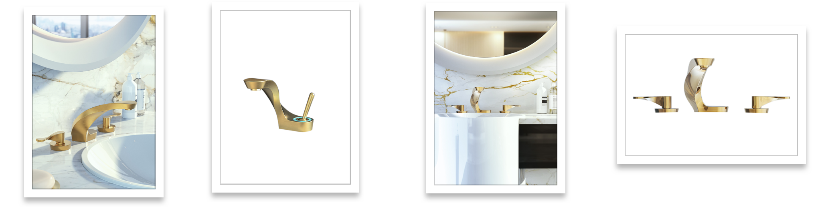
Three-hole mixer - BAU Single lever mixer with LED BAU Three-hole mixer - AU

GRAFF EUROPE
Via Aretina 159, 50136 Florence - ITALY
Tel: +39 055 9332115
info@graff-designs.com | www.graff-designs.com

PRESS OFFICE
tac comunic@zione milano | genova
press@taconline.it | www.taconline.it

