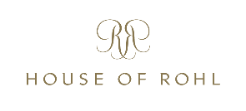
SALONE PRESS RELEASE
HOUSE OF ROHL & RIOBEL OFFICIAL EUROPE LAUNCH AT SALONE DEL MOBILE 2022
19/5/22
The House of Rohl will officially launch in mainland Europe at the International Bathroom Exhibition at Salone del Mobile Milano 2022.
House of Rohl is the new family name for established luxury bathroom and kitchen brands, Perrin & Rowe (brassware and sanitaryware), Victoria + Albert (baths and basins), Shaws (fireclay sinks) and new brassware brand, Riobel. House of Rohl’s collective expertise and support will help designers, architects, specifiers and consumers create their perfect bathroom and kitchen spaces.
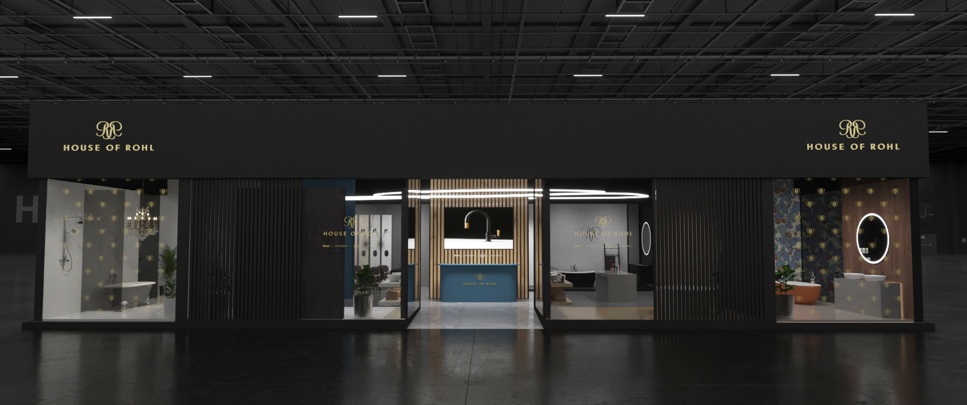
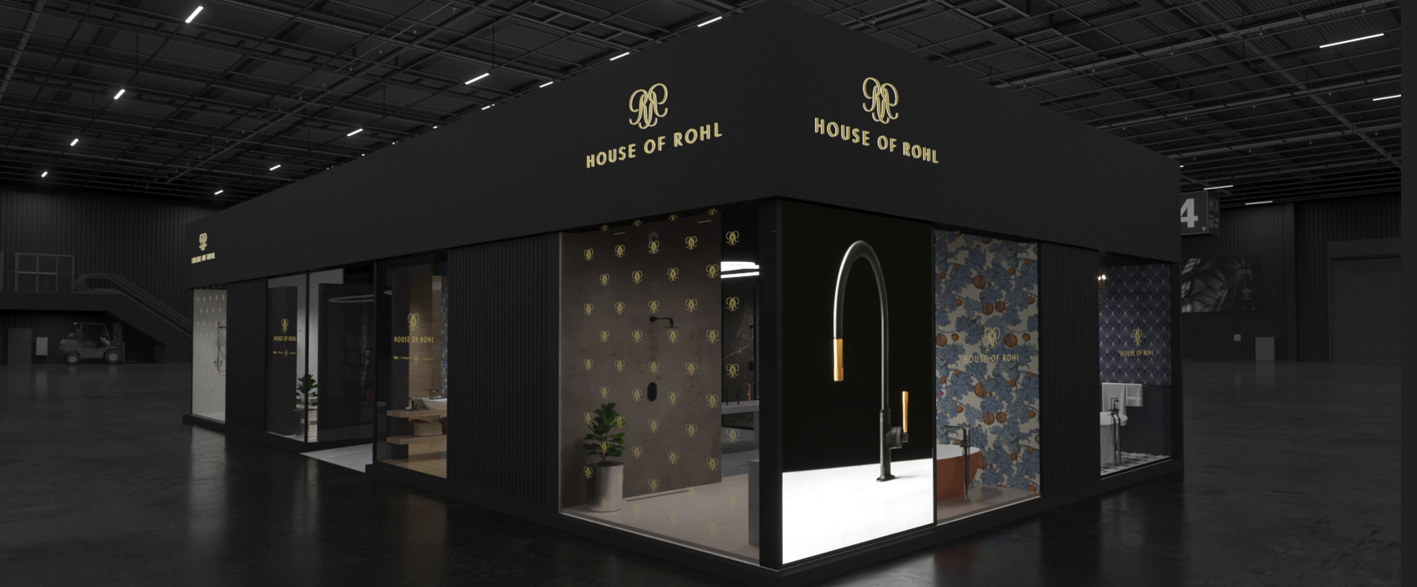
House of Rohl stand design for Salone 2022
Taking a floor area of 200m² in Pavilion 22, the House of Rohl stand will feel like a luxury showroom dropped in from Via Montenapoleone or Bond Steet. Showcasing exciting new products from Perrin & Rowe and brilliant new colour palettes from Victoria + Albert, the stand will also launch Riobel into Europe.
Founded in French-speaking Quebec, Canada’s largest and most distinctive province, Riobel’s designs are inspired by this meeting place of cultures and ideas. Mario Bélisle, a plumber from a family of plumbers, wanted high performance taps that were easy to fit and easy to maintain.
So he built his own company to make them. Riobel is now preparing to challenge the European brassware brands with its fresh ideas and innovation. Mario’s name is still at the heart of the brand: maRIO BELisle.
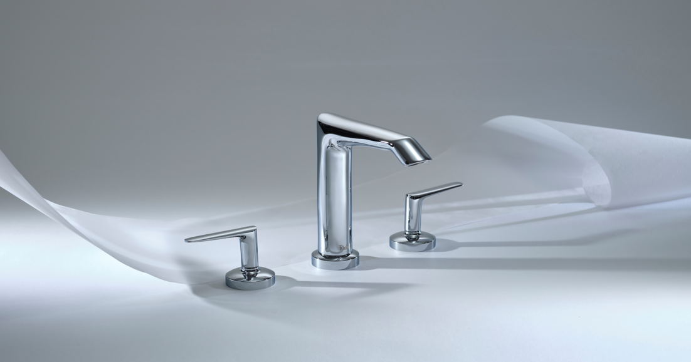
Riobel Venty three-hole basin mixer
Designs to look out for include the award-winning Parabola collection. Its parabolic spout and chamfered body give it a distinctive profile. Also the new Venty collection, a beguiling mix of curves and angles that demonstrate a unique design DNA.
Perrin & Rowe will present their new Langbourn bathroom brassware, an understated modern collection made by hand in England. Visitors taking coffee at the stand will also see Perrin & Rowe’s beautiful instant-hot kitchen taps in use.
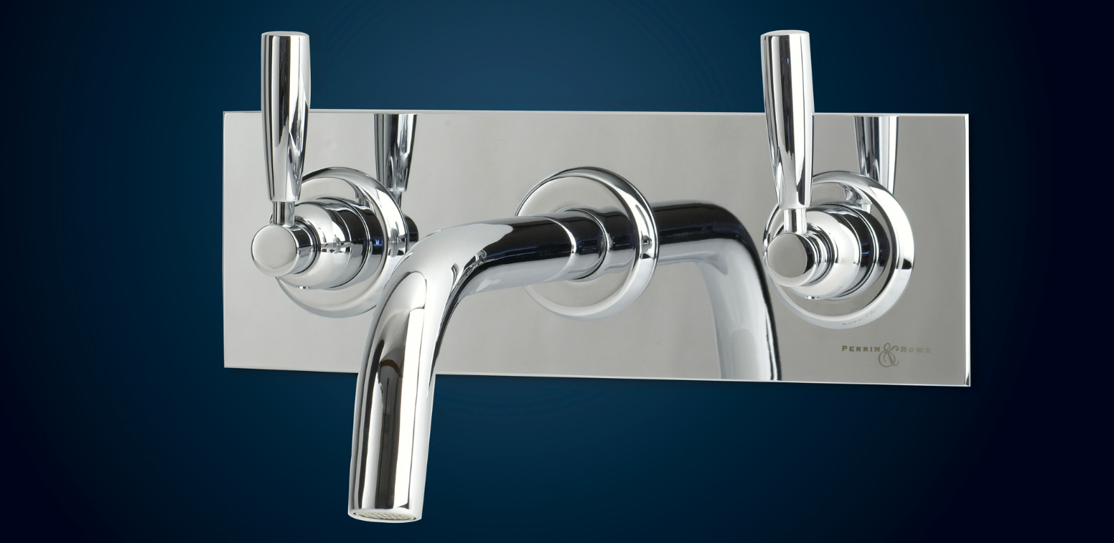
Perrin & Rowe Langbourn wall-mounted bath filler
Victoria + Albert’s new colour collaboration with Wallpaper* magazine will be shown. Three new colour palettes have been created for the bathroom, inspired by modern architectural movements. Victoria + Albert’s baths and basins can be ordered in any of these en vogue colours, or a choice can be made from 200 colours on the RAL chart.
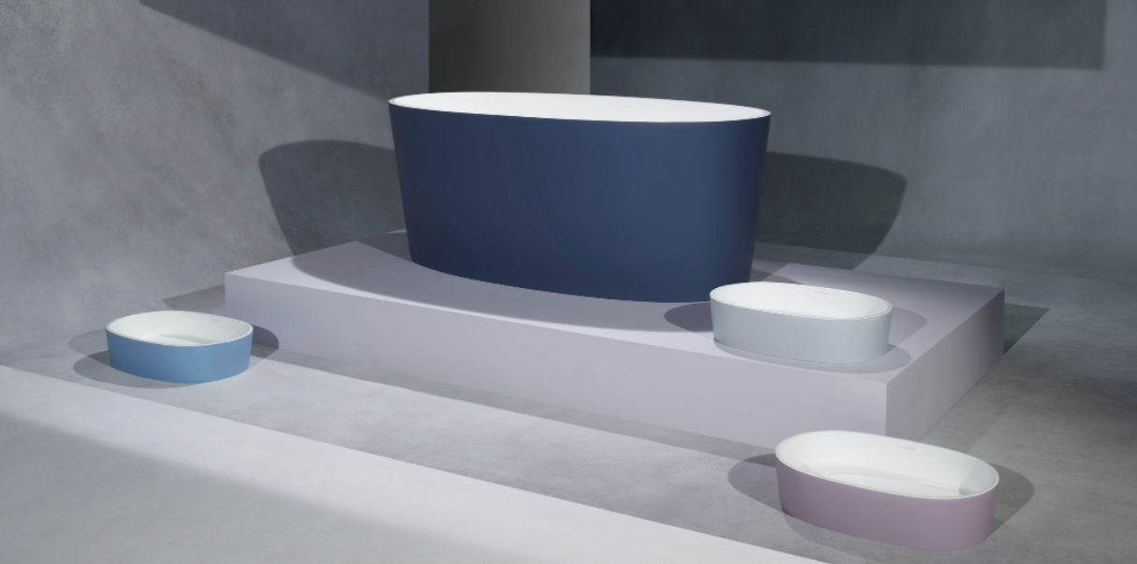
Victoria + Albert Wallpaper* magazine colour collaboration (‘Belgian Minimalism). Image: William Bunce

The stand itself is a remarkable design, with large glass windows to resemble a fashionable boutique. Seven inspirational bathroom displays are on show, each combining the individual brands within the House of Rohl family. The four companies in the House of Rohl have their own heritage and independent spirit, but the different products seem to work together naturally. It makes it easy to specify a luxury bathroom.
Hospitality will be offered on the stand, with ample space for client meetings. For many, Salone 2022 is the first opportunity to meet customers for over 2 years.
David Cole, Channel Marketing Manager EMEAA at House of Rohl stated: ‘The official European launch of House of Rohl is something we have been working towards for a long time and we are delighted to finally share it with the European design industry. The acquisition of these four brands places House of Rohl in a unique position at the top end of the market, acting as an industry authority on everything from sanitaryware and taps, to the latest bathroom and kitchen design trends. Most importantly, it brings the investment and long-term support that a Fortune 500-listed can offer to four extremely special artisan manufacturers and their customers.’
For all press enquiries please contact houseofrohl@littleredpr.co.uk

Further Background
The House of Rohl story began in 1983 with American entrepreneur Ken Rohl. Ken was struck by the impressive design he found in European bathrooms and kitchens, which at the time was unavailable in the US. With his three sons, he built a successful business importing the finest products from Europe and around the world. This fascination with high-quality, international design culminated in the creation of the House of Rohl. The House of Rohl’s family of artisan bathroom and kitchen brands brings a unique cross-category offer to the market, helping designers, architects and specifiers create luxury spaces.
House of Rohl is owned by Fortune Brands, a Fortune 500-listed company. In Europe, the House of Rohl family comprises four brands: Riobel, Victoria + Albert Baths, Perrin & Rowe and Shaws.
Riobel are designers of kitchen and bathroom taps that have been hugely successful in North America. Founded in Quebec, Riobel’s award winning designs fuse brilliant engineering with an architectural style drawing on influences from both Europe and North America.
Victoria + Albert’s freestanding baths have a global reputation, and the company celebrated its 25th anniversary last year. Each bath and basin is manufactured and hand-polished from its unique QUARRYCAST™ material, strong, light and warm to the touch. The brand now offers over 40 baths in both modern and traditional designs, and recently introduced a choice of 200 RAL colours, in matt or gloss.
Perrin & Rowe is a distinctly British brand. With a casting plant in Wolverhampton, it represents the heart of the British brassware industry, still making taps in small batches by hand to achieve the highest possible quality.
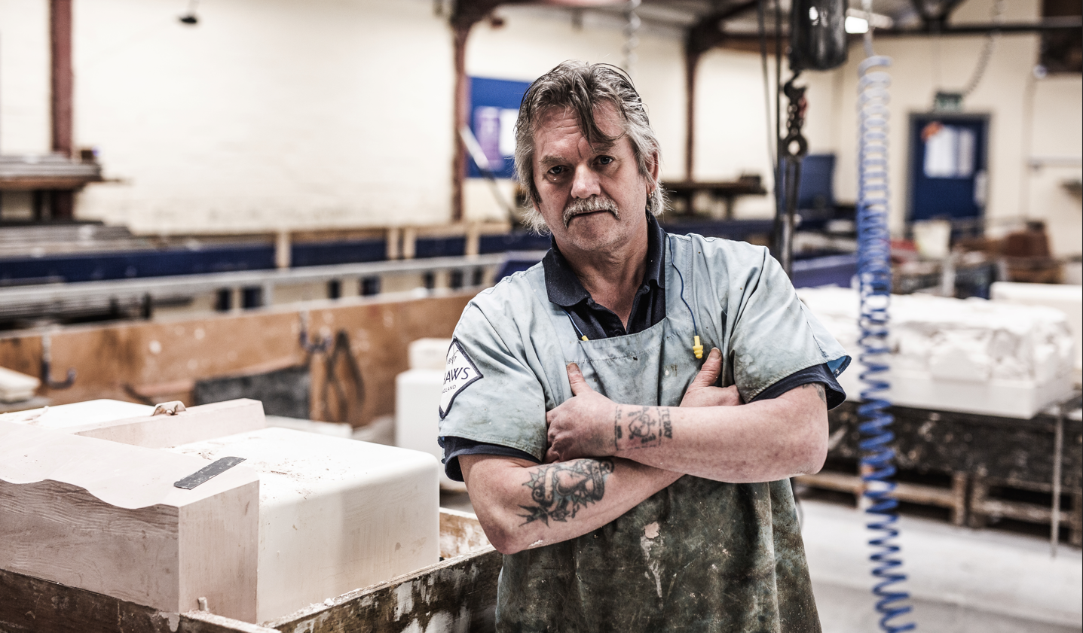
Shaws craftsman at the Darwen factory, Lancashire, England. Shaws celebrate their 125th anniversary in 2022.

Shaws has been making extraordinary fireclay sinks for 125 years. In a process essentially unchanged since the business was established by Arthur Shaw on St Valentine’s Day 1897, Shaws fireclay sinks are hand finished, then fired for longer and at a higher temperature than conventional ceramics to achieve an intensely durable material with a deep gloss finish.
The House of Rohl has a London showroom at the Design Centre, Chelsea Harbour, opened late 2021. All four brands are on permanent display in this state-of-the-art space.

