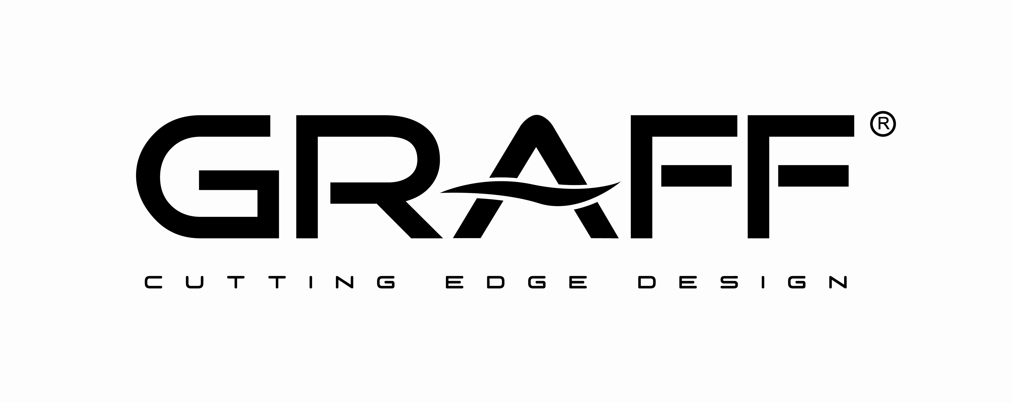

MARCH 2012

GRAFF: innovative design, contemporary aesthetic and beautiful products for the shower system
AQUA-SENSE, the future of living design
The newest collection of GRAFF, AQUA-SENSE, is destined to become the future of shower design, confirming the company’s commitment to design, innovation and sustainability.
AQUA-SENSE is a full sensory experience, a shower system inspired by the feeling and luxury one experiences at SPAs; created for a discerning clientele who want to achieve both an innovative and high-style design with an eye towards the environment.
The collection plays a leading role with these four elements of design:
- Electronic system with ceiling-mounted shower-head, RGB effect, speakers and touch-screen
- waterfall
- wall-mounted cascade and rainfall shower-head
- wall-mounted cascade and rainfall with RGB LED shower-head
The electronic system with ceiling-mounted shower-head creates a very intense central rainfall effect resembling a real waterfall. The RGB LED changes color, shaping diffused chromatic lines to produce a soothing effect of the bathroom environment. The system is controlled by a touch-screen with simple and intuitive interface controlling water functions, color changes, music and videos.
Music can be easily uploaded using an i-Pod connected to a wall-mounted USB port, while the speakers are ceiling-installed. The system is well equipped with hand-shower, foot-shower and adjustable side body-sprays.
Material: polished stainless steel
Finishes: 4 colors RGB white, red, blue and green
Wall-mounted waterfall: this elegant and impressive element finds its location in the shower environment not as an accessory but as a real shower-head creating a perfect blade effect. The shower-head-waterfall works with all GRAFF thermostatic product ranges.
Material: polished stainless steel
Wall-mounted cascade and rainfall shower-head: the distinctive characteristic is the ultra-slim profile and the delicate edges, which give the product more than a touch of elegance. The cascade creates a subtle and well-shaped blade of water. The rain effect is extremely rich. The wall-mounted cascade and rainfall shower-head can be used with all GRAFF thermostatic ranges.
Material: polished stainless steel
Wall-mounted cascade and rainfall with RGB LED shower-head: provides the same functions as the wall-mounted cascade and rainfall shower-head, yet in addition it contains a concealed LED system; a non-invasive and completely integrated design that produces a minimalist effect while delivering maximum benefit.
Material: polished stainless steel
Finishes: 4 colors RGB white, red, blue and green
Emanuela Tavolini, Sales Director of Graff Europe, comments: “Our new collections cross design borders. The finish choices, the chromatic effects and the technological solutions are amazing and are designed for the clientele looking for a completely new and original product. Our design is able to create something very unique.”
The GRAFF manufacturing system is based on an innovative concept of Lean Manufacturing Management. Eliminating excessive consumption of time, energy and material, every process attains high efficiency standards. Even for the fusion, plating and galvanic processes, GRAFF uses a zero- System that recycles 100% of brass and paper.

In line with its strong commitment to environmental sustainability, products in the AQUA-SENSE collection are among the most sustainable. GRAFF is an American company that fully expresses its willingness to eliminate its impact on the environment as much as possible.

GRAFF
Headquartered in Milwaukee, Wisconsin, USA, and with locations throughout Europe, GRAFF is recognized globally for its trend-setting products and unique vision. Supported since 1922 by extensive plumbing and hardware manufacturing experience, GRAFF offers a wide range of contemporary, transitional and traditional styling.
Utilizing the latest manufacturing technology and supported by a tradition of old-world craftsmanship, GRAFF’s commitment to creating cutting-edge, premium-quality fixtures is evident in each and every product. GRAFF employs over 1000 dedicated professionals and has control over the full production process, making it truly a vertically-integrated manufacturer.
GRAFF’s parent company, Meridian International Group, is an ISO 9000 certified company comprised of five business units. Meridian strategically combines a strong European OEM faucet and valve production history with over 30 years of American excellence in OEM machined parts. Meridian's prestigious customer list includes many global plumbing companies as well as the number one manufacturer of American motorcycles.

GRAFF - Member of Meridian International Group
Headquarters: 3701 Burnham St. Milwaukee,
WI., 53215 USA; graff@graff-faucets.com
Division Europe - via Aretina 159, Firenze ITALY
Tel. +39.055.9332115; Fax. +39.055.9332116
info@graff-mixers.com; www.graff-mixers.com
Press&PR: TAC Ti Aiutiamo Comunicando
Via Costanza 26 – 20146 Milano
tel. +39 02 48517618
fax + 39 02 462037
e-mail: press@taconline.it
sito web: www.taconline.it
Contatto: Monica Robustellini – Paola Staiano

