Preview Cersaie 2012

SENTO

Sento is Graff’s latest collection of bathroom faucets and accessories created and coordinated by Angeletti Ruzza.

The new collection embodies characteristics of synthesis. By reducing ornamentation and focusing on SENTO’s basic aspect – functioning as an element of the bathroom – Angeletti Ruzza gives life to various elements with strong visual influence and bold lines.

The classic faucet form has been newly redefined by slim, contemporary forms without harming functionality. The lever is solid but also light and because of its intelligent design, the faucet body covers the sink or countertop hole, therefore avoiding the need for an unsightly covering plate. The spout was crafted in such a way to allow water to flow out centrally while the slim angles give the faucet a feeling of openness.

Through focusing priority consideration and sensitivity on the demands of daily contemporary life, Graff has incorporated a series of wall and floor mounted options within the SENTO series which are both practical and aesthetically pleasing.

SENTO claims to be a product line capable of existing across time through adapting to society and its transformations.

The SENTO collection consists of 15 faucet elements and includes a complete line of accessories available in four finishes: polished chrome, black or white matte with chrome accents, and Steelnox.

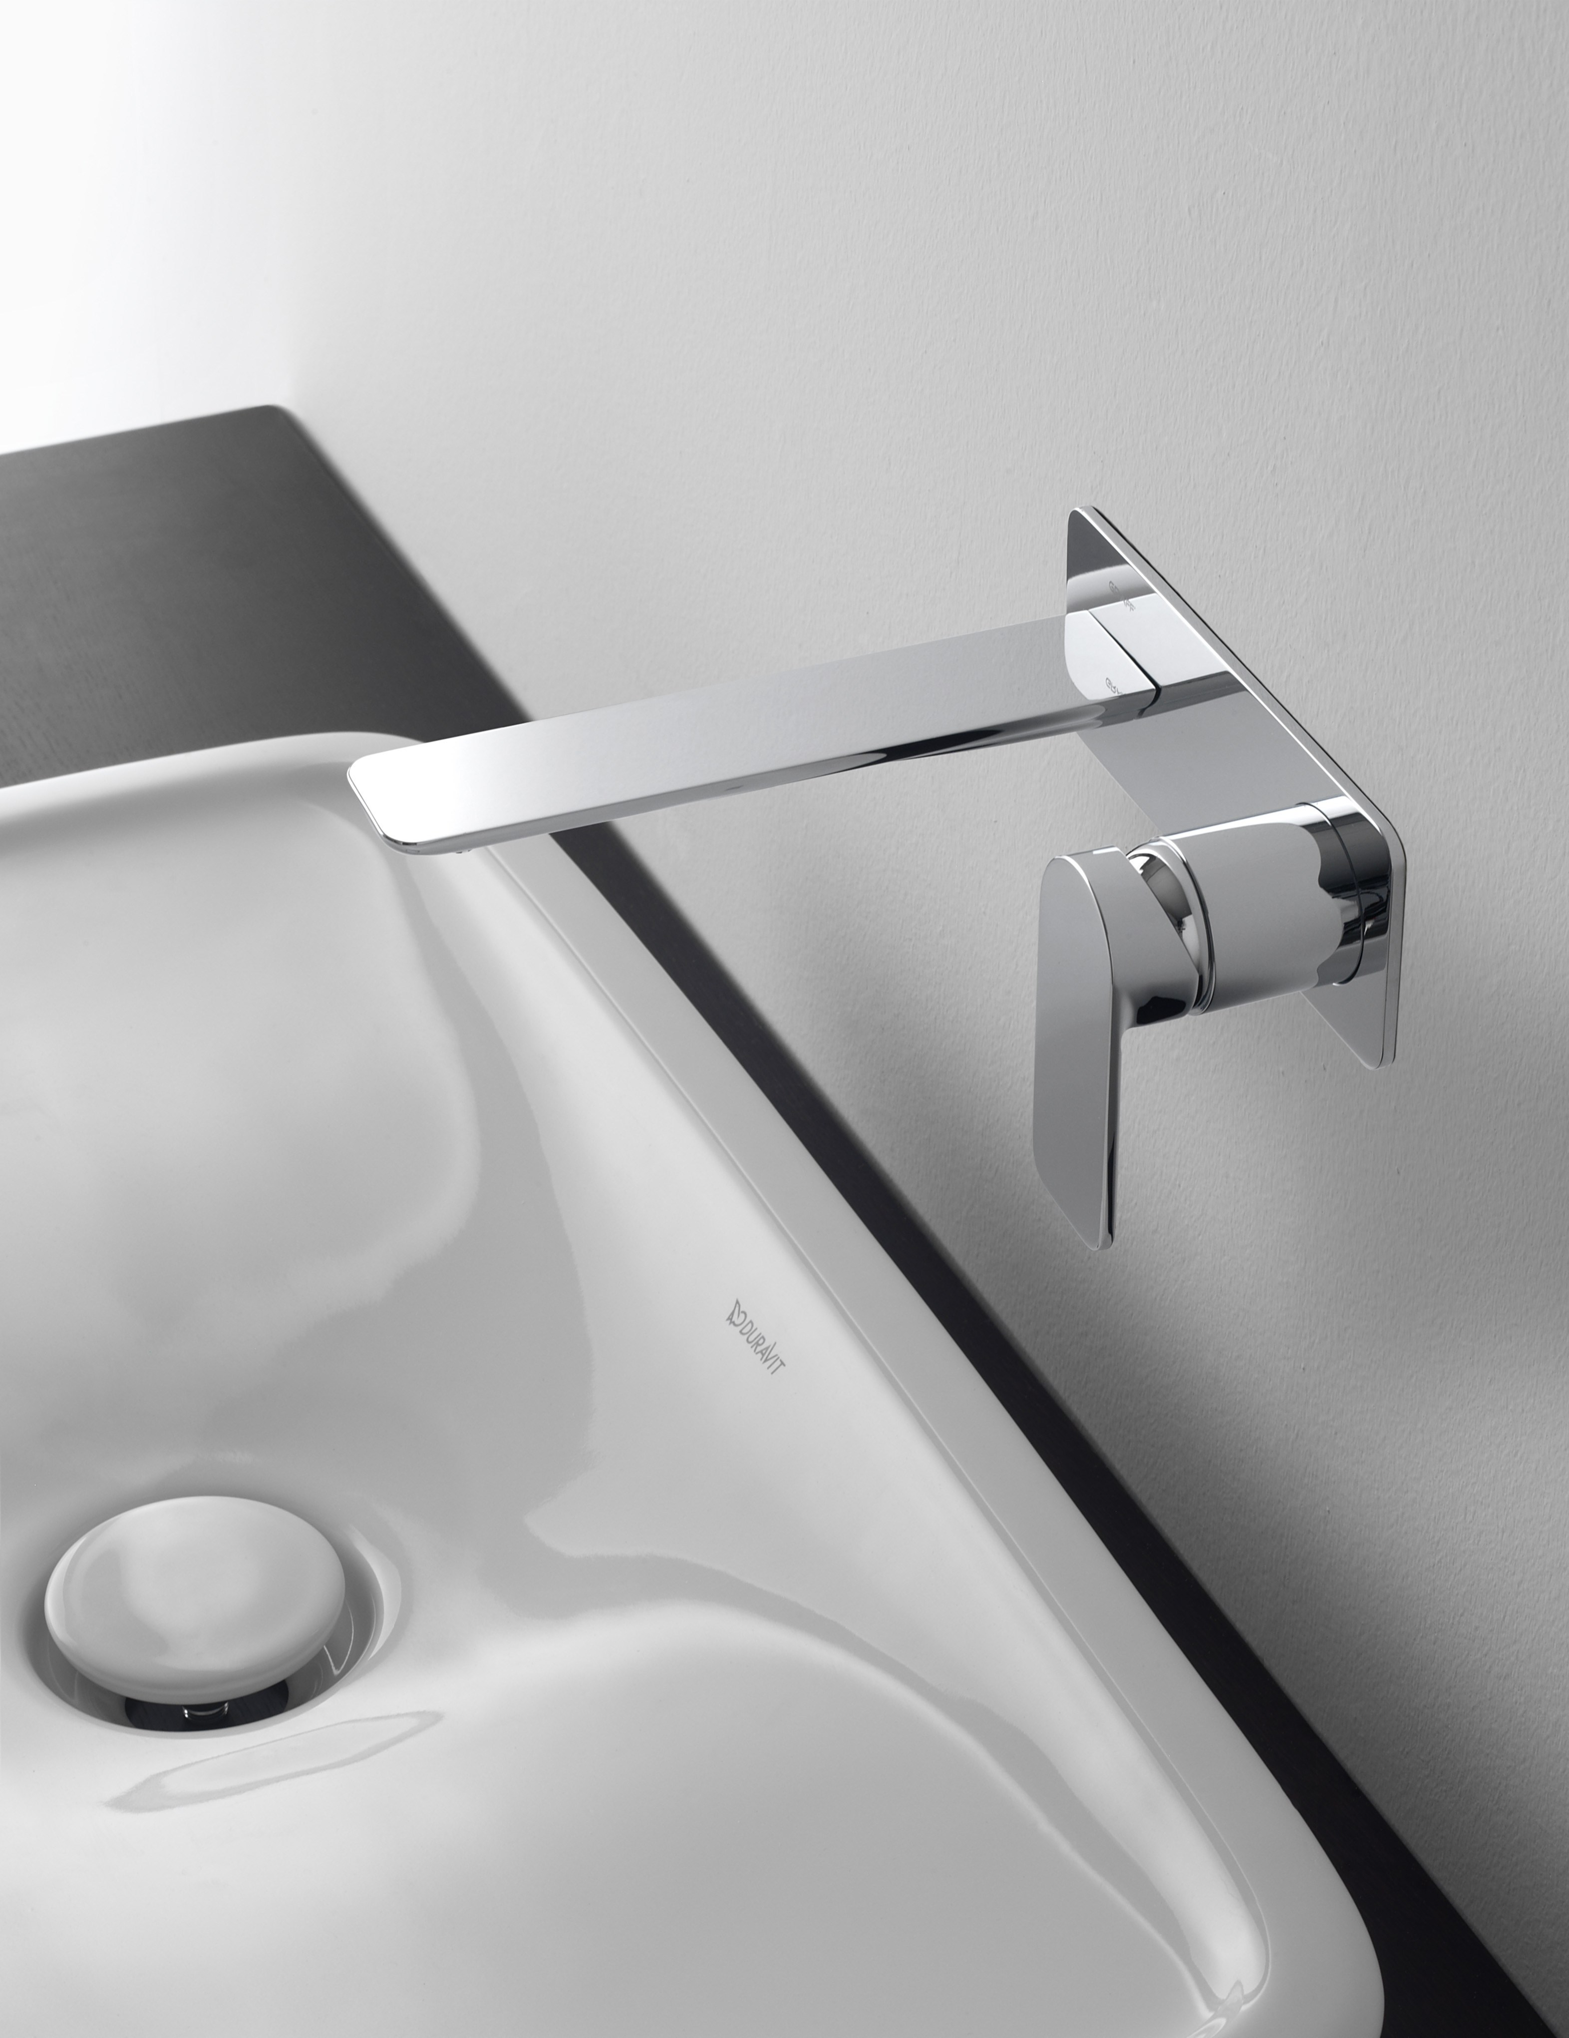

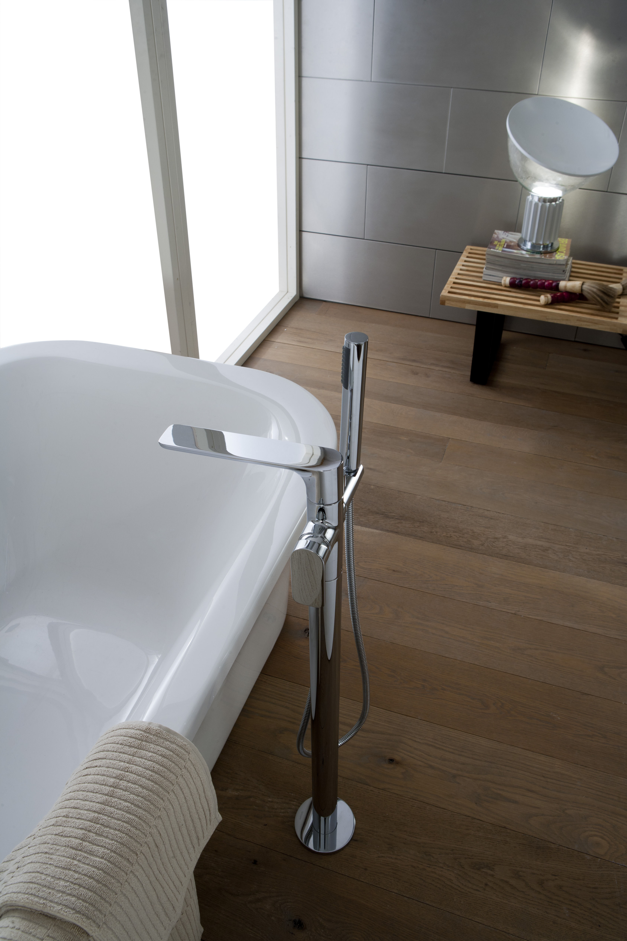

GRAFF

With headquarters in Milwaukee, Wisconsin (USA) and branches in various parts of Europe, Graff is known throughout the world for its unique vision and originality of its products to create new trends. Graff offers numerous models in modern and traditional styles thanks to unmatched experience in the installation and production of faucets since 1922.

Utilizing the newest state of the art technologies and building upon a rich tradition in manufacturing, Graff’s dedication to producing innovative products of the highest quality is evident in every piece. The company employs more than 1,000 highly skilled employees and controls the entire value-added chain of production, making it a manufacturer with perfect vertical integration.

Graff represents one of six companies administrated through Meridian International Group, which is an ISO 9000 certified company. Meridian strategically combines a strong history of producing OEM faucet and valve products with over 30 years of American excellence in OEM machined parts. Meridian's prestigious customer list includes some of the world's leading plumbing companies, as well as the number one manufacturer of American motorcycles.

ANGELETTI RUZZA DESIGN
Silvana Angeletti was born 1969 in Rieti, Italy. Daniele Ruzza was born in 1967 in Rome, Italy. After finishing their degrees as industrial designers at I.S.I.A. Rome in February 1994, they founded their own project studio: Angeletti Ruzza design.
The studio is mainly focused on industrial design and collaborates with companies such as TEUCO, FLAMINIA, AZZURRA, F.LLI FANTINI, GUZZINI, COLOMBO DESIGN, GSI, IRSAP, AD HOC, SERAFINO ZANI, NEMO, POLTRONA FRAU, R.S.V.P.
Since November 2007 they have managed creative direction for the manufacturer of sanitary ceramics AZZURRA. From 2002 till 2006 they carried out creative direction for GSI. Interior Design Projects include the Relais Villa d’Assio, and the Quinto Assio Hotel in Rieti. They have been members of ADI since 1999.
"RED DOT AWARD 2009" communication design, AZZURRA
“DESIGN PLUS 2009” happy hour caraffa, prod. GUZZINI
“DESIGN PLUS 2009” collection NUVOLA prod. AZZURRA
”ADI DESIGN INDEX 2006” Stand GSI Cersaie 2005
“ADI INDEX 2004”, serie PLANO prod. F.lli Fantini
www.angelettiruzza.it

Press&PR: TAC Ti Aiutiamo Comunicando
Via Costanza 26 – 20146 Milano
tel. +39 02 48517618
fax + 39 02 462037
e-mail: press@taconline.it
sito web: www.taconline.it
Contatto: Monica Robustellini – Paola Staiano

GRAFF - Member of Meridian International Group
Headquarters: 3701 Burnham St. Milwaukee,
WI., 53215 USA; graff@graff-faucets.com
Division Europe - via Aretina 159, Firenze ITALY
Tel. +39.055.9332115; Fax. +39.055.9332116
info@graff-mixers.com; www.graff-mixers.com

