

INTERNATIONAL
FURNITURE FAIR
8-13 April 2025
Milan Fairgrounds, Rho
Hall 14 Stand E44

PRESS STOP
8-9-10 April
10:00 am to 5:00 pm

INTERVIEWS SCHEDULE
Patrick Norguet Wednesday 9 Marcello Ziliani Tuesday 8
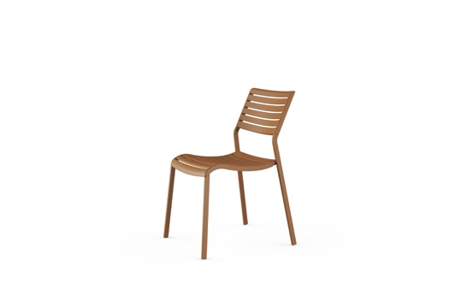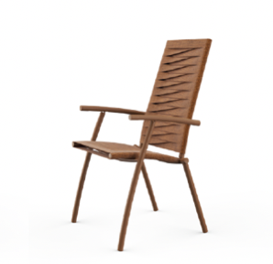
Nina design Studio Zetass Volée design Marcello Ziliani

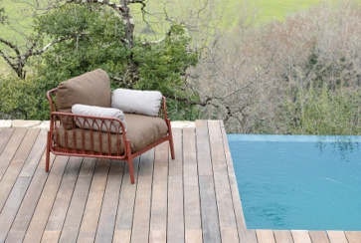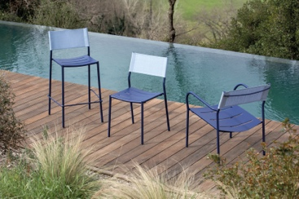

Meltemi design Patrick Norguet Vera design Patrick Norguet

PRESS RELEASE (more images in the press kit)

VERMOBIL: OUTDOOR DESIGN CAPTIVATES AND SPEAKS A NEW LANGUAGE

Outdoor design becomes an all-round experience: innovative materials, refined shapes and a genuine design language. Design objects created to last: functional, meaningful, deeply connected to today's new ways of living and experiencing outdoor spaces.

Vermobil returns to Milan’s Salone del Mobile for the 2025 edition of the trade fair, to showcase its new furniture collections designed by two key players on the international design scene: Patrick Norguet and Marcello Ziliani + Studio Zetass.
With a stand fully completely revamped in Hall 14, Vermobil confirms its growth as a benchmark in the outdoor furniture and outdoor contract sector, combining visual appeal, functionality and sustainability.

There is more to Milan that an exhibition space, there is an invitation to embrace a new concept of outdoor living: more cultured, more daring, more authentic.
Forget the traditional garden. Forget the compromise between form and function. With Vermobil, the outdoors becomes an experiential space, where architecture, materials and comfort live together in perfect harmony.
In a sector where aesthetics must unite with durability, the Umbria-based company continues to grow and to distinguish itself as an authoritative interpreter of Made-in-Italy outdoor design, with the aim to strengthen an increasingly high-profile position on the international scene.

Vermobil stands out with a proposal that doesn't just follow trends but sets them. 100% Italian production, obsessive attention to detail, concrete sustainability and an ongoing dialogue with designers: this is Vermobil's DNA.

Designer outdoor furniture: Norguet and Ziliani for Vermobil

Two different visions, a single mission: to redefine contemporary outdoor living.

Patrick Norguet, one of the most appreciated names in European design, presents MELTEMI, a collection consisting of modular sofa, armchair, dining chair, table and coffee table. An innovative project born of the idea of modularity and materials interchangeability.
Aluminium structures, in fact, can be combined with elements in metal (including enamelled metal), or with rope, fabric, wood, ceramic, to round off a product and give it a personal and unique touch.

Elevating metal so that it can be used to furnish the most prestigious outdoor spaces is one of the goals of Vermobil's most recent developments. An aluminium structure and Limonta cushions are combined with rope-woven elements and a table with exclusive finishes, including handcrafted enamelled metal – an absolute first in the outdoor world in terms of performance and heat resistance (over 800°C).

“One blank page in front of me. A creative talk with the Vermobil team to identify the next challenge: to design a modular system of products, based on a generous handcrafted aluminium frame, suitable to host many different materials (enameled steel, wood, fabrics, rope, stoneware …) with harmony and coherence. It is a Meltemi around the world; every port gave us the chance to collect a new material and make it part of a longlasting story, inspired by the 20th century style, when travelling became a new exciting challenge.” (Patrick Norguet)

Alongside MELTEMI, the VERA collection has acquired three new pieces:
- Chair without arms
- Lounge armchair with footrest
- Bar stool

Technical materials, intelligent comfort, and a colour palette inspired by nature – Coral, Wood, Oasis, Dune, Lagoon, Ocean – make VERA a sensory and versatile collection, conceived to furnish with style terraces, gardens and hospitality premises.

Marcello Ziliani makes his début with VOLÉE and NINA, two collections designed for the residential and contract sectors.

VOLÉE was born from the idea of bringing back the classic, comfortable high-backrest multi-position seats (with adjustable backrest operated by the armrests) – popular in the ‘70s and ’80s – in a modern and technological version, featuring cutting-edge finishes, materials, colours and comfort. A hymn to wellbeing in the garden, where lunch becomes a moment of relaxation and conviviality. Volee is a stackable multi-position armchair with a backrest adjustable to three positions and herringbone woven Olyna straps. It is resistant to UV rays, harsh weather, humidity and wear and tear.

The reclining backrest enables the user to choose between an upright, a semi-reclined and a fully reclined (bed-like) position, offering maximum comfort for conversation, relax or sunbathing. Ideal for many uses: reading, relaxing, taking a break after a visit to a spa, or just waiting.
The herringbone weave is not only aesthetically pleasing and modern, it is also ergonomically designed, as it distributes weight evenly, improving the comfort of the seat. Ideal for hotels, spas and resorts.

“Haute cuisine is the expression of uncommon different ingredients preparations, giving birth to something innovative and never seen – nor tasted - before. With Volée I tried to integrate challenge and tradition, image and functionality, elegance and comfort, mediterranean flair and oriental spices, to create something that surprises without hurting, something I feel I had in my mind … but I’ve never seen before!” (Marcello Ziliani)

NINA is a stackable chair with or without arms, designed for bars, outdoor venues, poolsides, terraces and urban spaces. It enables you to optimise space when not in use, a key feature for hospitality premises.
The frame is in galvanised steel and the body in recycled polypropylene, available in a range of bright, modern colours. Comfortable, light, sustainable. Vermobil once again combines metal and plastic to create a functional, comfortable and sustainable product.

NINA is an example of challenges I love to face with my design studio: work on existing objects and give them new life, sense and soul. With Nina we crafted a contemporary, fresh and functional chair, not just to restyle it and make it more long-lived, but to give it a bright new life. This is, in my opinion, one of the basic concepts of sustainability.” (Marcello Ziliani / Studio Zetass)

TECNICHAL DATA (CM)

H = height
L = lenght
P = depth
HS = seat height
HB = armrest height

ARTICOLO |  | H | L | P | HS | HB
VOLE'E | MULTI-POSITION | 109 | 63 | 66 | 47 | 69
NINA | CHAIR | 82 | 52 | 59 | 46 | X
 | ARMCHAIR | 82 | 58 | 59 | 46 | 64
VERA | ARMCHAIR | 89 | 56 | 50 | 45 | 68
 | LOUNGE | 77 | 66 | 66 | 42 | 65
 | CHAIR | 85 | 49 | 49 | 45 | X
 | STOOL | 102 | 53 | 50 | X | X
 | FOOTREST | 41 | 58 | 61 | 72 | X
MELTEMI | LOUNGE | 79 | 107 | 99 | 40 | 65
 | CORNER | 79 | 96 | 99 | 40 | X
 | FINAL DX/SX | 79 | 100 | 99 | 40 | 65
 | CENTRAL | 79 | 95 | 99 | 40 | X
 | ARMCHAIR | 74 | 65 | 58 | 47 | 66
 | TABLE | 32 | 90 | 90 | X | X
 | DINING TABLE | 74 | 257 | 114 | X | X

Vermobil in a nutshell

With 100% Italian production, Vermobil specialises in the processing of steel, stainless steel and aluminium for the outdoor and contract furniture sector. Its collections furnish with style private gardens, hotels, resorts and public spaces all over the world. Collaborations with designers such as Patrick Norguet, Marcello Ziliani and Nicola Bonriposi drive ongoing and consistent growth, rooted in quality, sustainability and innovation. Eco-friendly materials, responsible production processes and attention to detail define the DNA of a company that doesn't follow trends but sets them.

Press Office and Digital PR: TAConline
press@taconline.it
www.taconline.it

Contacts
Paola Staiano
staiano@taconline.it
+39 3356347576
Giulia Solari
solari@taconline.it
+39 3201841476

Company:
Vermobil Style Srl
Via Antonio da Migliano, 1
06055 Marsciano (PG)
www.vermobil.it
vermobil@vermobil.it
+39.075.8742662

