3 DAYS OF DESIGN
COPENHAGEN 10-12 JUNE 2026

LOCATION / EXHIBITION SPACE The Italian Residence Fredericiagade 2, 1310 Copenhagen

PRACTICAL INFORMATION FOR VISITORS Opening hours: 10:00 - 18:00 (all three days) The space is open to the public Opening event: inauguration cocktail on 10 June, 18:00 - 20:00

WHY COPENHAGEN, WHY NOW We chose Copenhagen because we wanted to bring something different to a market known for minimalism. Our collections are the opposite: rich in colors, materials and personality, while sharing with Scandinavian culture a sustainability-oriented vision and a strong artisanal tradition.

NODO ITALIA SOCIAL MEDIA instagram @nodo_italia

PRESS RELEASE

NODO ITALIA PARTICIPATES FOR THE FIRST TIME IN 3DAYSOFDESIGN
Between textile culture, outdoor tailoring and contemporary weaving

From 10 to 12 June 2026, Nodo Italia participates for the first time in 3daysofdesign, the international festival that every year transforms Copenhagen into a widespread platform dedicated to contemporary design, involving over 460 brands, 600 events and more than 60,000 visitors from around the world.

A debut that marks a new step in the international journey of this Brianza-based company, called to engage with one of the most influential events in the Northern European design landscape, in an edition that revolves around the theme "Make This Moment Matter": an invitation to design with intention, responsibility and awareness of the present.

For three days Copenhagen stops being merely a European capital and transforms into an urban laboratory where architecture, material research, sustainability and living culture dialogue through showrooms, installations, galleries and historic spaces scattered across the eight Design Districts of the city. From the regenerated waterfronts of Islands Brygge and Nordhavn to the historic neighborhoods of Christianshavn, Holmen and Frederiksstaden, the festival uses the city itself as a widespread exhibition space, transforming architecture, canals, courtyards and historic locations into an immersive narrative dedicated to contemporary design.

It is within this scenario that Nodo Italia makes its debut with a design vision rooted in textiles and developed through weaving, surfaces and manual craftsmanship capable of connecting indoor and outdoor, artisanal tradition and contemporary language.

The company presents a selection of its rug collections and the Big Stone and Small Stone poufs, together with the products developed in collaboration with designer Antonio Marras: the EVA collection — comprising a sofa and armchair — and the Pantheon poufs. All collections are made with Olyna®, the proprietary yarn developed by Nodo Italia to combine aesthetics, performance, durability and sustainability.

This is where Nodo Italia's work takes shape, where thread transforms into rope, manual weaving, fabric, rug and furniture. Headquartered in Lazzate, in Brianza, Nodo Italia is among the few Italian companies to manage the entire creative and production process internally: from spinning to weaving through to the final creation of furniture, rugs and accessories for indoor and outdoor use.

At the foundation of this vision is Olyna®, a fully recyclable yarn, produced without the use of water in the production process and without chemical additives.
A material designed to guarantee high technical performance and strong aesthetic quality, capable of meeting the needs of contemporary spaces while maintaining a responsible approach toward the environment.Nodo Italia's collections stand out for a coordinated approach in which hand-woven rugs, naturally appearing fabrics, furniture and accessories dialogue with each other continuously. A language that also looks toward the world of fashion and clothing, where color harmonies, textures and surfaces become an integral part of the project.

From this foundation comes the concept of tailored outdoor solutions: a vision of outdoor living that goes beyond standardized products to build bespoke solutions capable of entering into a relationship with architecture, landscape and the way spaces are lived in.
"We propose a vision of furnishing that comes from a precise point of view," comments Matteo Seroldi, CEO of Nodo Italia. "Our collections are not born to pursue universal consensus. They are born to express an identity. This is why our design demands attention and sensitivity, and is defined through balance, research and coherence."
"Our work is born from tailoring experience and the tradition of manual weaving," continues Seroldi. "It is a vision that is further enriched through dialogue with designers like Antonio Marras, with whom we share a sensitivity for color, surfaces and the narrative value of materials."

With its participation in 3daysofdesign, Nodo Italia brings to Copenhagen an Italian design culture that unites manufacturing, textile research and contemporary vision, placing itself within an international debate increasingly oriented toward authenticity, materiality and quality of living.

Nodo Italia + Antonio Marras (2-seater sofa and Eva armchair | Pantheon Pouf)

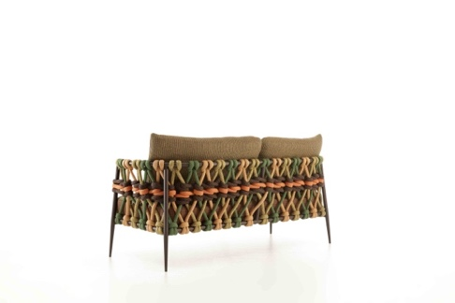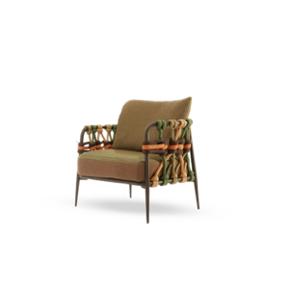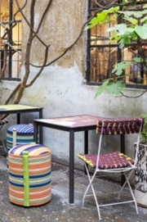
Nodo Italia (Big Stone and Small Stone Poufs | Rugs)
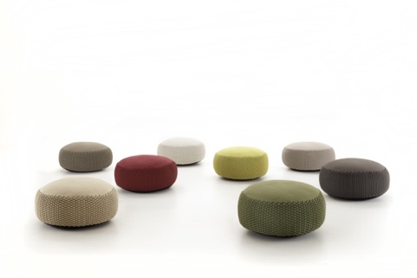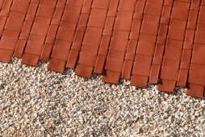

Press Office and Digital PR: TAConline www.taconline.it
Press contact Paola Staiano staiano@taconline.it
Company: NODO ITALIA nodoitalia.com info@nodoitalia.com

