CANTERBURY, elegance and technology in the tradition of GRAFF
Canterbury, completely designed by GRAFF, is a traditional collection of faucets, tub fillers, (including floor-mounted tub fillers), shower systemsand a variety of accessories.
Finishes includepolished chrome, with an indisputable resistance and a splendid mirror effect characterized by the perfection of the curves and lines – as well as Steelnox® (satin nickel), polished nickel, olive bronze, antique brushed brass and gold.

Canterbury satisfies the desire of a classical bathroom while adding a breath of modern flair; making it a fashionable choice for the bath.
Canterbury can also be constructed to meet the drinking water and low flow requirements for any specification.
As with all GRAFF products,Canterbury offers a five year warranty
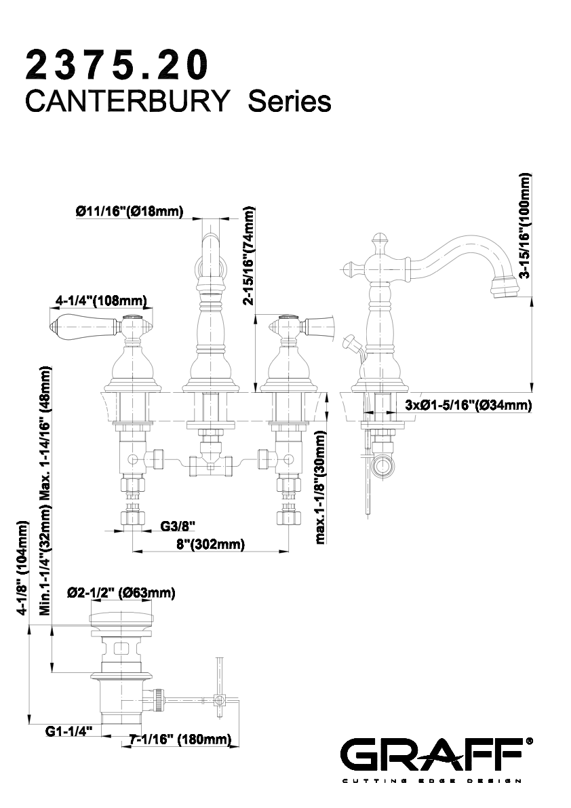

GRAFF
Headquartered in Milwaukee, Wisconsin, USA, and with locations throughout Europe, GRAFF is recognized globally for its trend-setting products and unique vision. Supported since 1922 by extensive plumbing and hardware manufacturing experience, GRAFF offers a wide range of contemporary, transitional and traditional styling.
Utilizing the latest manufacturing technology and supported by a tradition of old-world craftsmanship, GRAFF’s commitment to creating cutting-edge, premium-quality fixtures is evident in each and every product. GRAFF employs over 1000 dedicated professionals and has control over the full production process, making it truly a vertically-integrated manufacturer.
GRAFF’s parent company, Meridian International Group, is an ISO 9000 certified company comprised of five business units. Meridian strategically combines a strong European OEM faucet and valve production history with over 30 years of American excellence in OEM machined parts. Meridian's prestigious customer list includes many global plumbing companies as well as the number one manufacturer of American motorcycles.

Press&PR: tac comunic@zione
Via Costanza 26 – 20146 Milano
tel. +39 02 48517618
fax + 39 02 462037
e-mail: press@taconline.it
sito web: www.taconline.it
Contatto: Paola Staiano – Monica Robustellini

GRAFF HEADQUARTERS
3701 W. Burnham Street Milwaukee, Wl 53215, USA Toll free: 800 954 4723 (graf), fax: 414 649 9852
email: sales@graff-faucets.com www.graff-faucets.com

GRAFF EUROPE - WEST
Via Aretina 159 50136 Florence ITALY Tel: +39 055 9332115, fax: +39 055 9332116
email: info@graff-mixers.com www.graff-mixers.com

GRAFF CENTRAL EUROPE
32-080 Zabierzów Krakowska 280 KBP100, Poland Tel. +48 12 257 60 30, fax. +48 12 257 60 31
email: graff@graff-mixers.com www.graff-mixers.com

