PRESS RELEASE ISH 2015

GRAFF: INTERIOR DESIGN STEPS INTO THE BATHROOM
With the Ametis Ring, winner of the Interior Design Best of Year Award and Dressage, GRAFF presents the perfect bathroom.

For GRAFF, design is a natural attitude, a passion that has lasted for years and over the years has consolidated, managing to combine ideas, cultures, craftsmanship, materiality and experimentation. The company presents its new creations dedicated to the world of the bathroom, able to interpret the design and the home space in a unique language through new formal expressions.

GRAFF displays the full range of two major projects that are born from the collaboration with Davide Oppizzi and Nespoli e Novara Design Studio. The first one is the award-winning Ametis Ring, the latest creation to complement the original design collection for the bathroom and the shower; Dressage is the other project, the first GRAFF collection of bathroom furniture, manufactured in solid wood and DuPont ™ Corian®.

GRAFF products are true “across-the-board” elements that live in the house and become an integral part of it. Design products that can meet the different tastes of the audience while remaining consistent with their own history and concept.

AMETIS RING
Ametis Ring, winner of the Interior Design Best of Year Award in the Bath Fittings category, in December 2014, is certainly an avant-garde project, recognizable by its fluid design and light effect, a representation of the merger between the universe and oceans; almost a futuristic "ode" to high design. On the basis of an online voting system administered by architects, design firms and internationally renowned designers, Ametis Ring was selected among over 2000 exclusive projects.
Oppizzi’s intention was to create, for GRAFF, a collection of unique items that reveal the deep connection between existence and the nature around us, in which the intrinsic value of the objects, inherent in matter, transfers emotions to be enjoyed each and every moment.

Drawing inspiration from his experience with water and colors, from the waves movement and from the old tradition of Japanese typography, executed with a single brush stroke, this new collection transforms water, such a precious element, in a hymn to purity that allows you to get closer to the most intimate expressions of the soul.

Ametis Ring is a simple but, at the same time, very refined object: the project incorporates many features of high-tech engineering and uses a full-spectrum LED RGB color therapy lighting system with 6 colors. The showerhead main body, completely empty inside, is internally designed so that the rainfall flows in a perfect angle, merging exactly below the center of the ring. Manufactured in steel, for a long life guarantee, Ametis Ring integrates a LED system that gives the object a new dimension thanks to indirect light, a still not widely used concept in bathroom design.

The showerhead has two distinct functions: the user can easily switch from the "rain" effect to the "waterfall" jet. Available in chrome, matte black and matte white (both obtained through a ​powder coating process).

For more information visit: www.graff-mixers.com

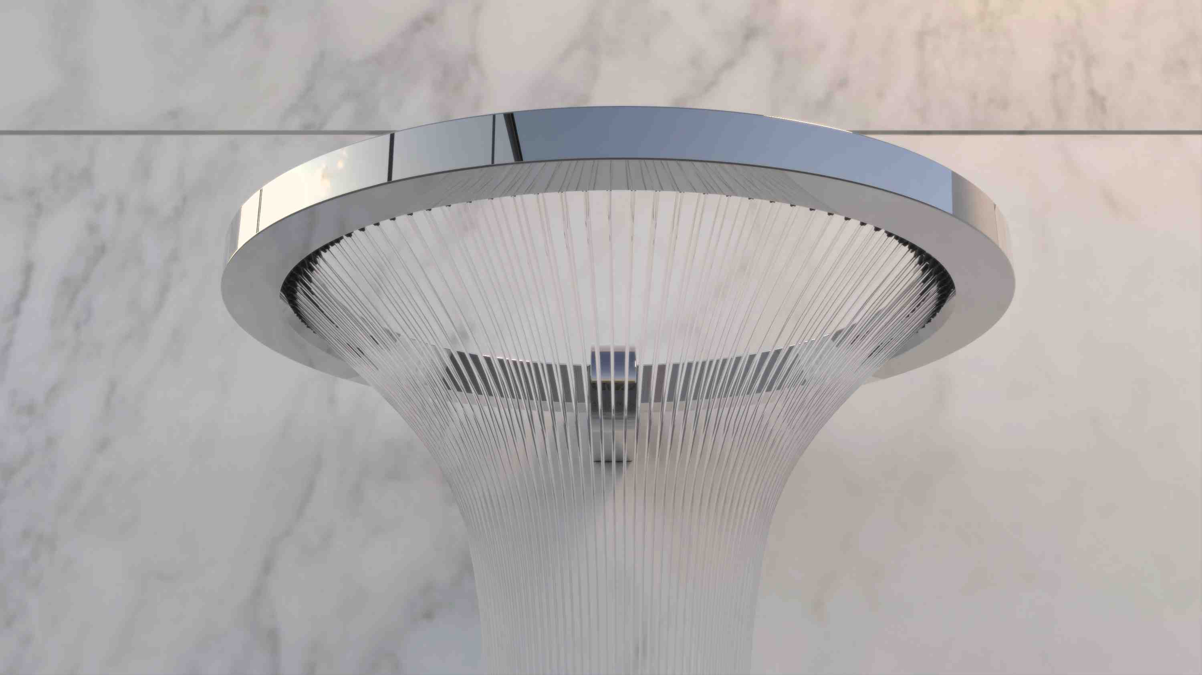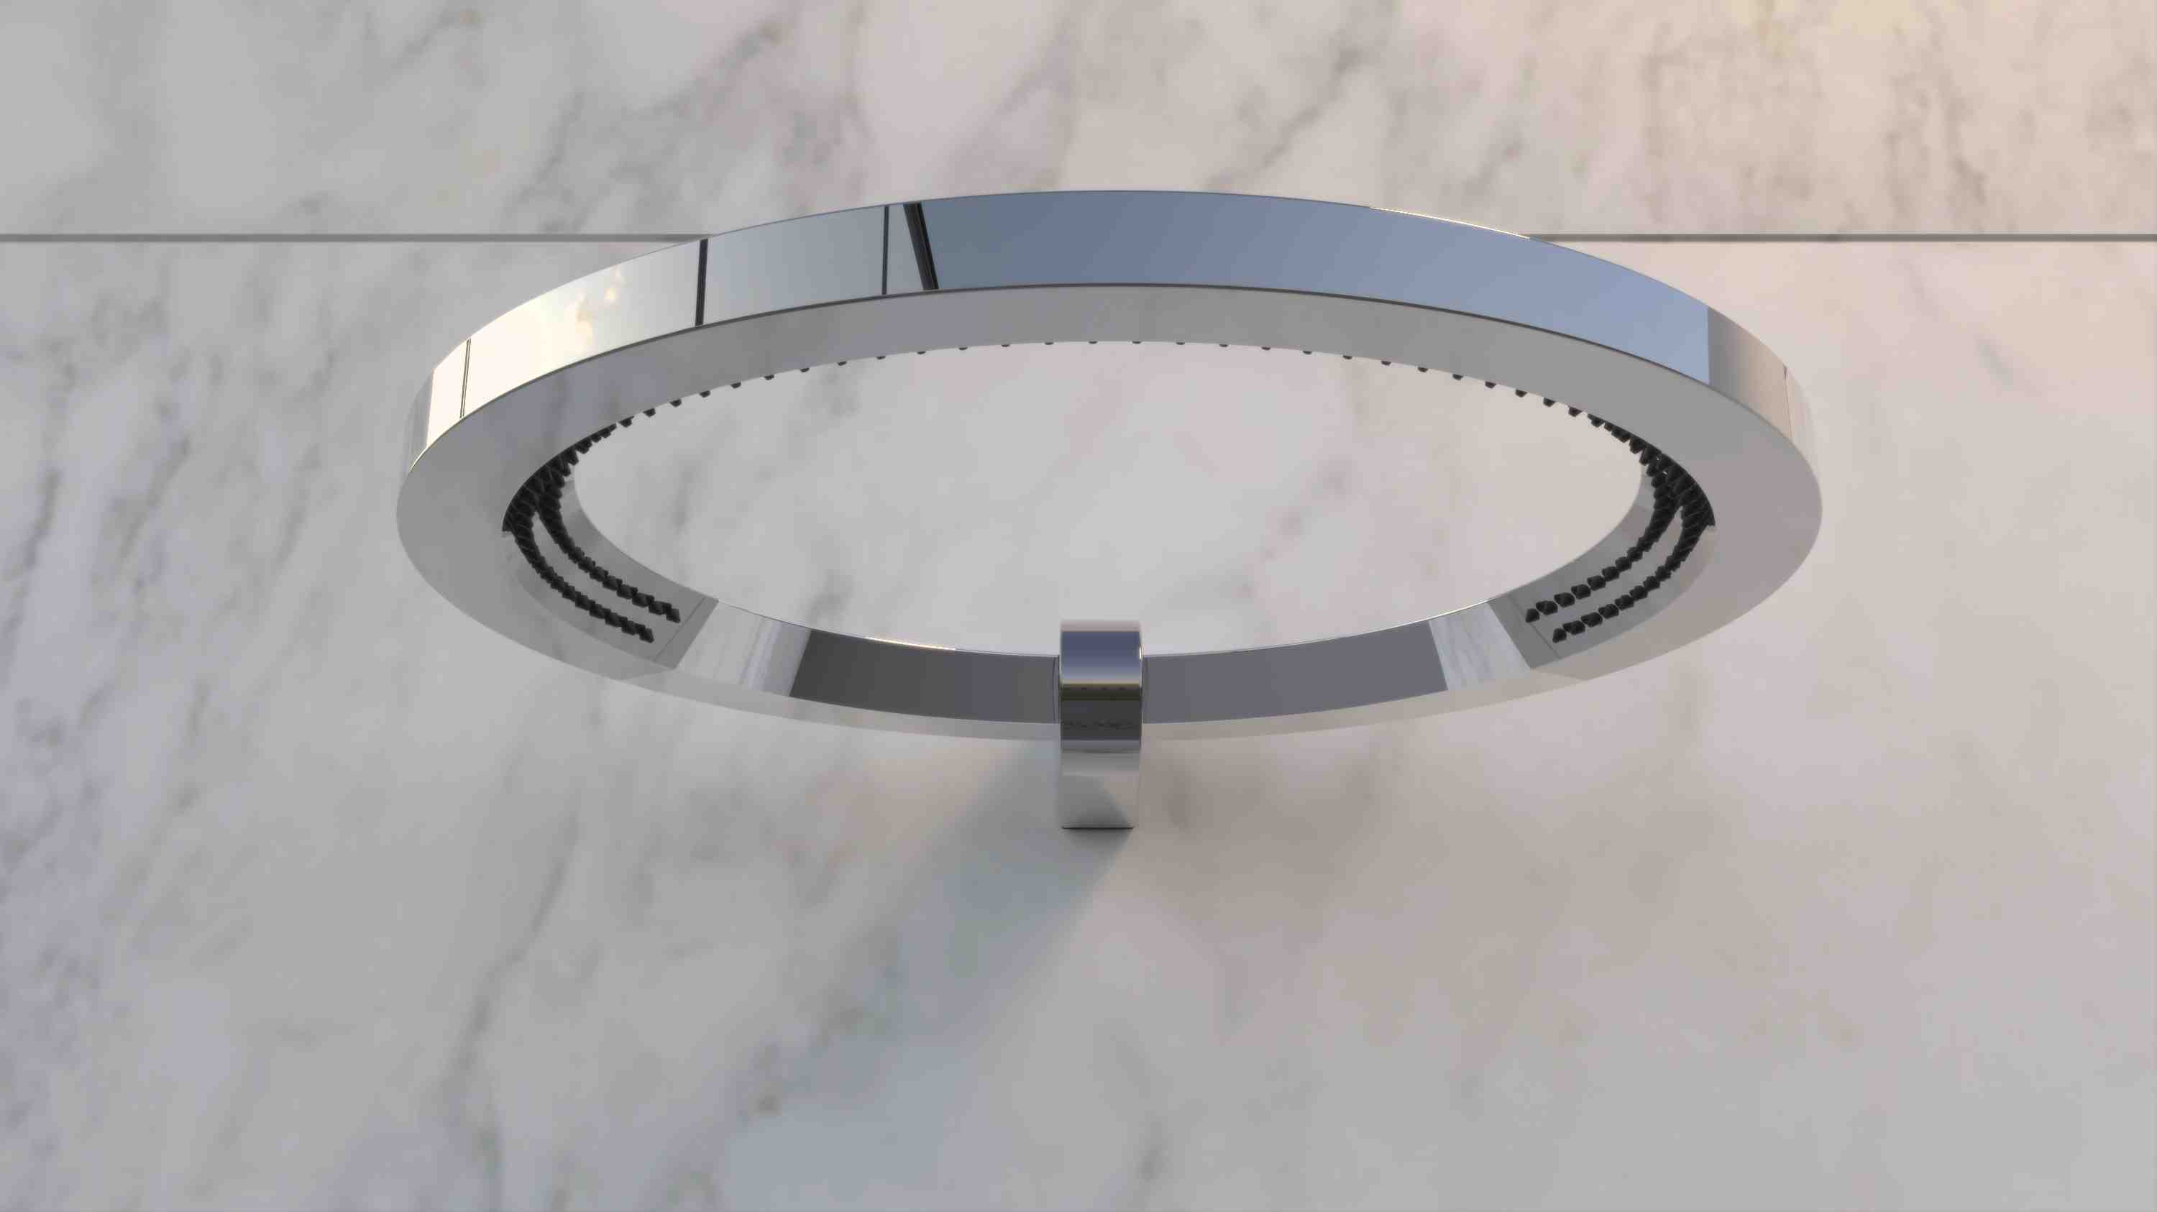
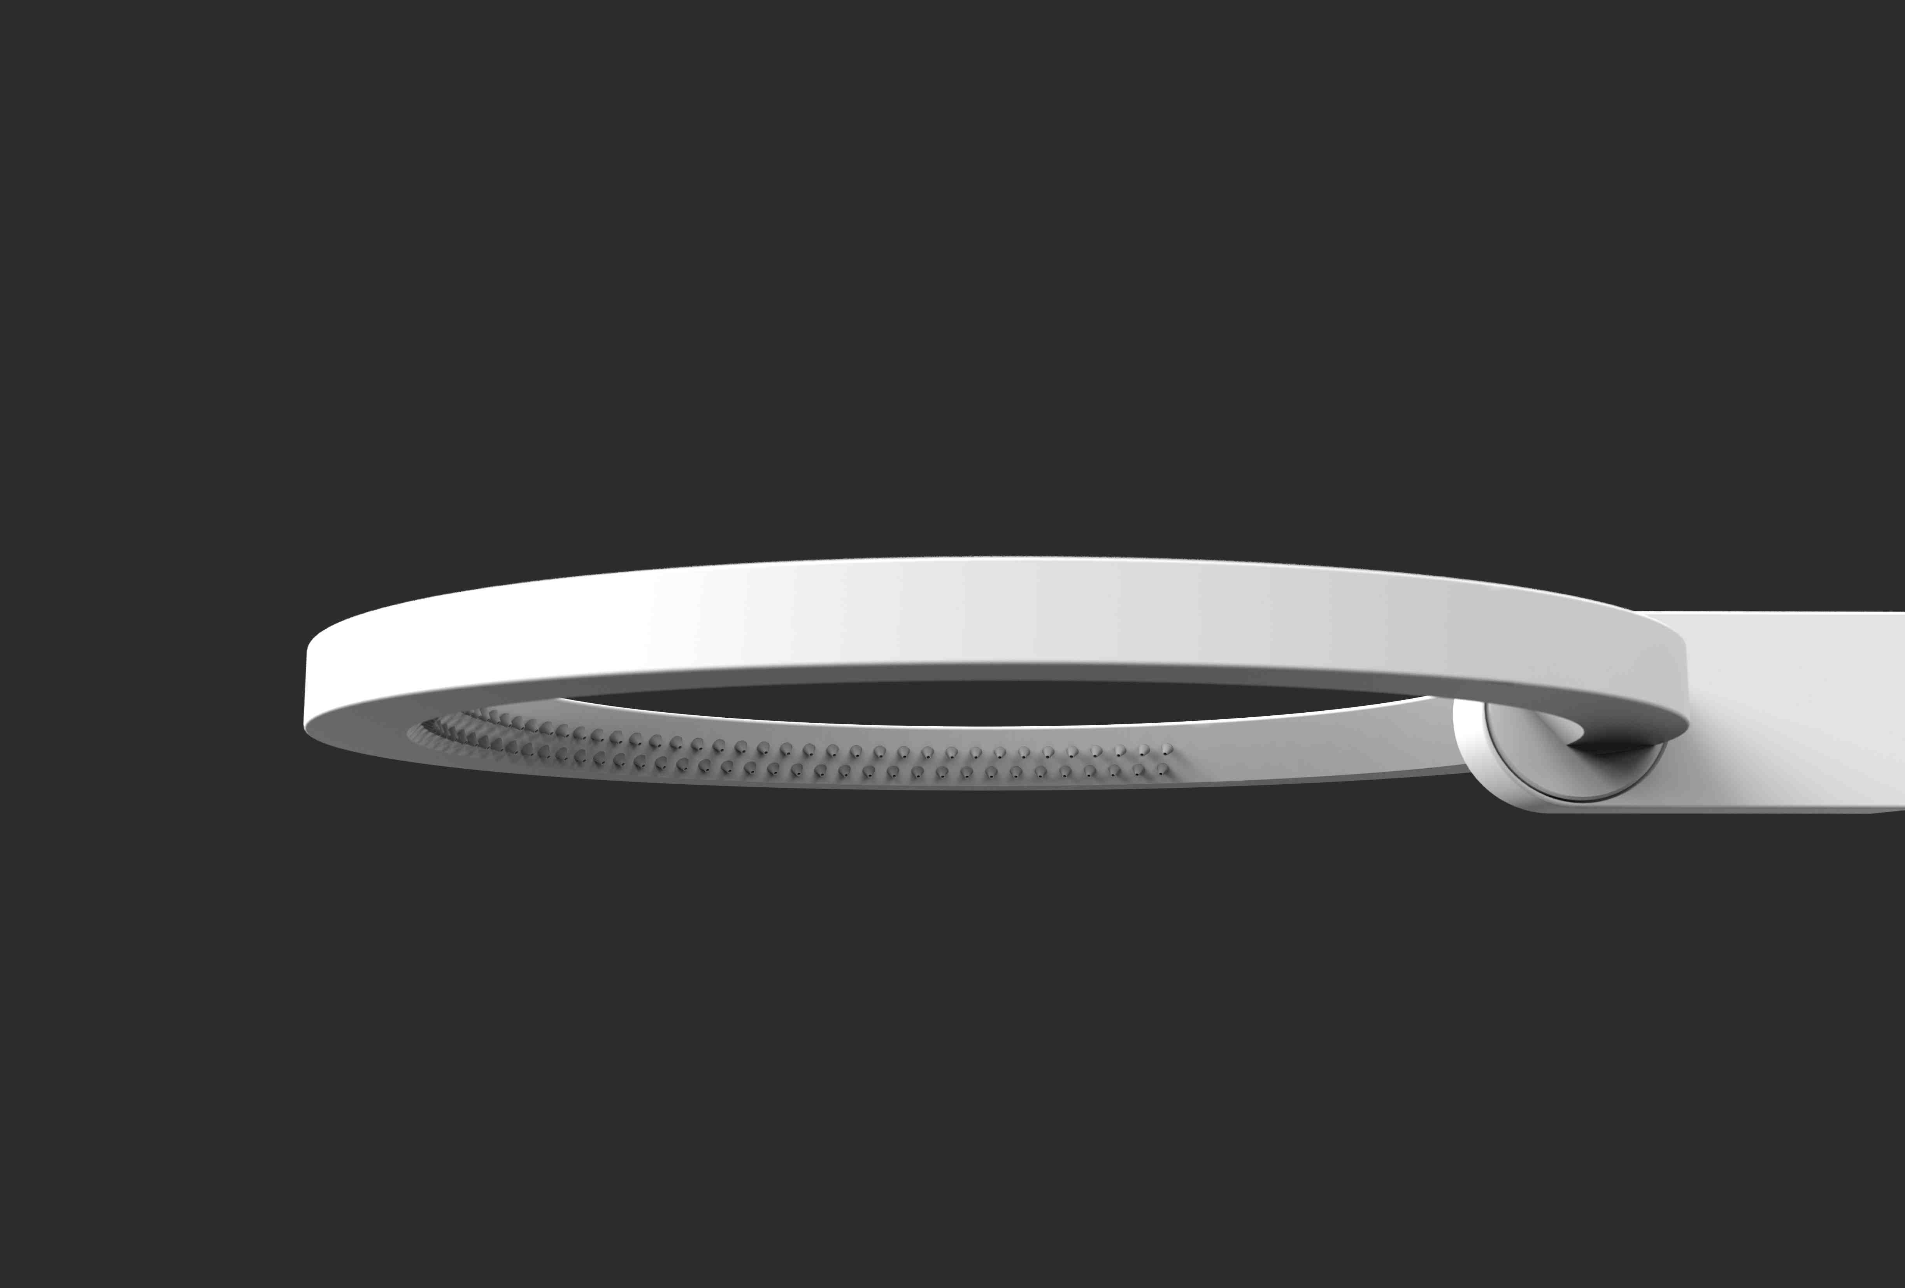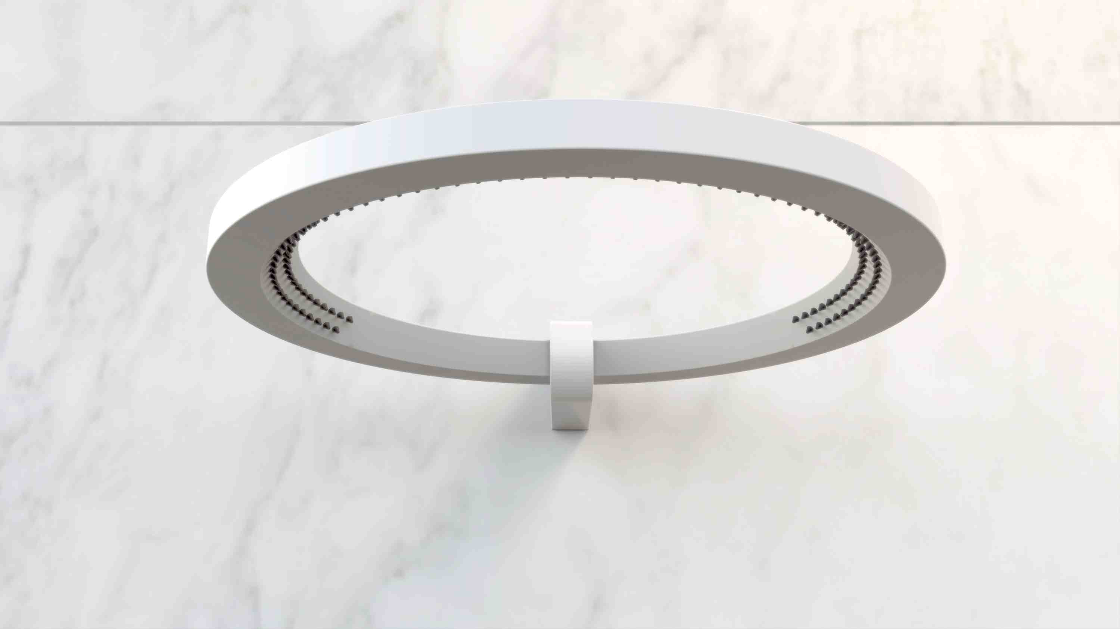

DRESSAGE design studio Nespoli e Novara
From the creative hand of designers Nespoli and Novara, Dressage is a collection of furniture with a strong handicraft and manufacturing element, where the warmth of tradition, transmitted by the use of solid wood, meets with the functionality of an innovative material such as DuPont Corian®.
The strong artisan component represents one of the distinctive elements of a collection designed for the bathroom but inspired by the world of interior design. Dressage is harmony, geometry, versatility. The main furniture piece is a free-standing unit in solid wood, compact and functional.

All the elements for the water supply and discharge are housed inside, invisible from the outside. It can be equipped with a sink in solid wood and DuPont ™ Corian® and accompanied by a shelf, a towel hook, a set of drawers and a rotating mirror.

The tub is constituted from a sheet of thermoformed DuPont ™ Corian® coupled with solid wood. Its transverse cut creates an invitation to enter the bath and the higher zone allows the user to stretch and relax. The tub is designed to live in the center of the room space, in its free-standing version with head-rest and a shelf for holding cosmetics.
The craftsmanship “cut” is also perceived from the presence of two other coordinated elements: the stool and the clothes hanger. Each object is self-sufficient and versatile and can become part of an overall theme that can be gradually composed over time, involving the main rooms of the house.
Dressage is available in the following finishes: Canaletto walnut, oak, wenge, matte white.

For more information visit: www.graff-mixers.com

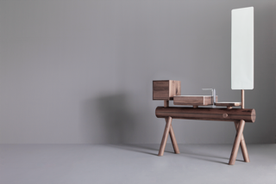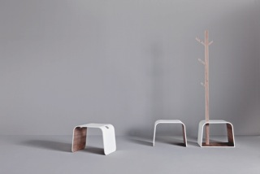
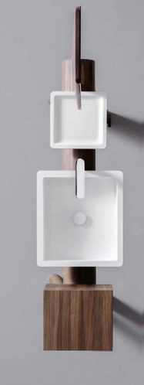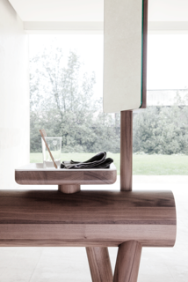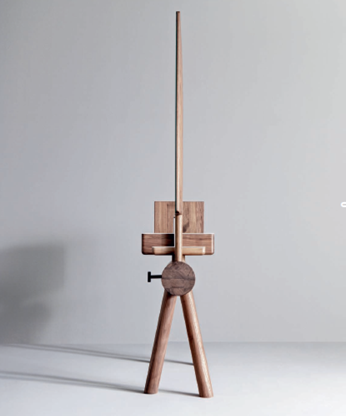
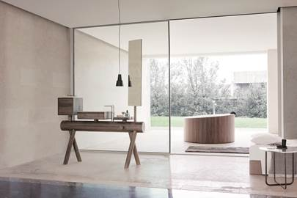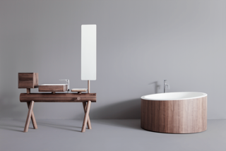

COMPANY PROFILE
Headquartered in Milwaukee, Wisconsin, USA, and with locations throughout Europe, GRAFF is globally recognized for its trend-setting products and unique vision. Supported since 1922 by extensive plumbing and hardware manufacturing experience, GRAFF offers a wide range of contemporary, transitional and traditional styling. Utilizing the latest manufacturing technology and thanks to a tradition old-world craftsmanship, GRAFF’s commitment to creating cutting-edge, premium-quality fixtures is evident in each and every product.
GRAFF employs over 1000 dedicated professionals and has control over the full production process, making it a truly vertically-integrated manufacturer. GRAFF’s parent company, Meridian International Group, is an ISO 9000 certified company, comprised of several business units. Meridian strategically combines a strong European OEM faucet and valve production history with over 30 years of American excellence in OEM machined parts. Meridian's prestigious customer portfolio includes many global plumbing companies as well as the number one American manufacturer of motorcycles.

Press&PR Italia: tac comunic@zione
di Paola Staiano e Andrea G. Turatti
Milano- Genova
tel. +39 02 48517618 – 0185 351616
fax + 39 02 462037
e-mail: press@taconline.it
sito web: www.taconline.it
GRAFF EUROPE
Via Aretina 159,50136 Florence - ITALY
Tel: +39 055 9332115,
fax: +39 055 9332116
email: info@graff-mixers.com
www.graff-mixers.com

