PRESS RELEASE DESIGN WEEK 2015

GRAFF: INTERIOR DESIGN STEPS INTO THE BATHROOM

In preview of Milano Design Week 2015, GRAFF offers a project that is born from the collaboration with David Oppizzi; it complements the original design collection for the bathroom and the shower.

Ametis Ring, winner of the Interior Design Best of Year Award in the Bath Fittings category, in December 2014, is certainly an avant-garde project, recognizable by its fluid design and light effect, a representation of the merger between the universe and oceans; almost a futuristic "ode" to high design.

Oppizzi’s intention was to create, for GRAFF, a collection of unique items that reveal the deep connection between existence and the nature around us. His approach is undoubtedly one of handicraft and manufacturing, which goes beyond the intrinsic value of the objects, relying on the transfer of emotions, inherent in matter, as a living vibration to enjoy in each and every moment.

Drawing inspiration from his experience with water and colors, from the waves movement and from the old tradition of Japanese typography, executed with a single brush stroke, this new collection transforms water, such a precious element, in a hymn to purity that allows you to get closer to the most intimate expressions of the soul.

Ametis Ring is a simple but, at the same time, very refined object: the project incorporates many features of high-tech engineering and uses a full - spectrum LED RGB color therapy lighting system with 6 colors. Manufactured in steel, for a long life guarantee, Ametis Ring integrates a LED system that gives the object a new dimension thanks to indirect light, a still not widely used concept in bathroom design.

The showerhead has two distinct functions: the user can easily switch from the "rain" effect to the "waterfall" jet. Available in chrome, matte black and matte white (both obtained through a ​powder coating process).

For more information visit: www.graff-mixers.com

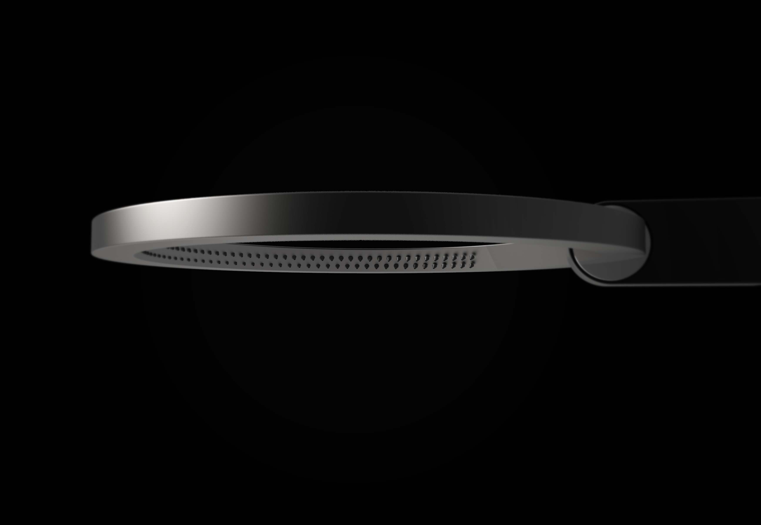

COMPANY PROFILE
Headquartered in Milwaukee, Wisconsin, USA, and with locations throughout Europe, GRAFF is globally recognized for its trend-setting products and unique vision. Supported since 1922 by extensive plumbing and hardware manufacturing experience, GRAFF offers a wide range of contemporary, transitional and traditional styling. Utilizing the latest manufacturing technology and thanks to a tradition old-world craftsmanship, GRAFF’s commitment to creating cutting-edge, premium-quality fixtures is evident in each and every product. GRAFF employs over 1000 dedicated professionals and has control over the full production process, making it a truly vertically-integrated manufacturer. GRAFF’s parent company, Meridian International Group, is an ISO 9000 certified company, comprised of several business units. Meridian strategically combines a strong European OEM faucet and valve production history with over 30 years of American excellence in OEM machined parts. Meridian's prestigious customer portfolio includes many global plumbing companies as well as the number one American manufacturer of motorcycles.

Press&PR Italia: tac comunic@zione
di Paola Staiano e Andrea G. Turatti
Milano- Genova
tel. +39 02 48517618 – 0185 351616
fax + 39 02 462037
e-mail: press@taconline.it
sito web: www.taconline.it
GRAFF EUROPE
Via Aretina 159,50136 Firenze - Italia
Tel: +39 055 9332115,
fax: +39 055 9332116
email: info@graff-mixers.com
www.graff-mixers.com

