PRESS RELASE

GRAFF presents an iconic Shower collection during Salone del Mobile in Milan

Art of the Bath Gallery is the new emotional journey undertaken by GRAFF, which will have its leading appearance during the next Salone del Mobile in Milan. The company will present its products in a decontextualized, almost metaphysical and abstract, setting characterized by strong ties with art.

Shower systems, faucets, showerheads and accessories communicate among themselves, creating interesting, colorful images together with the elements of the latest GRAFF collections.

Each piece, in its own way, is the protagonist of the valuable “mise en scene”, and reflects a specific aesthetic philosophy: the search for essentiality, free of excess. If a company's ability lies in capturing a form and turning it into a trend, GRAFF accomplishes the task in an excellent manner.

To tie a brand like GRAFF to art has been very natural. The products of the American company, recognized worldwide for his unique vision and originality of its collections, are developed with the highest quality materials, reflecting the long manufacturing tradition acquired since 1922.

GRAFF’s new proposals include a complete presentation for the shower area and an extremely versatile wellness program. The multiple suggestions of this program will offer an answer to every design need, giving a solution to those who seek aesthetics, functionality, technology, eco-sustainability and performance.

The wellness program includes also a new range of modular thermostatic sets for simultaneous control of several water outlets and a new range of showerheads.

From watching videos and listening to music to enjoying color therapy, the Aqua-Sense shower system provides a multimedia experience through the use of a technological touchpad.

The Ametis Ring supplies the dual function of waterfall and rain shower settings combined with color therapy, for those looking for strong aesthetics and technological innovation.

Another innovation in GRAFF offerings consists of a series of modern and classic free-standing washbasins and bathtubs. GRAFF continues to prove itself as a manufacturer of excellence, capable of offering new styles for the whole bathroom.

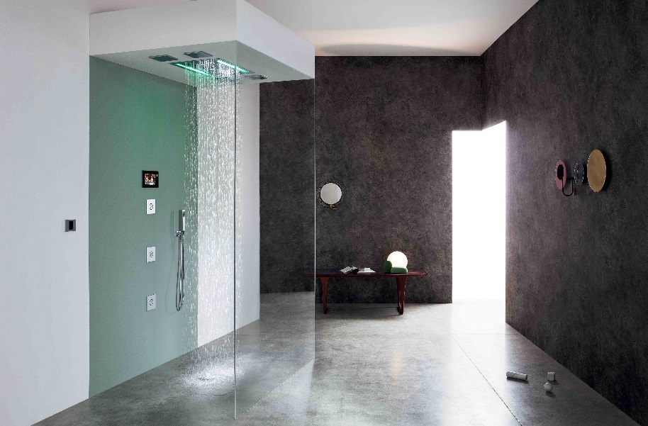

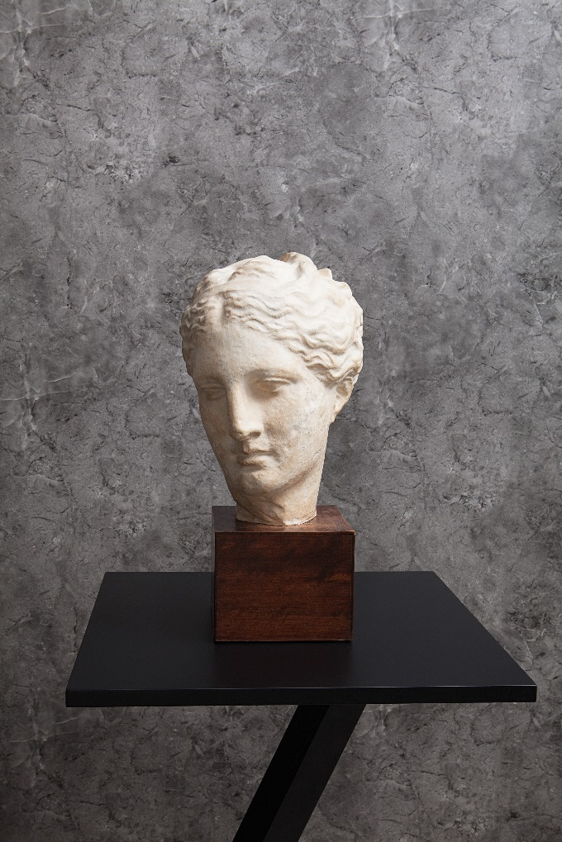

Per informazioni e immagini in alta risoluzione
Ufficio Stampa:
tac comunic@zione milano|genova
tel +39 02 48517618 | 0185 351616
press@taconline.it | www.taconline.it
GRAFF EUROPE
Via Aretina 159, 50136 Florence - ITALY
Tel: +39 055 9332115,
fax: +39 055 9332116
email: info@graff-mixers.com
www.graff-faucets.com

