Press release
January 2018

PLANIT, A DYNAMIC COMPANY FROM ALTO ADIGE, CONTINUING IN ITS SUPPORT in terms of PERSONAL WELLNESS AND CARE, CONTRIBUTING TOWARDS THE CREATION OF AN OASIS IN NATURE: THE SEEHOF HOTEL

The huge growth in tourism in Trentino/ALTOADIGE is tangible, so much so that in a recent article by the New York Times, it is listed among the 52 recommended destinations for 2018.
“The region has succeeded in using and exploiting an obstacle such as the absence of airplane connections to its advantage”, the magazine congratulates “transforming into an uncontaminated and tranquil area for all of those who want to relax among the limpid skies and unexplored areas and the wellness hotel”.

The wellness hotels mentioned by the magazine include the new Seehof, opened in the spring of last year, rising close to a small lake on the mountains in the heart of Val d’Isarco, submerged in greenery among apple trees and fir trees, just a few kilometers from Bressanone and it has worked with PLANIT for the creation of the bathroom areas.

PLANIT is once again at the forefront in order to embellish the bathroom areas with its made-to-measure washbasin tops in Corian® in the Canyon finish.
Again in the washbasin area it has also created a Corian® finish for a flap cover with wood inside, holding a mirror and a compartment: an extra pamper for personal care.

Combining a high level of technology and attention to design, PLANIT offers an emotional experience through its two decades of specialization in the production of Corian®, well and truly a material undergoing constant development.
The surface embellished by architectural details that combine with clean and essential lines, is characterized by a whole range of features that make it perfect for indoor and outdoor environments in which it is inserted: velvety and warm to the touch, eco-sensitive and malleable in a completely personalized manner.
The project is by a team of architects and designers from studio noa*. The keyword of the project, also representing the philosophy of the group is “emergence”, where the value of everything is more than the total of each single element, an approach and a holistic strategy.

PLANIT an Italian company specialised for more than twenty years in the processing of Solid Surface – especially Corian® DuPontTM, claiming numerous collaborations with prestigious international designers and with furnishing companies.
The objective of the company is to combine artisan skills with a high level of technological and innovative technical efficiency. Apart from the finished product, PLANIT also offers a before and after sales service providing consultancy in the choice of materials and technologies available in order to complete even the most ambitious project. The flexibility of the production processes and the advanced plants allow for the creation of unique made-to-measure pieces, but also small productions. PLANIT has become a leader in the field of bathroom furnishings with its own collections of high level washbasins, shower base and bathtubs. The Contract field represents one of the main business sectors of the company. Fittings for public areas include hotel, bar and shop furnishings as well as public buildings and products for hospital constructions. They also create work surfaces for kitchens made for carpenters and furniture workshops.

SOME IMAGES AVAILABLE FOR THE PRESS
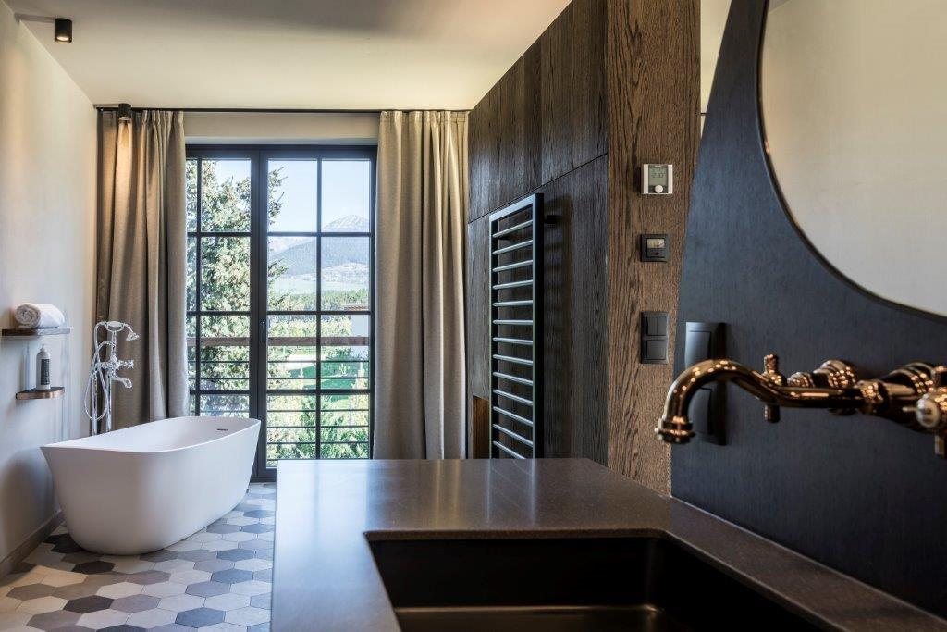

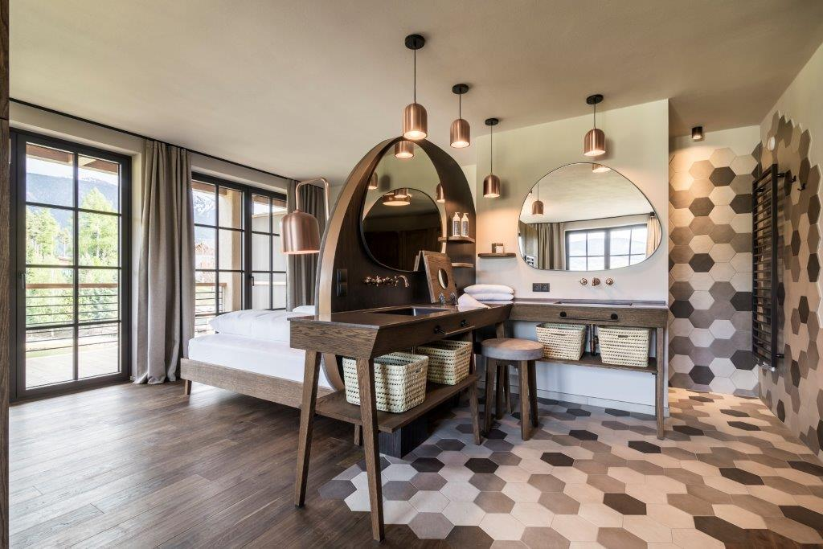

For further information and information
tac comunic@zione milano|genova
tel +39 02 48517618 | 0185 351616 press@taconline.it | www.taconline.it
Silvia Gabalin c/o PLANIT srl
Via Nazionale 61 – 39040 Ora (BZ) Italia
Tel. +39 0471 811490 - Fax +39 0471 811494 - gabalin@planit.it - www.planit.it

