PRESS RELASE

GRAFF presents an iconic art gallery at the next edition of Salone del Mobile in Milan

Art of Bath Gallery is the new artistic and emotional journey undertaken by GRAFF, an original, visual leitmotiv displayed at next Salone del Mobile in Milan.
Created by Davide Oppizzi in partnership with D-Cube Design, the GRAFF booth at the International Bathroom Exhibition is a veritable art gallery. Its visitors are invited to see, from a modern angle, classical artworks in which history, art, symbology and sensuality, past and present, mingle.

GRAFF’s artistic products definitely connect with iconic artworks in Milan. The latter are reinterpreted by Vincent Calmel, an internationally known photographer, specialized in portraying eminent, international personalities such as Monica Bellucci, Jean-Paul Belmondo, Charlotte Gainsbourg, Bertrand Blier etc.
The display revolves around five pictures: the Birth of Venus by Botticelli, Death of Marat by Jacques-Louis David, La Grand Odalisque by Ingres, Ophelia by John Everett Millais and Gabrielle d'Estrées by the Fontainebleau school. These images have a direct parallel with GRAFF’s design, due to the timeless, aesthetic forms characterizing the company, which, nonetheless, is capable of catering for modern taste as well.
The architecture of GRAFF’s booth is serious and monumental at the same time. Spaces are customized, room-by-room. Shower systems, faucets, showerheads and accessories connect, weaving interesting, colorful and iconic threads. The result is a strong and vibrant “canvas” depicting the most salient items from the latest GRAFF collections.
Each piece proves to be, in its own way, the protagonist of such invaluable “mise en scène”, aligning itself with a specific aesthetic philosophy: the search for essentiality, free of ornamentation. If demonstrating adroitness and bravura for a company coincides with being capable of capturing a shape and turning it into a trend, GRAFF is a master of it.

Tying GRAFF to art comes natural: on the one hand, the American company is hugely esteemed all over the world for its unique vision and for the originality of its trend-setting and trend-forecasting collections. On the other hand, its products are veritable works of art whose execution implies the use of the highest quality materials in agreement with the long manufacturing tradition acquired since 1922.

Moreover, art, as well as home décor, is at the very foundation of fine living. “We have chosen the emblematic and high-impact iconography of Vincent Calmel’s works as the new display concept for 2016, because we believe that real beauty springs from timeless

and classical shapes, reinterpreted and adapted to the changing contexts with which we are confronted today ,” says Emanuela Tavolini, Sales Director for GRAFF Europe.
“This is the goal we want to achieve through the design of GRAFF products, by introducing iconic objects with a strong aesthetic content in today's world of bathroom design,” Tavolini concludes.

GRAFF’s innovation springs from a solid tradition, inspired by the concept of classical beauty, seen with a modern twist, just like Vincent Calmel’s work. At the International Bathroom Exhibition, the atmosphere of a veritable art gallery comes true. An art gallery hosting as many artists as much time passes by.

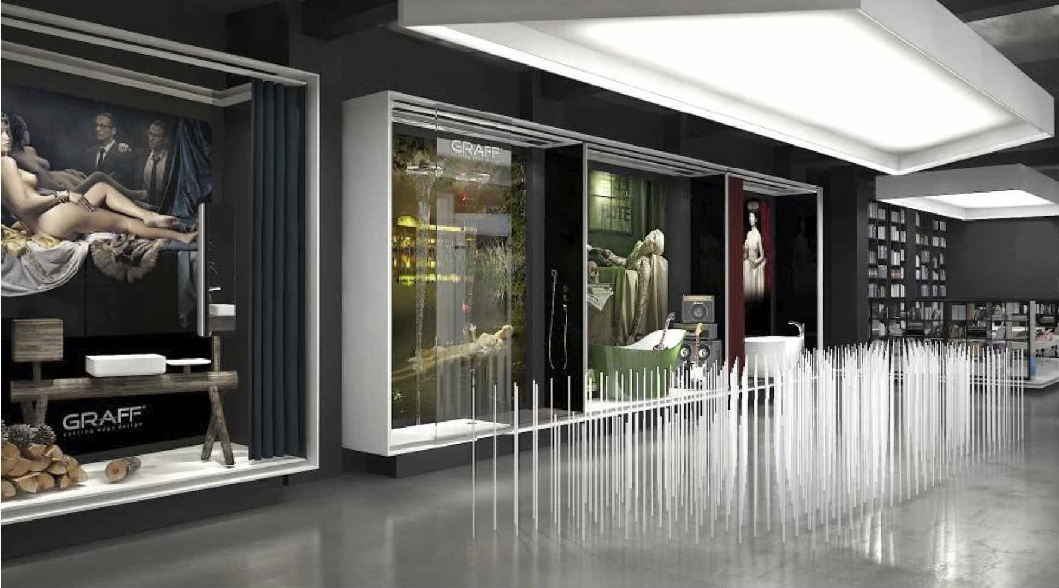

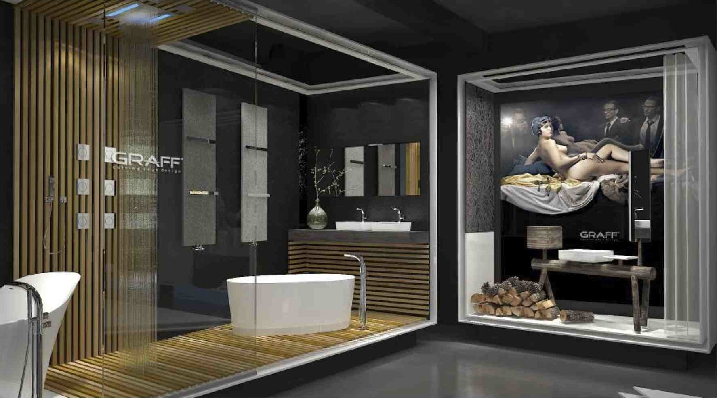

GRAFF EUROPE
Via Aretina 159, 50136 Florence - ITALY
Per informazioni e immagini in alta risoluzione
Ufficio Stampa:
tac comunic@zione milano|genova
tel +39 02 48517618 | 0185 351616
press@taconline.it | www.taconline.it
Tel: +39 055 9332115,
fax: +39 055 9332116
email: info@graff-mixers.com
www.graff-faucets.com

