Press release
Salone del Mobile 2016

GRAFF SHOWERS, artistic icons at the
International Bathroom Exhibition

Unique vision, international design, precise materials, manufacturing tradition.
These are some of the secrets of the new GRAFF SHOWER offerings, a project that includes a complete collection for the shower area, an eclectic and versatile wellness program with solutions for every need and original answers for those who seek aesthetics, functionality, technology, eco-sustainability and performance.

The GRAFF SHOWER program is the result of a modern and innovative approach to the industry. It includes several modular thermostatic elements for simultaneous control of separate jets, and a new range of showerheads with innovative functions.

From watching videos and listening to music to enjoying color therapy, the Aqua-Sense shower system provides a multimedia experience through the use of a technological touchpad.
The Ametis Ring supplies the dual function of waterfall and rain shower settings combined with color therapy, for those looking for strong aesthetics and technological innovation.

As part of the project "Art of the Bath Gallery", which has its highest expression at Salone del Mobile in Milan, GRAFF collections are decontextualized in a setting which is almost metaphysical, abstract and characterized by strong ties with art. Showers faucets, showerheads, and accessories connect, weaving interesting, colorful and iconic threads.
"To tie a brand like GRAFF to art has been a very natural step," says Emanuela Tavolini, GRAFF Europe Sales Director. "The decision to set our collections in a real art gallery represents the spirit with which we develop our products: in terms of aesthetics the GRAFF wellness program carries a great iconic impact, reinterpreted in a modern way, thanks to the technology of the multifunction showers. In this way GRAFF creates a combination of aesthetics and functionality, two elements that, for us, should never be mutually exclusive (opposite). We think of the wellness area in the house as a luxury accessible to all. Our aim is to enable our customers who are looking for uniqueness and excellence, to enjoy, in their homes, an oasis of well-being, pleasure, charm, elegance and balance. The implicit unity that we have created between art and our bathroom furniture collections show, once again, that GRAFF is where beauty and design thrive”.

Enclosed images:

AQUA-SENSE
Ceiling mounted showerhead with rain and mist functions.
Dimensions: 500 x 350 cm. Material: Stainless steel

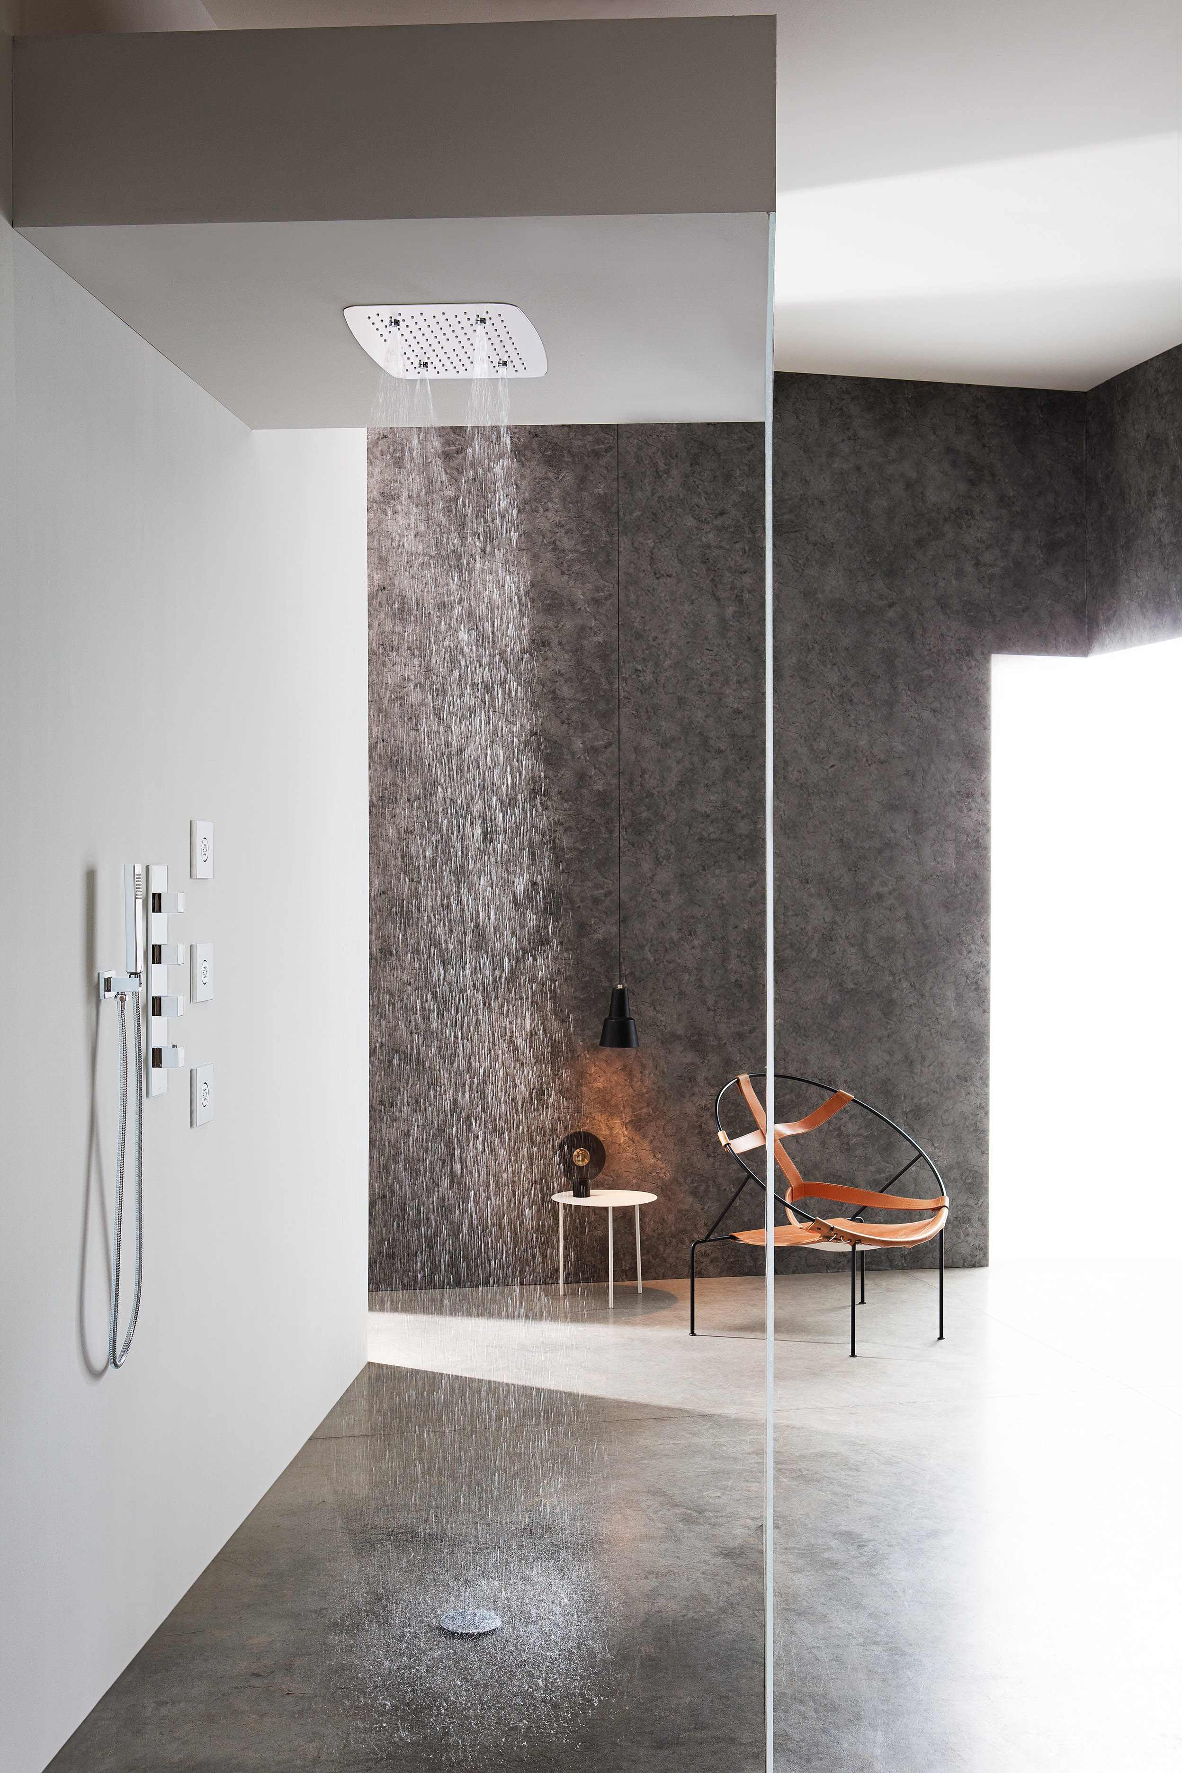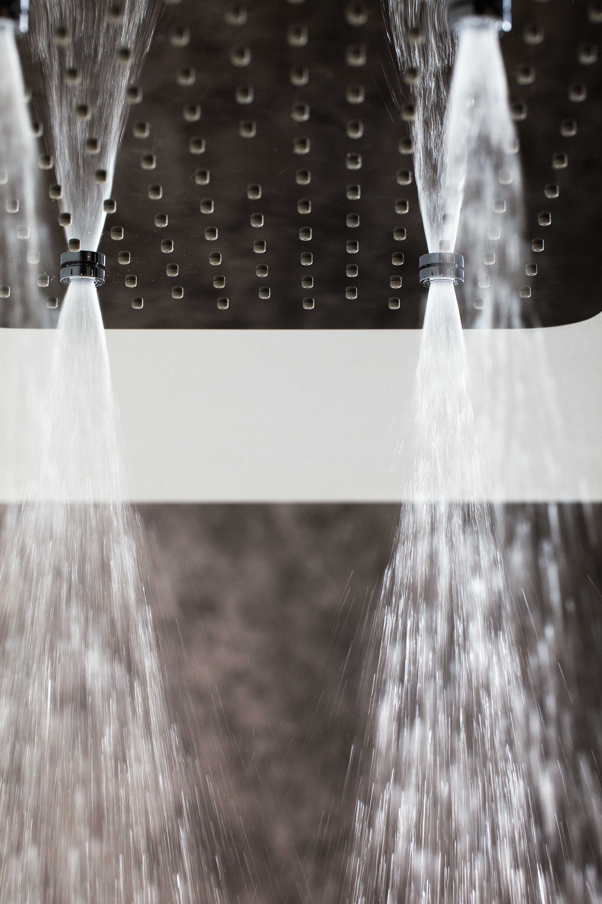

AQUA-SENSE
Ceiling mounted showerhead with rain and chromotherapy functions. Supplied with remote control. Dimensions: 500 cm diameter. Material: Stainless steel

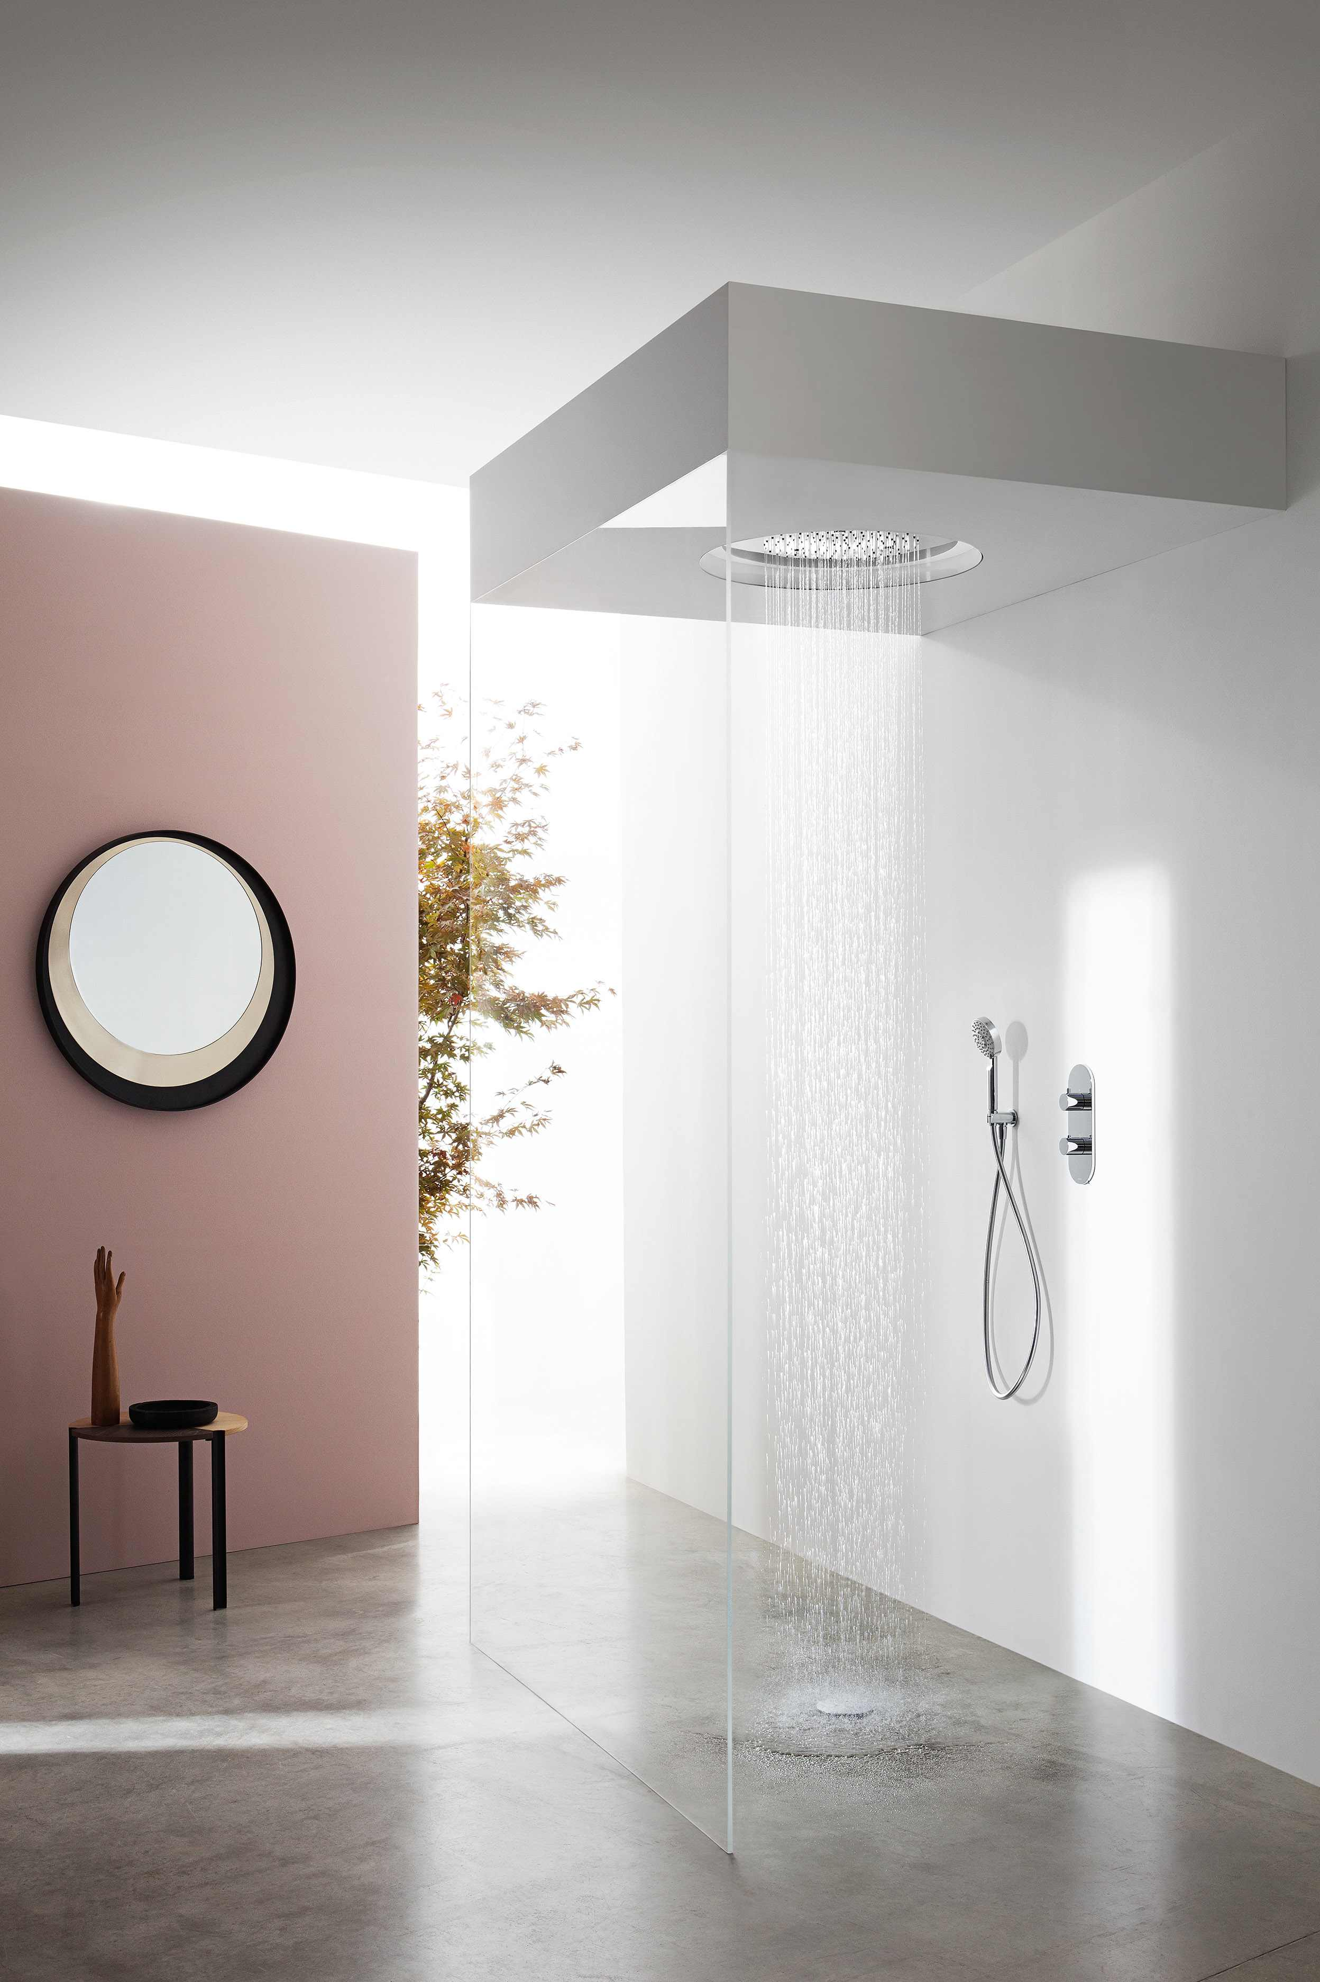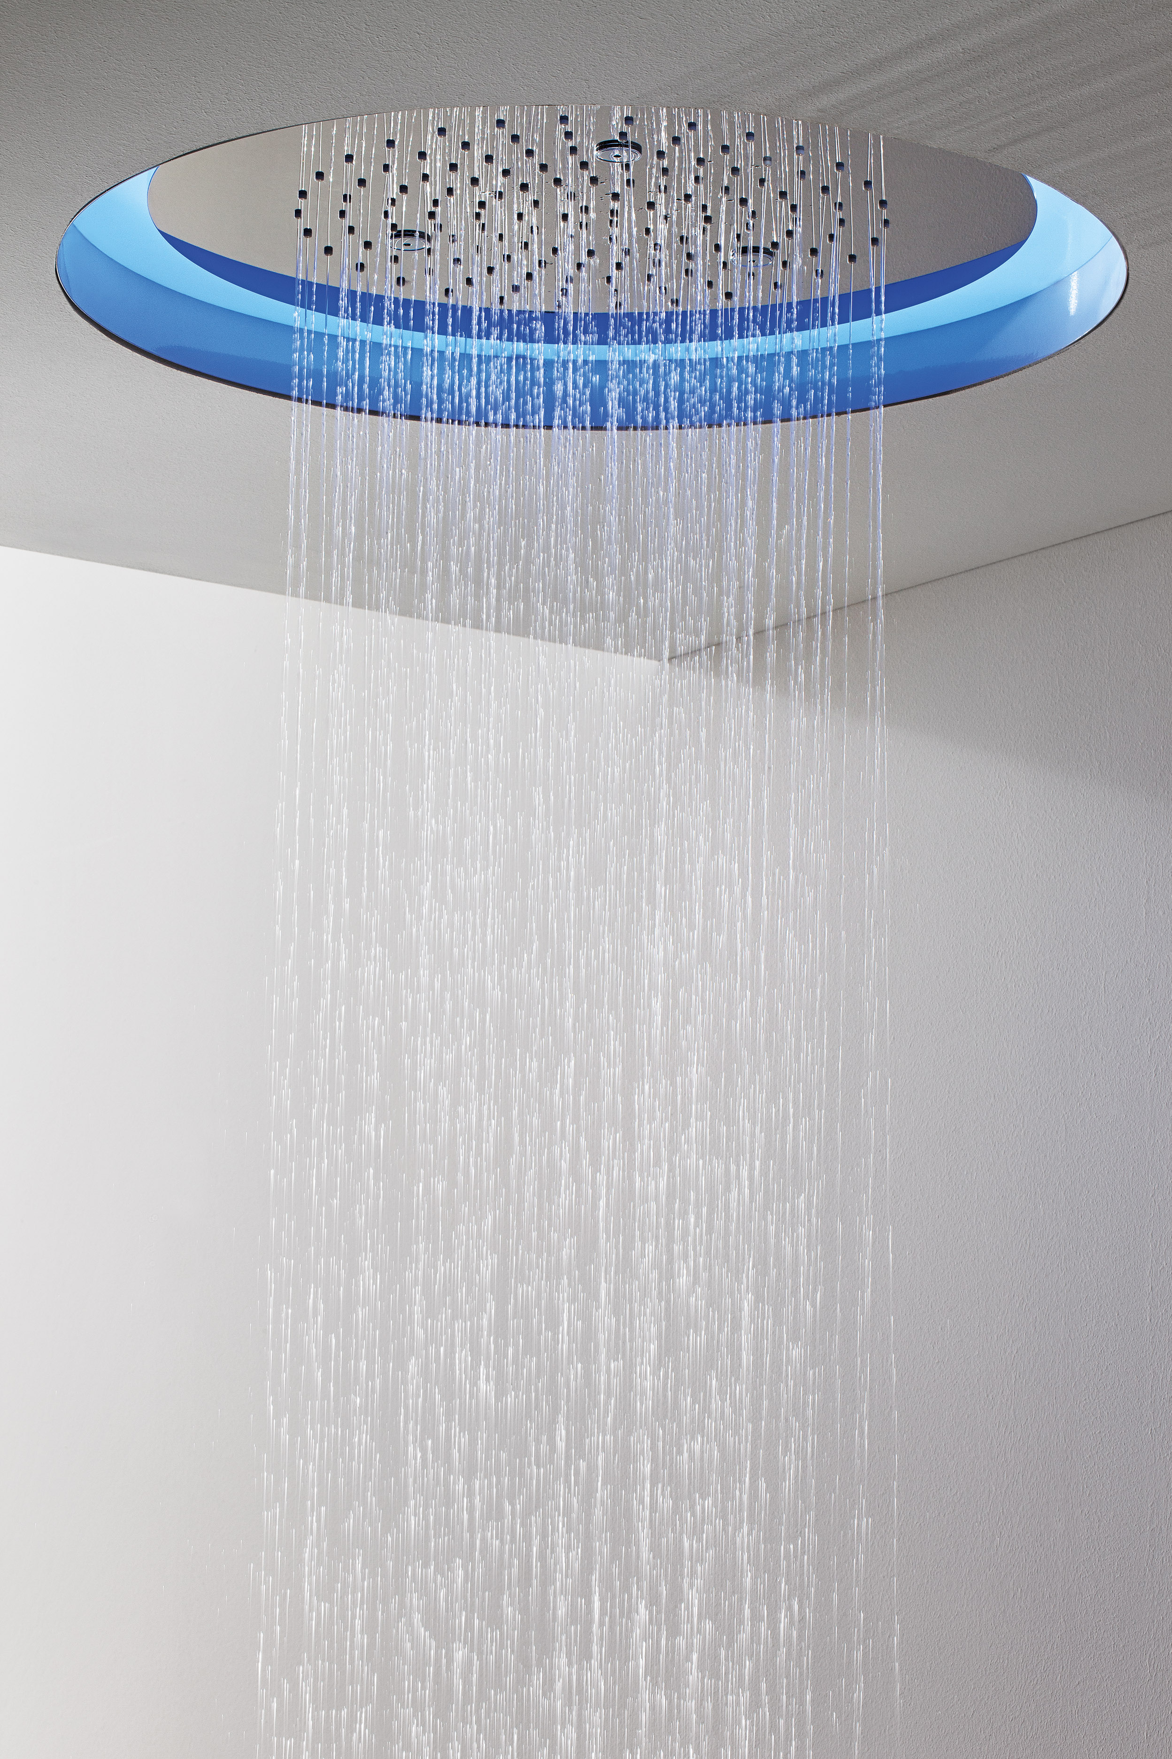

AMETIS collection
Multifunction wall mounted showerhead with rain, waterfall and chromotherapy functions. Dimensions: cm 431 diameter. Materials: stainless steel; matt black finish.

GRAFF EUROPE
Via Aretina 159, 50136 Florence - ITALY
Tel: +39 055 9332115,
fax: +39 055 9332116
email: info@graff-mixers.com
www.graff-faucets.com

PRESS OFFICE
Ufficio Stampa:
tac comunic@zione milano|genova
tel +39 02 48517618 | 0185 351616
press@taconline.it | www.taconline.it

