PRESS RELEASE
SUMMER 2017

An exclusive hotel in Austria, where the wellness features carry GRAFF’s signature collections

A must-see for those looking to explore the stunning landscapes of Austria, the 5-star Tannenhof Superior Hotel in St. Anton am Arlberg offers guests a sophisticated, luxury experience, characterized by traditional Habsburg hospitality and elegant design. The hotel’s many suites embody the natural beauty of the region, and create a guest experience that focuses on the tie between nature, luxury, and relaxation.

The iconic hotel’s recent renovation underscores this ideal, as best seen in its updated bathroom suites and wellness areas. Two of GRAFF’s innovative collections, Qubic and Immersion, were used in the update, yielding an exclusive experience, most appropriate for the Tannenhof Hotel.

The wall-mounted washbasin mixers of the Qubic collection and the Immersion free-standing bathtub mixer blend perfectly with the hotel’s aesthetic.

Qubic is both architectural and contemporary in style, projecting a chic design with its 190mm long spout and strong, geometric silhouette. The range - available in black, white, polished chrome, and brushed nickel finishes - creates a cohesive bathroom suite.

Slim and stylish lines define the freestanding Immersion bathtub mixer. The technical details, associated with a strong aesthetic, find their maximum expression in the flat and curved spout as well as the squared handles. Available in polished chrome and satin nickel finishes, GRAFF’s Immersion is characterized by simple lines, perfectly incarnating the definition of “minimal” and demonstrating, once more, that, in some specific contexts, "less is definitely more”.

Editor’s note: Both QUBIC and IMMERSION fittings are manufactured in emptied brass, with a minimum level of nickel and lead, and realized in compliance with all drinking water regulations - as established by the company policy - fully satisfying the most restrictive criteria required for the protection of health and the environment.

IMAGES AVAILABLE FOR THE PRESS
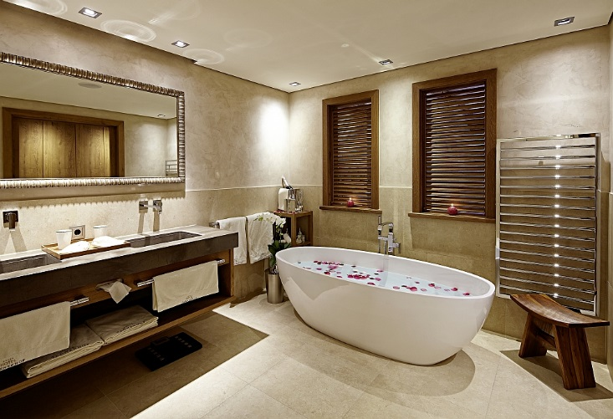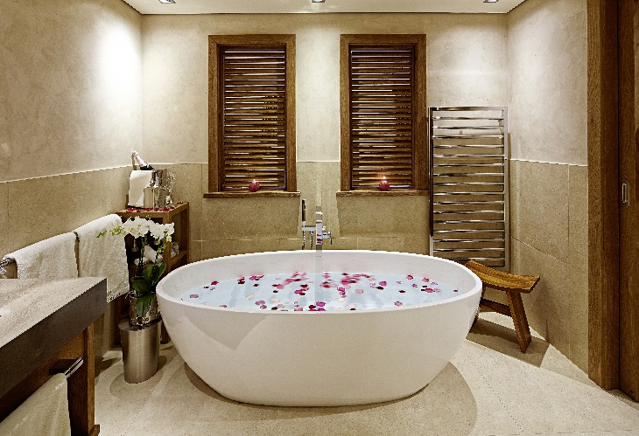

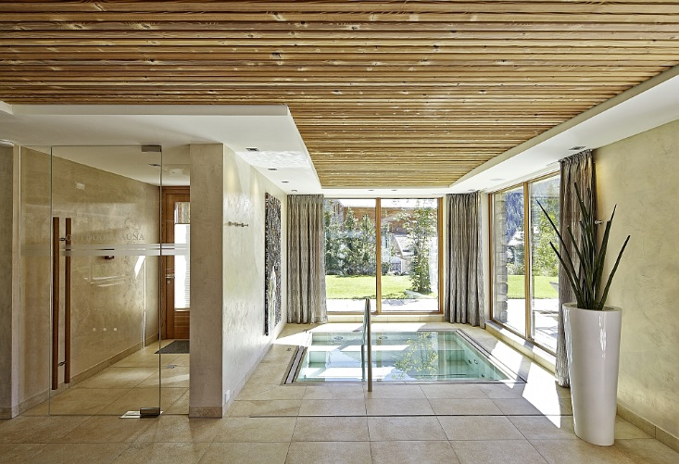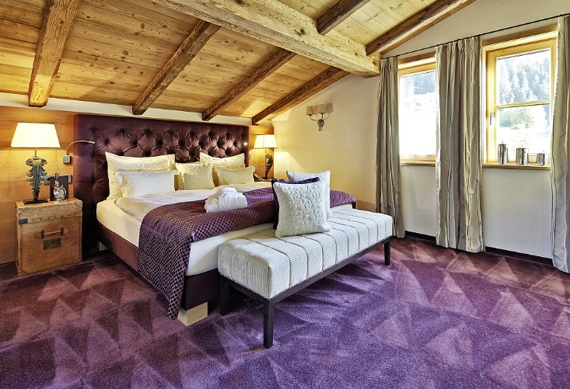

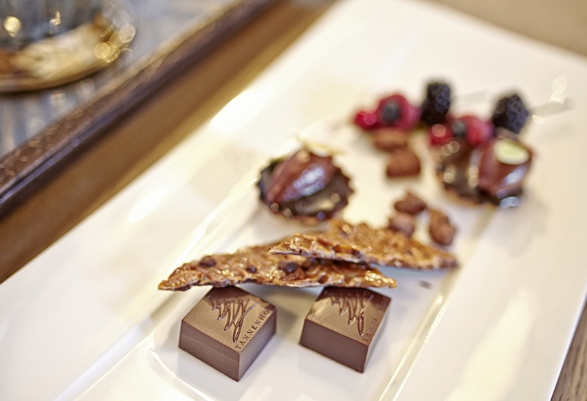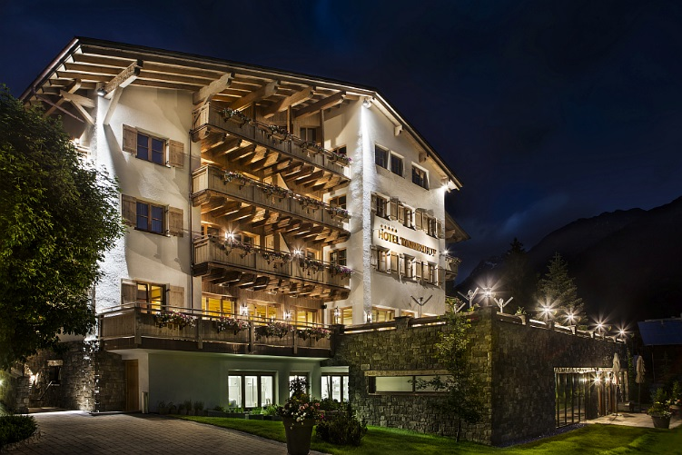

Photos of interiors by “Markus Gmeiner Photographer”
Photos of exteriors by “Felix Steck Photographer”.

www.hoteltannenhof.net

GRAFF EUROPE
Via Aretina 159, 50136 Florence - ITALY
Tel: +39 055 9332115,
fax: +39 055 9332116
email: info@graff-mixers.com
www.graff-faucets.com

For further information and high resolution images:
Press release:
tac comunic@zione milano|genova
tel +39 02 48517618 | 0185 351616
press@taconline.it | www.taconline.it

